Risk Assessment
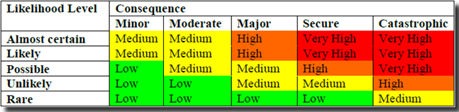
Add as many rows as you require.
Task | Hazards to consider | Risk rating

