Preparing a chemical mixture
In this activity you are to identify the hazards regarding preparation of a chemical mix.
You have been given the task of preparing a herbicide solution to kill the weeds around the property’s out-buildings and homestead’s fence lines. You will be using Roundup – a proprietary named product.
- Use the Use the Risk Rating table below to identify the risk level of the activity.
- Consider the controls you could use. (Hint: Check the Hierarchy of Control for possible solutions).
- Identify what you believe are the best options when doing this task.
- Complete the attached table and email this to your trainer.

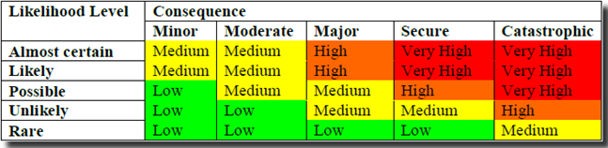

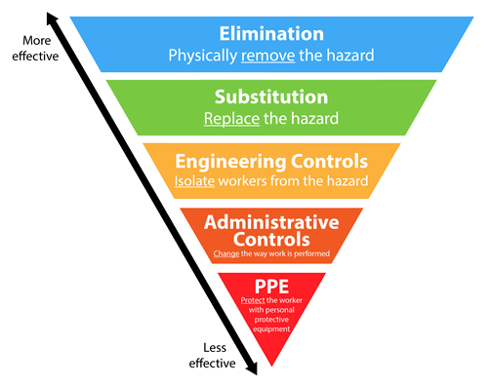

Preparing a chemical mixture – Response
Hazards | Risk rating | Control measures to be employed
Add more rows as needed

