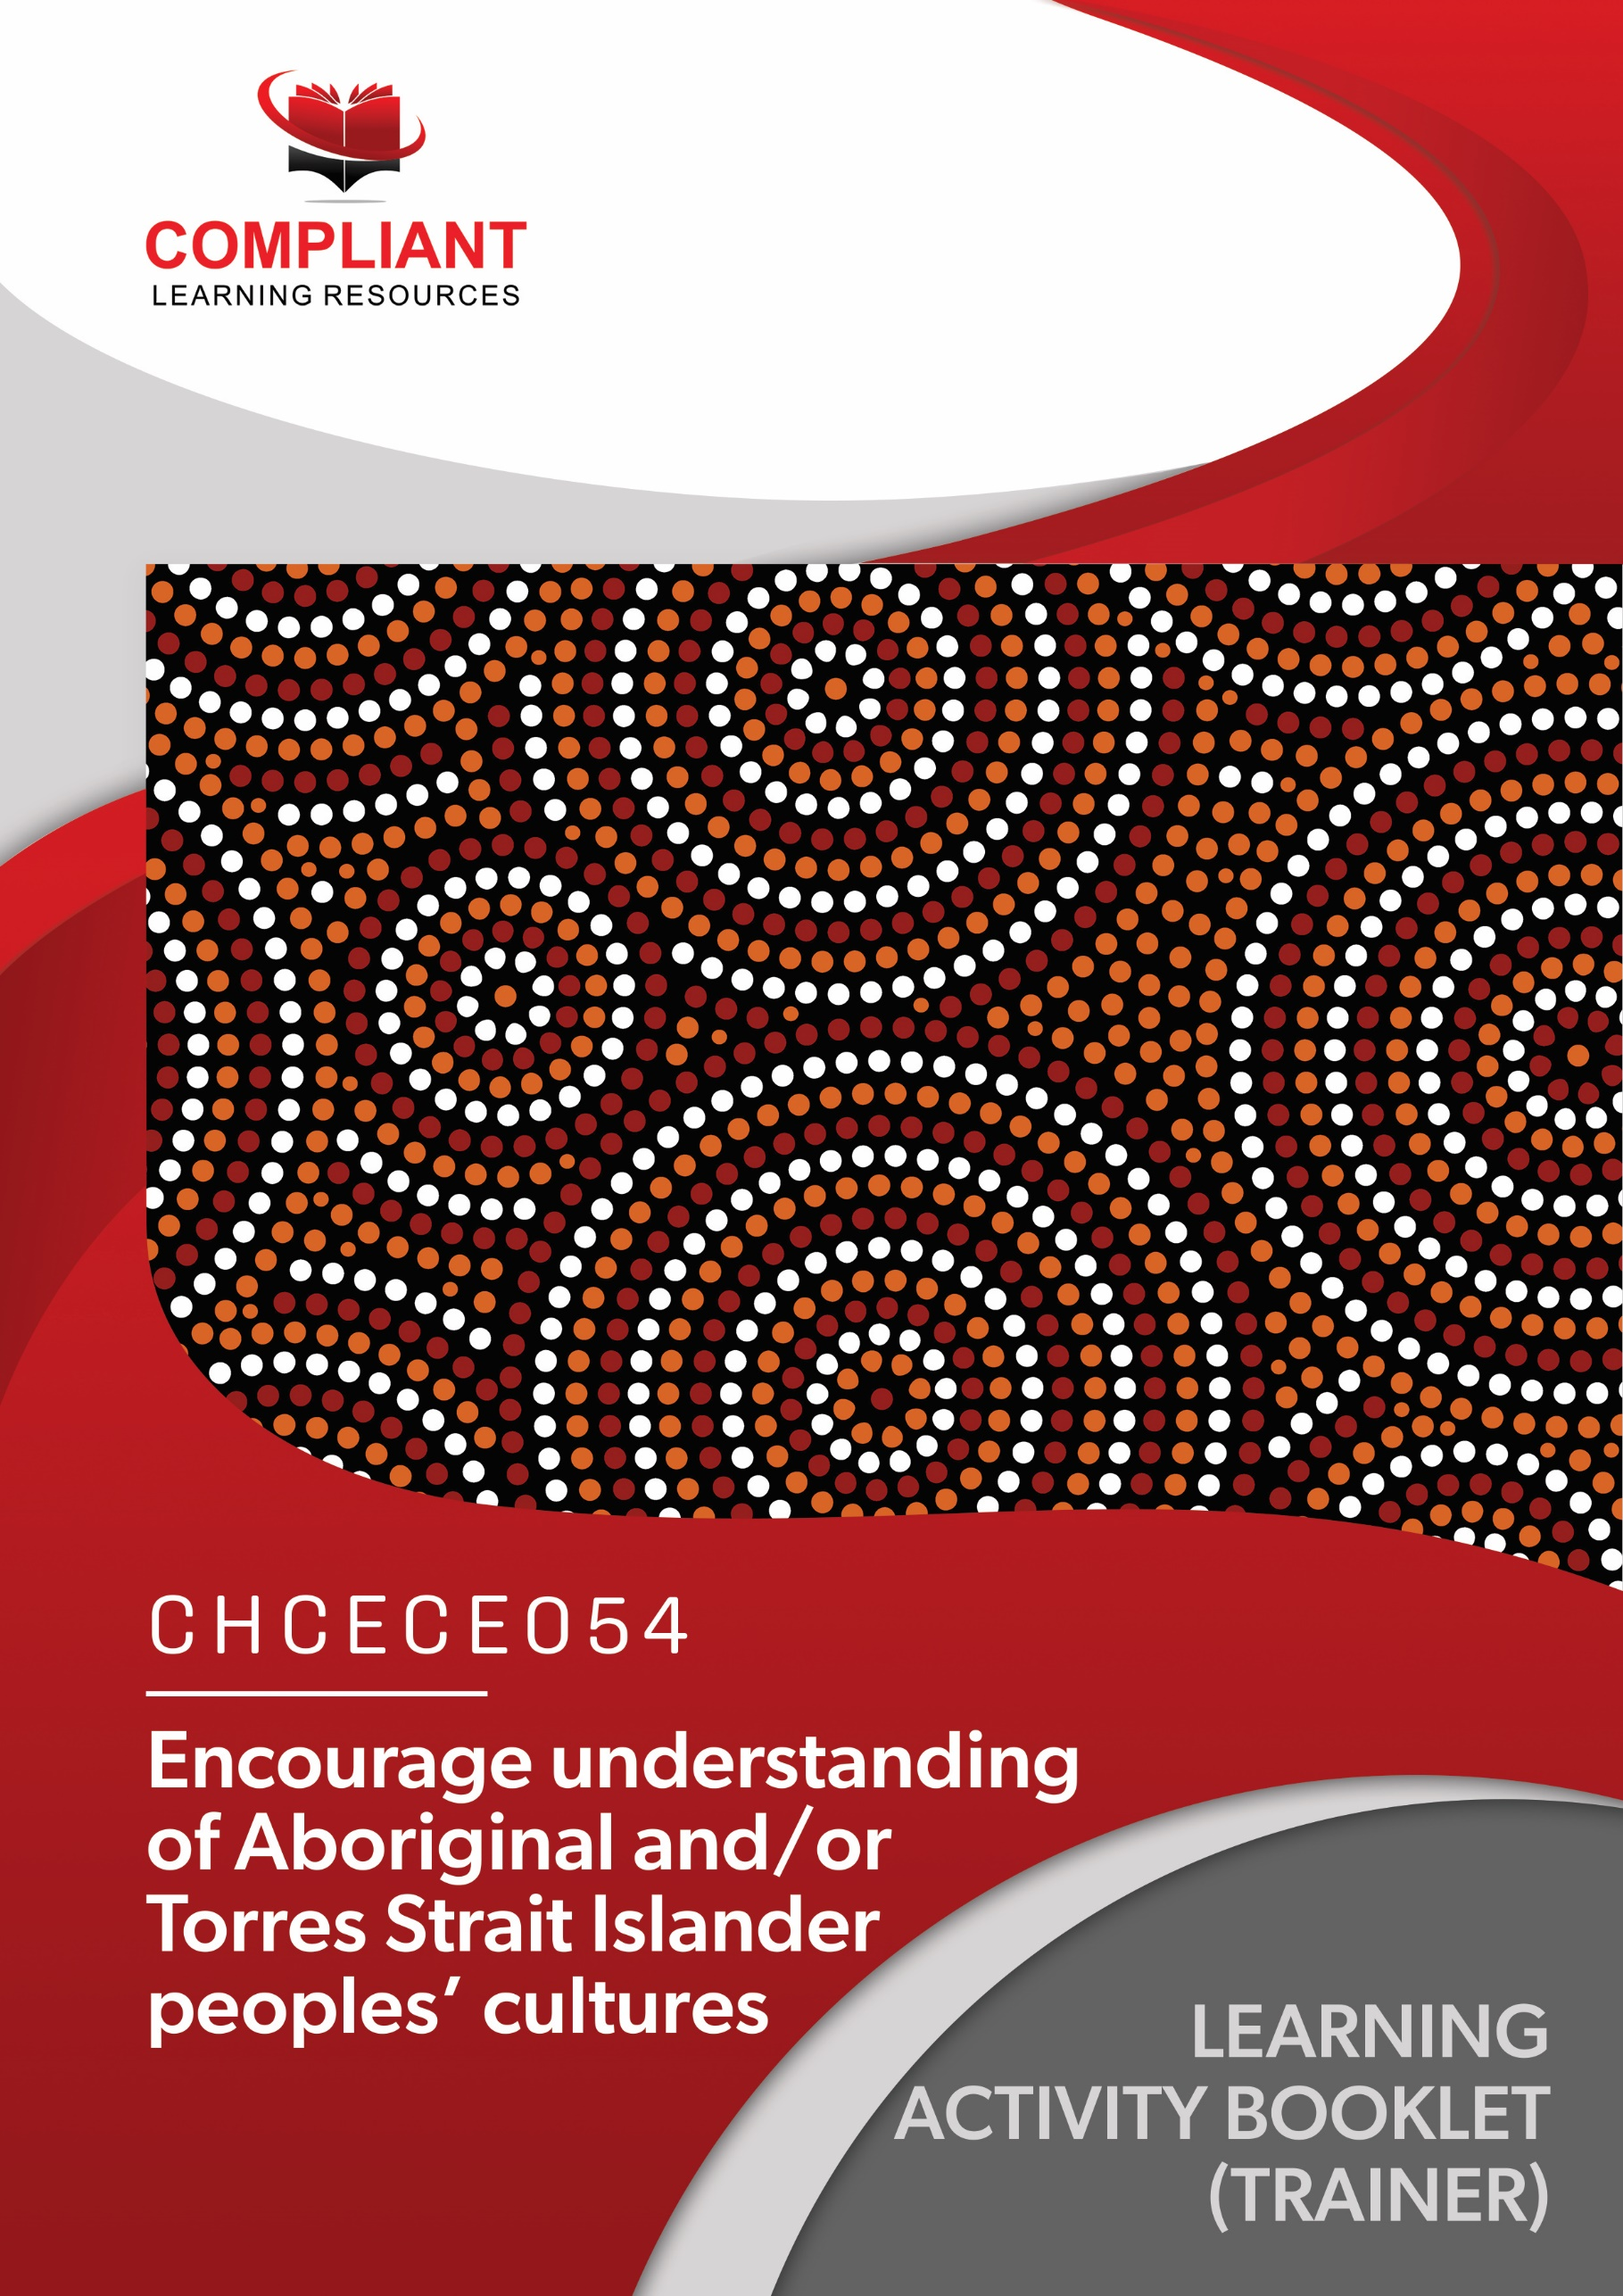

**Copyright**

This document was developed by Compliant Learning Resources.

© 2021 Compliant Learning Resources.

All rights reserved.

No part of this publication may be reproduced, stored in a retrieval system, or transmitted in any form or by any means, electronic, mechanical, photocopying, recording, or otherwise without the prior written permission of Compliant Learning Resources.

**Version Control & Document History**

|  |  |  |
| --- | --- | --- |
| **Date** | **Summary of Modifications** | **Version** |
| 10 July 2021 | Version 1.0 released for publishing | 1.0 |

# Table of Contents

Overview 4

Trainer Instructions 5

Learner Instructions 6

Learner Information 6

Trainer Information 6

Resources Required 7

Work Health and Safety 7

Reasonable Adjustment 8

Contextualisation 9

Formative Activities 10

I. Identify Perspectives on Aboriginal and/or Torres Strait Islander Peoples' Cultures 10

Activity 1.1 10

Activity 1.2 11

Activity 1.3 12

II. Investigate the Local Context for Aboriginal and/or Torres Strait Islander Peoples' Cultures 13

Activity 2.1 13

Activity 2.2 14

Activity 2.3 15

III. Contribute Ideas for Embedding Aboriginal and/or Torres Strait Islander Peoples' Culture in Daily Practice 16

Activity 3.1 16

Activity 3.2 17

IV. Support Children’s Understanding and Respect 19

Activity 4.1 19

Activity 4.2 20

# Overview

**CHCECE054** ‑ **Encourage understanding of Aboriginal and/or Torres Strait Islander peoples’ cultures (Release 1)**

This unit describes the performance outcomes, skills and knowledge required to identify different perspectives on Aboriginal and/or Torres Strait Islander peoples’ cultures, develop an understanding of the local and broader cultural contexts, and use the identified information to embed culturally appropriate experiences, interactions, behaviours and physical environments into daily practice with children.

This unit applies to educators who work in regulated children’s education and care services or schools in Australia, including those who identify as Aboriginal and/or Torres Strait Islander and educators from other cultural backgrounds.

The skills in this unit must be applied in accordance with Commonwealth and State/Territory legislation, Australian standards and industry codes of practice.

No occupational licensing, certification or specific legislative requirements apply to this unit at the time of publication.

**A complete copy of the above unit of competency can be downloaded from the TGA website:**

<https://training.gov.au/Training/Details/CHCECE054>

# Trainer Instructions

This Learning Activity Booklet contains formative activities that learners will complete in the classroom or a similar environment.

These formative activities include knowledge questions to test learners’ underpinning generic knowledge and practical activities to test their skills relevant to the unit/s of competency.

These formative assessments are used by trainers to complement both the learning and training processes, and to evaluate how learners are progressing throughout these processes.

**IMPORTANT:**

**The completion of the formative assessments and learning activities included in this workbook DOES NOT lead to a Qualification or a Statement of Attainment (SOA).**

Reasonable adjustment applies here, and while the majority of learners will complete this assessment as a written assessment, verbal assessment may be an option for those who need it. The assessor must use the marking guide as the principal marking tool unless a reasonable adjustment is demonstrated.

The Learning Activity Booklet (Trainer Copy) provides model answers to all the questions, setting out which key responses must be included as well as indicating where flexibility is acceptable.

The number of responses required is specified in each assessment task to avoid ambiguity. In these cases, the model answer will provide a list of possible answers. For instance, if a question requires the learner to list three examples, then their response must include three of the items listed in the model answer.

# Learner Instructions

This Learning Activity Booklet contains formative activities that learners will complete in the classroom or a similar environment.

These formative activities include knowledge questions to test your underpinning generic knowledge and practical activities to test your skills relevant to the unit/s of competency.

These formative assessments are used by your trainer to complement both the learning and training processes, and to evaluate how you are progressing throughout these processes.

You may reference your Learner Guide and other learning materials to complete the activities included in this workbook.

**IMPORTANT:**

**The completion of the formative assessments and learning activities included in this workbook DOES NOT lead to a Qualification or a Statement of Attainment (SOA).**

## Learner Information

|  |  |
| --- | --- |
| Learner name |  |
| Phone |  |
| Email |  |

## Trainer Information

|  |  |
| --- | --- |
| Trainer name |  |
| RTO name |  |
| RTO phone |  |
| RTO email |  |

# Resources Required

Resources needed to complete activities included in this workbook include:

* Computer with Internet, email access, and a working web browser
* Installed software: MS Word, Adobe Acrobat Reader
* Learner guide

# Work Health and Safety

Both the trainers and learners have duty of care in ensuring that the learning environment is free from hazards that may pose risks to their health and safety.

According to WHS legislation, trainers and learners must take reasonable care while undertaking the activities included in this workbook in the learning environment.

# Reasonable Adjustment

‘Reasonable adjustment’ in VET is the term applied to modifying the learning environment or making changes to the training delivered to assist a learner with a disability. A reasonable adjustment can be as simple as changing classrooms to be closer to amenities or installing a particular type of software on a computer for a person with vision impairment.

**Why make a reasonable adjustment?**

We make reasonable adjustments in VET to make sure that learners with disabilities have:

* The same learning opportunities as learners without disabilities, and
* The same opportunity to perform and complete assessments as those without disabilities.

**Reasonable adjustment applied to participation in teaching, learning, and assessment activities can include:**

* Customising resources and assessment activities within the training package or accredited course
* Modifying the presentation medium
* Learner support
* Use of assistive/adaptive technologies
* Making information accessible both before enrolment and during the course
* Monitoring the adjustments to ensure learner needs continue to be met

**Assistive/Adaptive Technologies**

Assistive/adaptive technology means ‘software or hardware that has been specifically designed to assist people with disabilities in carrying out daily activities’ (World Wide Web Consortium - W3C). It includes screen readers, magnifiers, voice recognition software, alternative keyboards, devices for grasping, visual alert systems, and digital note-takers.

*(Adapted Reasonable Adjustment in teaching, learning and assessment for learners with a disability - November 2010 - Prepared by - Queensland VET Development Centre)*

**IMPORTANT:**

**Reasonable adjustment made for collecting learner assessment evidence must not impact the standard expected by the workplace, as expressed by the relevant unit/s of competency. For example, if the assessment were gathering evidence of the learner’s competency in writing, allowing the learner to complete the assessment verbally would not be a valid assessment method. The method of assessment used by any reasonable adjustment must still meet the competency requirements.**

# Contextualisation

Contextualisation is the process of modifying assessment tools to make learning more meaningful for your students and their employers.

Compliant Learning Resources highly recommends that your RTO contextualise the assessment tools before using them.

You must contextualise the assessment tools to suit:

* Your student’s needs
* Your RTO’s training and assessment processes
* The work and industry context in which you operate

**Contextualising for your state/territory**

The contents of this assessment tool are not written for a specific state/territory unless stated otherwise. Where the assessment tool refers to legislation and other industry requirements, which may vary across states/territories, model answers are based on one state/territory.

Should your RTO intend to use this assessment tool for learners from your state/territory, Compliant Learning Resources recommends you to:

* Access and review the legislation and industry requirements applicable in your state/territory.
* Update assessments and benchmark answers to reflect the legislation and industry requirements applicable in your state/territory.

When you are contextualising assessment tools, you must ensure that you retain the integrity of the assessment and the outcomes of the unit of competency.

**A comprehensive guide to contextualising your assessment tools for your RTO can be accessed through this link:**

<https://compliantlearningresources.com.au/blog/simple-guide-to-contextualising-rto-training-resources-and-assessment-tools/>

# Formative Activities

## I. Identify Perspectives on Aboriginal and/or Torres Strait Islander Peoples’ Cultures

### Activity 1.1

|  |  |
| --- | --- |
| **True or False**  Review the statements below about perspectives on Aboriginal and Torres Strait Islander people. Indicate whether each statement is True or False.  Tick the box that corresponds to your answer. | |
|  | |
| *Mapping: CHCECE054 PC1.1 (p), KE7.1 (p)*  *Learner guide reference: CHCECE054 Learner Guide, Chapter 1, Section 1.1.1* | |
| TRUE  FALSE | 1. Your ‘Perspective’ is how you see the world around you. Perspectives shape how you interact with the world, as well as how you see yourself and others. |
| TRUE  FALSE | 1. “Indigenous”, “Aboriginal” or “Torres Strait Islander” are names that are the legacy of British colonisation. |
| TRUE  FALSE | 1. An Aboriginal person is someone with dark skin and has lived in the jungles of Australia for centuries. |
| TRUE  FALSE | 1. Terms such as Koori, Kurri, Moori are terms reserved for any person who wants to identify as indigenous. |
| TRUE  FALSE | 1. “Indigenous”, “Aboriginal” or “Torres Strait Islander” are colonial labels imposed on a range of people with extremely diverse cultures and languages. |

### Activity 1.2

|  |
| --- |
| Briefly explain what meaningful reflection means. |
|  |
| *Mapping: CHCECE054 PC1.1 (p), KE8.3*  *Learner guide reference: CHCECE054 Learner Guide, Chapter 1, Section 1.1.2*  **Marking guide**  The learner must briefly explain what meaningful reflection means.  For a satisfactory performance, although the wording may slightly vary, their response must be consistent with the benchmark answer below. |
| Reflection is meaningful when the educator is aware of their own thought process, can come up with potential applications for their reflection, and when the conclusions or outcomes are shared with relevant individuals within the centre. |

### Activity 1.3

|  |
| --- |
| List three common misconceptions people have about Aboriginal and/or Torres Strait Islander peoples. |
|  |
| *Mapping: CHCECE054 PC1.1 (p)*  *Learner guide reference: CHCECE054 Learner Guide, Chapter 1, Section 1.1.1*  **Marking guide**  The learner must list three common misconceptions people have about Aboriginal and/or Torres Strait Islander peoples.  For a satisfactory performance, their response must include at least three of the following:   * The Aboriginal people in Australia all belong to the same culture * You can mostly find aboriginals in the wild outback * All aboriginals have dark skin * Aboriginal people only excel at arts and sports * Aboriginal children need to aspire to higher callings   If the learner’s responses are none of the above, they are still acceptable as long as they demonstrate sufficient knowledge of common misconceptions people have about Aboriginal and/or Torres Strait Islander peoples. |
|  |
|  |
|  |

## II. Investigate the Local Context for Aboriginal and/or Torres Strait Islander Peoples’ Cultures

### Activity 2.1

|  |
| --- |
| **Fill in the blanks**  The following are statements about local Aboriginal and/or Torres Strait Islander peoples' cultures and history. Review each and complete the statement by filling in the missing words/phrases. |
|  |
| *Mapping: CHCECE054 PC2.1 (p), PC2.2 (p)*  *Learner guide reference: CHCECE054 Learner Guide, Chapter 2, Section 2.1 and Section 2.2* |
| 1. A “     credible source” of information is unbiased and true and can be backed up by evidence. |
| 1. The term ‘     Stolen Generations’ refers to Aboriginal and Torres Strait Islander Australians who were forcibly removed from their families and communities by government, welfare or church authorities as children and placed into institutional care or with non-Indigenous foster families. |
| 1. In the broader Australian context, the impact of the      Whitlam Government’s policy of self-determination was that Aboriginal and/or Torres Strait Islander Peoples were given the opportunity to participate in making policy decisions that would affect them. |
| 1. Land councils serve as representative bodies for Aboriginal and Torres Strait Islander peoples in state or territory level |
| 1. It is essential to check      credibility to make sure that the information you are disseminating are accurate and factual. |

### Activity 2.2

|  |
| --- |
| List three impacts of forced separation on different generations of Aboriginal and/or Torres Strait Islander Australians. |
|  |
| *Mapping: CHCECE054 PC2.2 (p), KE10.1, KE10.2*  *Learner guide reference: CHCECE054 Learner Guide, Chapter 2, Section 2.2*  **Marking guide**  The learner must list three impacts of forced separation on different generations of Aboriginal and/or Torres Strait Islander Australians. For a satisfactory performance, although the wording may slightly vary, their response must include three of the following:   * Many families experienced grief and guilt when their children were taken away from them. * They developed a reliance on substances such as alcohol and drugs because of their trauma and this has led to unhealthy lifestyles. * They lost their cultural affiliation and find it difficult to take a role in the cultural and spiritual life of their communities. * Members of the Stolen Generation are more likely to have been jailed compared to the general population. * Some of them were reported to have behavioral problems as an effect of their parents’ inability to provide proper parental care.   If the learner’s responses are none of the above, they are still acceptable as long as they demonstrate sufficient knowledge of signs that may suggest a child is feeling stressed at the time of separation into care service. |
|  |
|  |
|  |

### Activity 2.3

|  |  |
| --- | --- |
| **True or False**  Review the statements below about considerations for researching about Aboriginal and/or Torres Strait Islander people. Indicate whether each statement is True or False.  Tick the box that corresponds to your answer. | |
|  | |
| *Mapping: CHCECE054 PC2.3 (p), KE11.3*  *Learner guide reference: CHCECE054 Learner Guide, Chapter 2, Section 2.3* | |
| TRUE  FALSE | 1. Cultural Appropriation is when someone not belonging to specific cultural groups tries to reproduce parts of their culture such as art, clothing, or other items. |
| TRUE  FALSE | 1. Aboriginal and Torres Strait Islander People are the main custodians and presenters of their heritage. |
| TRUE  FALSE | 1. Permission is unnecessary if the information you are gathering is for personal research. |
| TRUE  FALSE | 1. There is no existing code of ethics that cover researching information about Aboriginal and Torres Strait Islander People |
| TRUE  FALSE | 1. There are historical issues that may be sensitive to discuss with the people in the community. |

## III. Contribute Ideas for Embedding Aboriginal and/or Torres Strait Islander Peoples’ Culture in Daily Practice

### Activity 3.1

|  |
| --- |
| Briefly explain what cultural protocols are. |
|  |
| *Mapping: CHCECE054 PC3.1 (p)*  *Learner guide reference: CHCECE054 Learner Guide, Chapter 3 Section 3.1*  **Marking guide**  The learner must briefly explain what cultural protocols are.  For a satisfactory performance, although the wording may slightly vary, their response must be consistent with the benchmark answer below. |
| Cultural protocols are ethical practices, principles and values that should be observed when interacting and working with people from various cultures. It was created to protect Aboriginal and Torres Strait Islander peoples and their rights. |

### Activity 3.2

|  |  |  |  |  |  |  |
| --- | --- | --- | --- | --- | --- | --- |
| **Matching Type**  Identify the considerations for promoting children’s understanding being described in each statement below.   |  | | --- | | **Considerations for Promoting Children’s Understanding** | | Cultural safety | | Cultural sensitivity | | Learning experiences | | Acknowledgement of Country | | Collaboration | |

|  |  |
| --- | --- |
| *Mapping: CHCECE054 PC3.1 (p), PC3.3 (p)*  *Learner guide reference: CHCECE054 Learner Guide, Chapter 3, Section 3.1 and Section 3.3* | |
| **Learning Outcomes** | **Description** |
| Cultural sensitivity | 1. This is the ability to understand that others have different backgrounds and cultures other than yours, and your actions are reflected by understanding and respect. |
| Cultural safety | 1. This means ensuring that a child is provided with an environment that is safe, nurturing and positive where children can be comfortable with being themselves, expressing their culture, spiritual and beliefs system, and are supported by their family and carers. |
| Collaboration | 1. This happens is when a group of people equally contribute and work together to finish a task or reach a common goal. |
| Acknowledgement of Country | 1. A way to show respect to the First Peoples and Traditional Custodians of the land |
| Learning experiences | 1. Refers to any program, activity or interactions in which opportunities for learning are present. |

## IV. Support Children’s Understanding and Respect

### Activity 4.1

|  |  |
| --- | --- |
| **True or False**  Review the statements below about facilitating children’s learning. Indicate whether each statement is True or False.  Tick the box that corresponds to your answer. | |
|  | |
| *Mapping: CHCECE054 PC4.1 (p), PC4.2 (p), PC4.3 (p)*  *Learner guide reference: CHCECE054 Learner Guide, Chapter 4, Section 4.1, Section 4.2 and Section 4.3* | |
| TRUE  FALSE | 1. Facilitation of children’s experiences related to Aboriginal and Torres Strait Islander peoples should always reflect the cultural inclusivity of your program and must be geared towards portraying their culture in a positive light. |
| TRUE  FALSE | 1. Observational learning is when individuals learn by what they see and hear from other people and their behaviours are influenced by it. |
| TRUE  FALSE | 1. Aboriginal and Torres Strait Islander cultures should only be taught if you have children who identify with them. |
| TRUE  FALSE | 1. Culturally appropriate ways refer to practices that consider other people’s culture by respecting their preferences, understanding and accepting the historical context of their ways. |
| TRUE  FALSE | 1. Aboriginal and Torres Strait Islander people value their languages as those are strongly connected with their cultures, land, values, histories, and communities. |

### Activity 4.2

|  |
| --- |
| List Aboriginal and/or Torres Strait Islander peoples’ ways of learning. |
|  |
| *Mapping: CHCECE054 PC4.3 (p)*  *Learner guide reference: CHCECE054 Learner Guide, Chapter 4, Section 4.3*  **Marking guide**  The learner must list three Aboriginal and/or Torres Strait Islander peoples’ ways of learning.  For a satisfactory performance, although the wording may slightly vary, their response must include three of the following:   * Story sharing * Learning map * Non-verbal * Symbols and images * Land links * Non-linear * Deconstruct/Reconstruct * Community links |
|  |
|  |
|  |

End of Document