How To Teach Critical Thinking Using Bloom’s Taxonomy

*By* [*Jeff Dunn*](http://www.edudemic.com/author/edudemic/) *on September 27, 2013*

[in**Share**](javascript:void(0);)140

841

The various levels of Bloom’s Taxonomy are well known to teachers, students, and the rest of the education world at this point. You need to slowly ascend the pyramid in order to effectively reach your goal(s). That’s great. But what happens when you try to apply other time-tested methodologies to the famous taxonomy?

This happens.

The visual guide you see below is from Flickr via Kris McElroy’s Pinterest board (she shares a lot of fabulous resources so check ‘em out!). It details the many critical thinking skills and related questions that you should use.

**Level One**

From the base knowledge level of the taxonomy you can see that you start with the usual ‘who’ ‘what’ ‘where’ and other questions. Those are useful fill-in-the-blank questions that help identification and recall of information.

**Level Two**

You’re asked to re-tell and dive in a bit deeper into the topic you’re researching or discussing. This helps aid in comprehension and organization / selection of facts and ideas.

**Level Three**

How do you actually apply the skills you’re learning? How can your newfound critical thinking skills be used to interpret new data from outside sources?

**Level Four**

Like a good scientist (this is close to the Scientific Method after all), we must analyze the results that are now coming forth. We should pause and figure out how critical thinking skills are being incorporated into our everyday lives. Just ask the questions in level four and you’re off to a great start!

**Level Five**

Time to remix and synthesize some new ideas or formulations. In other words, let’s take what we know and combine a bit of what we just discovered. That’ll help us form new ideas and interpretations of what we’re studying or discussing.

**Level Six**

Boom. You made it. Time to form your own opinion and be able to discuss the finer points of why you think the way you do! Who knew it took so much work to actually be able to accurately form your own opinion?

Think about that the next time you’re asked your opinion. It takes time to ponder and consider every level of the taxonomy.

[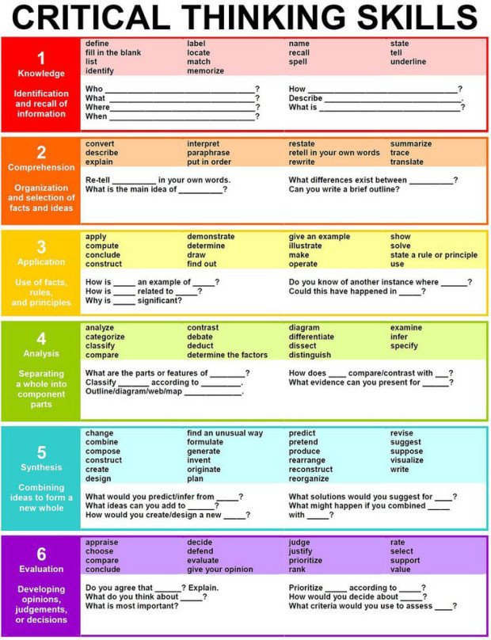](http://www.edudemic.com/wp-content/uploads/2013/09/critical-thinking-skills.jpg)

Related Items