10 good reasons why you should never trust Wikipedia as an accurate source of information:

Set in increasing order of importance…
10. You must never fully rely on any one source for important information.
9. You really can’t rely on something when you don’t even know who wrote it.
8. The contributor who is biased or has an agenda often prevails.
7. Individuals with agendas or who are biased on a topic sometimes have significant editing authority.
6. Sometimes “vandals” create malicious entries that go uncorrected for months
5. There is little diversity among editors.
4. The number of active Wikipedia editors has declined; there are not a great number given the amount of work that needs to occur.
3. It has become harder for people who find mistakes to contribute or have the errors repaired.
2. Accurate contributors can be silenced
And the number one reason:
1. It says so on Wikipedia
“Wikipedia says, “We do not expect you to trust us.” It adds that it is “not a primary source” and that “because some articles may contain errors,” you should “not use Wikipedia to make critical decisions.”
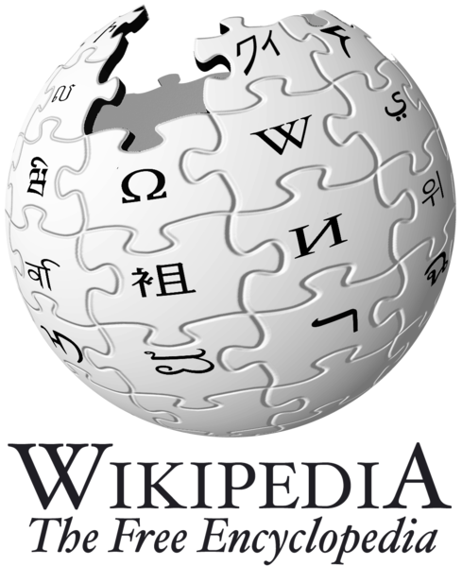
Furthermore, Wikipedia notes in its “About” section, “Users should be aware that not all articles are of encyclopedic quality from the start: they may contain false or debatable information.”

