How To Use Bloom’s Taxonomy To Write Learning Outcomes

*By* [*LindsayH*](http://www.edudemic.com/author/lindsayh/) *on June 28, 2014*

[in**Share**](javascript:void(0);)159

199

By: Scott Davis Business Analyst, Pearson

It is often quite difficult to relate inputs to outcomes in the world of education. Traditionally, much work has been done to develop and provide inputs into the process of education. These inputs, such as a textbook, an assessment, a learning technology or platform, a course, a qualification, a high-stakes test or professional development for teachers are put into the hands of an educational leader, a skillful teacher, or an eager student. And, for all of the investment, expertise, and care that go into their creation, that has typically been where the involvement ends. Rarely has one been able to measure or predict the learning outcomes from using these inputs.

If we are going to really understand how we might be impacting student learning we must do two things. First we must define our student learning outcomes – these are the goals that describe how a student will be different because of a learning experience. The focus should be on what a student will be able to do with the information or experience. And second, we must measure if the program or service implemented to facilitate the learning was effective.

[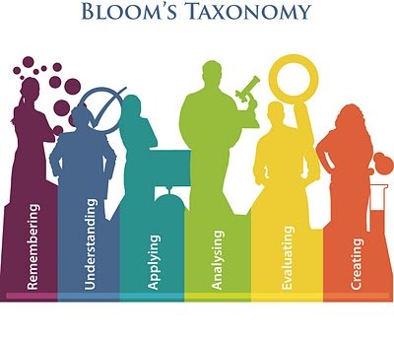](http://www.edudemic.com/wp-content/uploads/2014/05/Blooms_taxonomy_poster.jpg)

**Defining Learning Outcomes**

It may be difficult to know where to start in writing a student learning outcome. And you are not alone in facing the challenge of relating educational inputs to learning outcomes and understanding your impact on student learning. Learning taxonomies are a valuable tool for classifying learning objectives. A helpful and frequently used resource when writing student learning outcomes is [Bloom’s Taxonomy](http://www.edudemic.com/blooms-taxonomy-tools-worth-trying/) of Cognitive Skills. Bloom’s Taxonomy refers to a classification of the different objectives that educators set for students (learning objectives). [The taxonomy](http://www.edudemic.com/blooms-taxonomy-critical-thinking/) was first presented in 1956 through the publication “The Taxonomy of Educational Objectives, The Classification of Educational Goals, Handbook I: Cognitive Domain” (Bloom 1956). It is considered to be a foundational and essential element within the education community as evidenced in the 1981 survey “Significant writings that have influenced the curriculum: 1906-1981″ (Shane 1981).

The committee identified three domains of educational activities or learning (Bloom, 1956):

- Cognitive: mental skills (Knowledge)  
- Affective: growth in feelings or emotional areas (Attitude or self)  
- Psychomotor: manual or physical skills (Skills)

The domains are further subdivided, starting from the simplest behavior to the most complex. The first of these domains is the cognitive domain, which emphasizes intellectual outcomes. This domain is further divided into categories or levels. The divisions outlined are not absolutes and there are other systems or hierarchies that have been devised in the educational and training world. However, Bloom’s taxonomy is easily understood and is probably the most widely applied one in use today.

Various researchers have summarized how to use Bloom’s Taxonomy. Following is one interpretation that can be used as a guide in helping to write objectives using Bloom’s Taxonomy. The major idea of the taxonomy is that what educators want students to know (encompassed in statements of educational objectives) can be arranged in a hierarchy from less to more complex. The levels are successive, so that one level must be mastered before the next level can be reached.

The original levels (Bloom, 1956) were ordered as follows: Knowledge, Comprehension, Application, Analysis, Synthesis, and Evaluation.

Additional Information:

Bloom, B. S.; Engelhart, M. D.; Furst, E. J.; Hill, W. H.; Krathwohl, D. R. (1956). Taxonomy of educational objectives: The classification of educational goals. Handbook I: Cognitive domain. New York: David McKay Company.

Shane, Harold G. (1981). “Significant writings that have influenced the curriculum: 1906-1981″. Phi Delta Kappan 62 (5): 311–314.

Source: <http://www.edudemic.com/blooms-taxonomy-to-write-learning-outcomes/> 26 November 2014