Bookmarking Web Pages

Being digital literate is not just about finding information on the web. It is also about being able to organize and return to the sites you've searched at a later date.

The simplest way to do this is to **bookmark** a site. Every web browser lets you create bookmarks (sometimes called **Favorites** in some web browsers). These applications also let you rename and organize your bookmarks so that these reflect how you use these. Creating a bookmark takes very little time but it will save you heaps since you don't have to search the web to find it again.

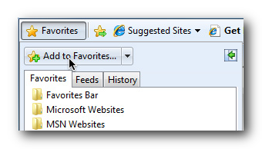

Web pages you might visit again can be added the **bookmarks** (sometimes called **Favorites**) of the web browser. Bookmarks make it easy to find a page at a later date. Instead of having to remember the exact **web address**, you find the site inthe **bookmarks** until you see the name of the page.

#### Cloud-Based Bookmarking Services

A disadvantage of browser based bookmarks is that you cannot access these from a different computer. To overcome this you can use a **cloud-based bookmarking service**, which stores your bookmarks online so that you can access these from any computer connected to the Internet. Listed below are some of these cloud based bookmarking services:

* [Google Bookmarks](http://www.google.com/bookmarks): **Google Account** holders can view and add bookmarks whenever they are signed in.
* [Delicious](http://www.delicious.com): Delicious makes it easy to share bookmarks with other people, which is especially useful if you are sharing work with other team members or friends. Bookmarks can be grouped into **Stacks**, which you can **share** with other people.
* [Google Chrome](http://www.google.com/chrome): If you use Chrome as your web browser, you could use its **bookmark syncing** feature. Whenever you are signed in to Chrome, your bookmarks and other settings are synced with your Google Account. You can access your bookmarks from any computer by simply signing in to Chrome.