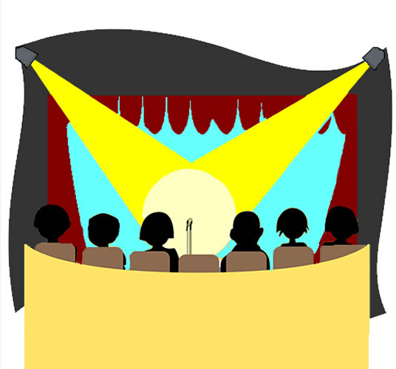
www.paperindustry.com

Creative Industries

Certificate II in Live Production, Theatre and Events

Lighting

Document details

© Copyright 2022 TEIA Ltd and its licensors. All rights reserved.
TEIA Ltd, PO Box 358, Charters Towers, Q 4820. Tele./Fax: 07-47877940
Email : training@aatacs.com Website : www.aatacs.com

This document is covered by copyright. This publication, including the accompanying software and data files or any part thereof, may not be reproduced or transmitted in any form or by any means, electronic or mechanical, including photocopying, recording, storage in an information retrieval system without the written permission of TEIA Ltd.

Software used in the development of this work included Microsoft Word 2007, Microsoft Windows Vista, Adobe Fireworks and a range of freeware applications.

Disclaimer

While great care is taken to ensure the accuracy and quality of these materials, all material is provided without any warranty whatsoever, including not limited to, the implied warranties of merchantability or fitness for a particular purpose. Further, the right is reserved to revise this publication and to make changes in its content at any time, without obligation to notify any person or entity of such revisions or changes

Revision 1-1 March 2009

Table of Contents
About This Booklet 8

Purposes of Lighting 9
Visibility: 9
Mood/Atmosphere: 9
Plausibility: 9
Composition: 9
Reinforcement: 9

Qualities of Light 10
Intensity 10
Colour 10
Distribution 10
Movement 10

General Types of Fixtures 11
Accenting 11
Washes 11

Lighting Fixtures 11
Floodlights 11
Spotlights 13

Controlling the Lights 14
Lighting Control Board 14
Dimmers 15
Distribution Network 16

Other Equipment 16
Cables 16

Placing lights 17
Placing the Lights 17

Colour 18

Texture 21

Technical Specification Sheets 22

Lighting Plans 23

Health and Safety with Lighting 27
Placement of gear 27
Cables 27
Electrical checks 27
Ladders 27
Lighting 28
Venue 28
Personal protection 28

Appendix One Lighting Terms 29

About This Booklet

This booklet provides background information on the various elements of lighting used in live productions that include theatre, live events, concerts, etc.

The information contained in this booklet is an introductory overview of the aspects of live production lighting.

Purposes of Lighting
The use of lighting in live productions has specific purposes, though there are many differing interpretations as to the purpose of event lighting. There is common agreement that there are five purposes of lighting:

Visibility:
If the audience can't see the performers then the production, regardless of whether it is theatre or some other live event, cannot succeed. The first purpose of lighting is to ensure what is needed to be seen, can be seen!

Mood/Atmosphere:
Mood or atmosphere is the raising within the audience of a desired emotion or state of being. It is this purpose that enables an event’s lighting to contribute to the purpose of the performers and the intent of the play or performance. For example, what lightning may need to be provided to support a scene where fear was being expressed by the performers?

Plausibility:
The use of light to construct a form of reality within which the performance may occur, For example, in a church scene light may be managed to convey stained glass windows!

Composition:
Just like the composition of a painting, light may sometimes be simply used to construct an area of visual display. This use of lighting is most commonly found in live music acts or similar non-narrative performances. The act of painting a picture, in this case, 'painting' with light.

Reinforcement:
Through the use of lighting and its effects, the words of the performer can be reinforced. However this reinforcing also occurs with the work of others, e.g. set and customer designers. The effective use of light will enhance the performance by drawing attention to the parts of the event that are to be emphasised.
Note that it is not expected that all five purposes must be found in each application of live event lighting, however the use of lightning will address one or more of these purposes at all times.

General Terms
If you are to work with live production lighting it is important to understand the terms that are used. Like any industry, there is a unique language that is used by people to describe their work tools, procedures and activities. The glossary for this course covers many lighting terms and you must become familiar with these, but to assist, some common terms are outlined in Appendix One.
Please refer to this resource as required throughout this course.

Qualities of Light
If you are to work with light, you will need to understand that light has some qualities that form the basis of many discussions and work directions. Ensure you understand what the following qualities are and how they can be identified in your work within live production lighting activities.

Intensity
The intensity of light is best described along the spectrum of bright or dim. Intensity may be adjusted using equipment and the amount of electricity flowing to the lamp.

Colour
Light has colour. The use of colour within the light provided for a production will often be a creative and subjective decision. It is often one of the factors used to construct the mood or atmosphere of an element within the production.

Distribution
Distribution is the term used to describes the direction of the light or I situations where the light is diffused and soft, its’ lack of direction. The distribution of lighting across a performing area will be represented differently than what occurred in reality.

Movement
In this term the movement of light is not about panning, tilting or moving spots. It is about how the light production changes during a scene to support the intent and emotion of the staged activity. It is the lengthy sequence of lighting changes where the light moves to support the intent of the performance.

General Types of Fixtures
There are so many different types of light fixtures it is easy to become confused or even over-whelmed. However with experience, you will find the names and purposes come to you very quickly.

Lighting fixtures can generally be classified into two different purposes.

Accenting
Accenting means making certain areas of the stage brighter than others so that the audience will direct their attention to that particular spot. For example, if two performers are talking at the front of the staging area, the director will want the audience to pay attention to those two performers, not other parts of the staging area. By highlighting their area, and perhaps even dimming the rest of the stage, the audience’s attention is directed to the two performers.

Washes
A wide area of light coverage or “wash” is used to provide colour or tone to the performance area. Producing a wash is carried out by using one or more light fixtures. Wash light fixtures are used to fill in the dark spaces of the stage. Wash lights provide a less directional beam of light than those used to accent an area.

Lighting Fixtures
There are two main types of lanterns, floodlights (washes) and spotlights (accenting). Floodlights do not use a lens to focus light while spotlights make use of lens to produce strong beams of light.
Most of these spotlights and floodlights are constructed so as to be able to be mounted on overhead bars, vertical bars or floor stands. Each fixture is generally fitted with a mounting yoke and/or a pipe hook clamp. The yoke and clamp allows for the lantern to be tilted, rotated or panned into a wide range of positions and then be locked into place. There is also generally a locking chain that acts a failsafe safety to stop the fixture falling!
The majority of lanterns will also be fitted with clips to hold a square metal frame for use with colour filters and gels. There may also be other accessories such as barn doors and top hats.
Lighting fixtures operate on 240 volt. This is the Australian standard, but will change if you work in other countries.
Lanterns generally use incandescent or electric filament lamp. Filament refers to the metal wire inside the lamp/bulb. By changing the amount of electricity passing through the filament of a lantern’s lamp through the use of dimmers, a lighting technician is able to change the intensity or brightness of the light beam of that later.
Lanterns range in size. General lighting say in a shop is generally around the 50 – 300 watt. Lighting used in live production and theatres will generally come from lanterns that operate at 500–2000 watt.

Floodlights
A floodlight is the simplest of lanterns and consists of a lamp as the light source, a reflector in a container with one side open for the light to beam through. These produce wash light; wide, unfocussed and quite evenly distributed light over relatively large areas.
Floodlights are relatively inexpensive, durable and lightweight. They cannot support patterns, their beam cannot be adjusted or make use of any accessories except colour gels.
A single floodlight hung on a lighting rig or floor mounted is called a flood.
Floods are often grouped into in rows. Rows of floodlights at floor level to light a set are called a groundrow.
A row of floodlights hung behind a border above stage are called borderlights.
A row of floodlights situated across the very front downstage edge of the performing area are called footlights.
A row of floodlights at the back of the stage that are used to light the cyclorama are called cyclights.
It is a general rule that floodlights will be in groups of three or four each with each in a different colour (red, blue, green and yellow).

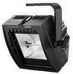 | 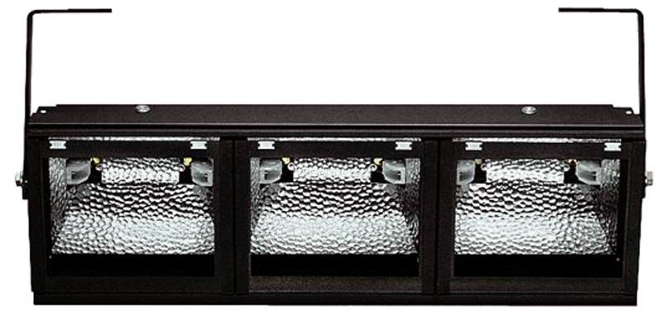 | 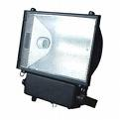

PAR can
Generally PAR cans are basic lightweight fixtures. Called PAR cans due to their appearance – looking like a car headlight stuck in the bottom of a large tin can – these fixtures were developed to meet a need for inexpensive, rugged and easy to use lighting fixtures for mobile live events. The fixture is essential simply a hollow tube with a powerful lamp.
The lamp consists of a Parabolic Aluminium Reflector (PAR) with a lens attached to the reflector; the lamp looks like a common sealed car headlight unit. PAR lamps are selected based on their wattage and beam spread of the lens, i.e. narrow to wide.  These fixtures produce an oval light beam with the only adjustment being the rotation of the lamp within the housing, i.e. rotating the oval beam of light. | 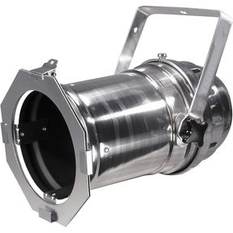
PAR cans are routinely used for providing wash light from the back or sides of a performing area. Barndoors are often used with PAR cans so that the “spill” off walls and scenery can be controlled or removed.

Spotlights
Spotlights are also categorized by the type of lens they use.

Ellipsoidal
This is the most common type of spotlight used for accenting. An ellipsoidal fixture is able to be adjusted from a sharp-edged, focused light beam to a soft, diffused light beam. Through the use of shutters a user can operate gates within the fixture that shape the light beam to suit the production’s needs. Ellipsoidal fixtures also hold patterns and gel. | 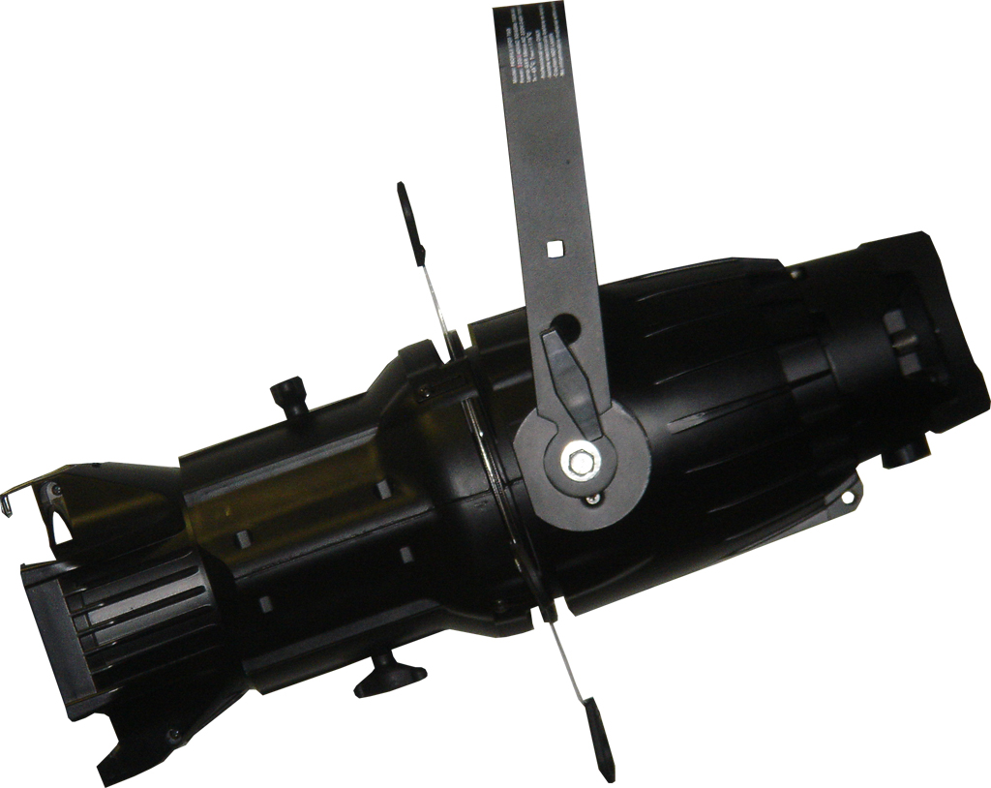
Followspots
This type of fixture is used routinely in theatres, concerts and other live events where characters move around and need attention focused on their action. The fixture ‘spotlights’ the performer in a bright pool of light and follows the performer as they move around the stage. An operator standing next to it controls its movements. Spotlights have the following common features: beam size may be adjusted; colour of light can be changed instantly; and there is pan and tilt adjustment. Size of the fixture will depend upon its location: a compact fixture for smaller performing areas to very large units used in stadiums. | 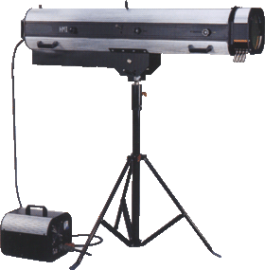
Fresnel
This is a fixture that accents; it is similar to the ellipsoidal fixture but has a softer edge to the light beam. The beam can be adjusted to go from narrow to wide but there are no shutters shape the beam and it cannot use patterns.  The name is pronounced fra nel’; it is named after the inventory of the lens used in this type of light fixture. This type of lens creates a very diffused, yet still controllable light beam. Fresnel fixtures are used to provide soft-edged wash lighting or colour wash to performance areas. | 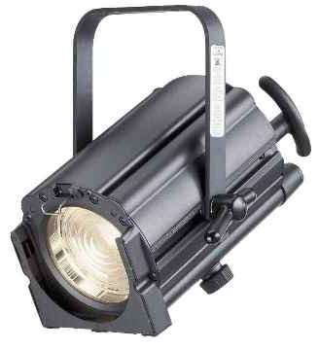
The Fresnel lens has a significant amount of glass cut out of the convex side of the lens, with many angles built into the cuts. The side profile or cross section view of a Fresnel lens is shown at the right. From the front it appears as a series of concentric circles cut into the lens. |  | Light source

Intelligent Fixtures
Intelligent fixtures refer to lighting fixtures that incorporate electronics and electric motors so that an operator may vary the colour of the light, its’position and the intensity of the light.
The majority of the intelligent fixtures will contain several “gobos” and an “iris” for making the beam large or small. There is also generally a method for colouring the light beam in pre-set colours.
Intelligent fixtures come in two basic styles:
- Moving-yoke: Motors control the pan and tilt of the entire fixture enabling seemingly random movements across a 360 degree range in the X and Y axis. | 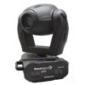
- Moving-mirror: A rotating mirror is mounted on the front of the fixture and this moves reflecting the light beams to give desired effects. | 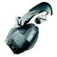
The functions of intelligent fixtures are controlled by signals from the lighting control board and its’ operator. These light fixtures are expensive and are generally used only for special effects. These fixtures, while not only being very expensive, also require continuous maintenance due to the increased complexity of their workings.

Controlling the Lights
The effects of production lighting are dependent upon the ability to control the fixtures. This is achieved through a control system that enables an operator to turn fixtures on and off as well as managing the light effects. Nearly all venues where live events are regularly held will have some form of lighting control system or the production crew may have portable control systems that travel with or have been hired for that event.
The lighting system will consist of four components:
- Lighting control board
- Dimmers
- Distribution network
- Fixtures

Lighting Control Board
Lighting control boards input from an operator, changes it to signals that the dimmers can understand and sends it down a control cable to the dimmers. The dimmers convert the message into the level of electrical current permitted to run to the light fixtures.
All lighting control boards operate on this underpinning process. This process is based on the following sequence of events in controlling a light fixture:
- Each fader on the lighting board is connected to a unique dimmer in a rack
- Each dimmer in a rack is connected to either an individual lantern or a rack of lanterns that are to work simultaneously
- When the board’s fader is used, the level of electricity that can pass through the dimmer is increased leading to an increase in the light produced by the lantern/s
Modern lighting control boards are computerised and after programming allow a group of lanterns each doing a different task to be controlled by one fader.
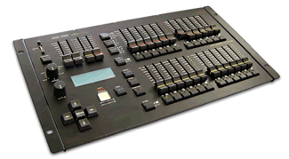 | 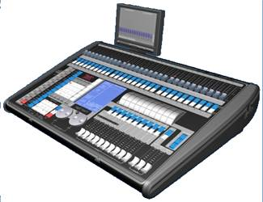
Image X: Medium lighting control board | Image X: Large lighting control board
Dimmers
Dimmers are generally located close to the performing area and then distribute electrical power directly to the light fixtures. The lighting control board determines what power goes to the light fixtures and the dimmers action this.
Dimmers can come in permanent and portable configurations. In permanent performance venues, the dimmers are arranged in dimmer.
Dimmers for portable applications are generally small and easily transportable.

Distribution Network
The distribution network is the wiring/cables that distribute the electricity from the dimmers to the light fixtures. This network can consist of preset cable channels, plug-in boxes, loose cables and power distribution connectors. It could even be as simple as several extension cords and power boards if this is permitted. | 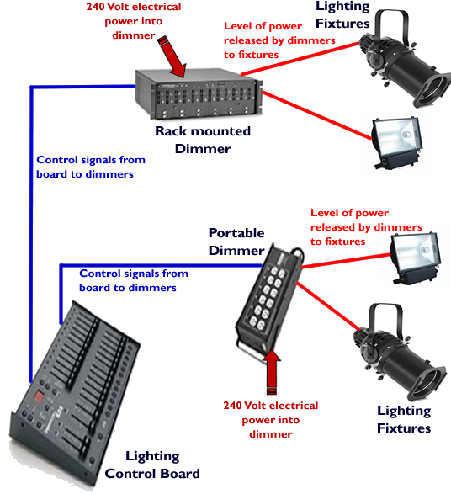  Diagram One: Distribution network for a lighting system

Other Equipment
Cables
Lighting cables used in live production are generally one of two formats within Australia: 3 phase or standard 240 volt.
A three-phase system is generally more economical than others because it uses less conductor material to transmit electric power than equivalent single-phase or two-phase systems at the same voltage
For further information on three phase power, investigate the website: http://www.3phasepower.org/
There are two metods for rolling cables: Over/under and
The over/under cable coiling refers to a method of storing cables that preserves the arrangement built into the cables by the manufacturer. This arrangement is in the form of a twist in the shielding that encases the wires and the wires themselves. This approach keeps tangles to a minimum, allows the cable to lie flat when uncoiled and makes it easoer to lay out the cables when positioning lumninaires.
The “over/under” name comes from the practice of twisting the cable in one direction to make the first coil, and un-twisting it to make the next, and repeating this until the cable is coiled. Connecting the ends on the outside of the coils or loops, or securing the cable ends in that position, ensures that the ends won’t slip through the coils while in storage so there are no tangles or knots when the cable is laid out.

Placing lights
There is no one way to set up lighting for a live production. The use of lighting within live events is a creative endeavour and each lighting director will have individual and changing views on this element of a performance.
There is however a popular theory for performance lighting called the McCandless (after its initiator) theory. This is not a bad starting point for those starting out in lighting. The McCandless theory believes that the performing area is segmented into small overlapping circular sections or acting areas. Each area is approximately 2.5 metres in diameter.

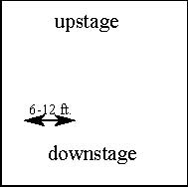Placing the Lights
Within the McCandless theory, each acting area is lit by three fixtures. Two lighting fixtures are placed in the front of the performer and one fixture behind. The front fixtures are located at a 45-degree angle to the left and right of the performer with the third fixture located at a height equal to an angle of 45-degrees above the performer. These fixture locations make the performer/s appear natural with a three dimensional form. This three dimensional effect is achieved by the light forming shadows that provide definition of form without causing dark and deep shadows across the performer/s features. The McCandless approach to the location and angle of light also continues to provide visibility as the performer/s moves.
The theory infers that by placing the fixtures and light angled at 45 degrees causes the development of shadows that enhance the performer/s features and appears to draw them away from the background. McCandless believed that when lighting fixtures were placed directly in front of a performer, the resulting light washed out the shadows leaving the performer/s looking two dimensional.
To create the three dimensional appearance and so give greater realism to the resulting image there is a need to separate the performer/s from the background. This can also occur with downlighting, backlighting and side lighting.
The third light, he argued, should be placed behind and high overhead the acting area, not directly over the area nor shining in the audience’s eyes. This “backlight” causes the performers to stand out from the background and further defines their form by lighting the back of the head and top of the shoulders. The colour of this backlight may vary depending upon the purpose and intentions of the director. For example, it may simply be a light gel induced colour that dampens the shadows thrown by the frontlight or it could be an intense, warm light to create a halo effect on the performers.

McCandleness theory of stage lighting worked in base groups of three fixtures, but this is not the maximum number of fixtures to be used. The ‘three grouping’ is for static performers, i.e. a speaker at a lectern. If you consider the typical height of a performance area and industrial standard style light fixtures, the area covered by a single three group of light fixtures would only be about 2.5 metres in diameter. To cover a performance area there would be a need for several groupings established between 2 and 2.5 metres apart. For example, if the performance area was 8.5 metres by 8.5 metres, the lighting team would need to set up for approximately nine ‘acting areas’ each of approximately 2 to 2.5 metres in diameter. That would be an ideal setup; remember in reality you may not have the resources, time or space to set up lighting in such a formation.

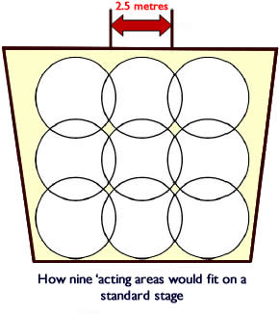
Diagram Two: Acting areas across a performance area
McCandless’ lighting approach provides basic illumination for a performing area. A production may require more angles, colours or special effects and this could lead to doubling, tripling or even quadrupling the number of light fixtures focused on an ‘acting area’.
For general performance requirements, the McCandless theory provides appropriate lighting.
For greater detail on the McCandless theory of lighting, check out these websites:
http://en.wikipedia.org/wiki/Stanley_McCandless#McCandless_Method
http://livedesignonline.com/venues/remember_stanley_mccandless/

Colour
In working with light it is important to understand that the colour of light and its management is very different to the colour of paints or pigments. When discussing the visual arts, we often work with the concepts of primary colours being red, yellow and blue; these may be mixed together to form various colours and shades eventually leading to black. However when we work in the colours of light, the primary colours are red, green and blue; these may be mixed together to form other colours and when added together in equal levels, the final colour is white.
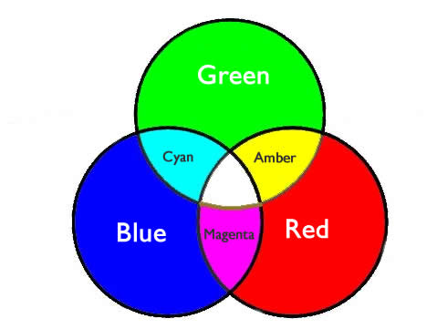
Diagram Three: Primary lighting colours

It is suggested that you look at some further references on the make up of light. Some of these are listed below:

To add colour to light, what you are doing is to place coloured filters in front of white light. These filters are generally transparent pieces of specially made coloured plastic in front of the light fixture. These plastic sheets are more commonly known as ‘gel’ though the terms ‘colour filter’, ‘colour media’ or just ‘colour’ are also used in this industry. (Note: An interesting piece of theatre history: The term ‘gel’ comes from the fact that the first colour filters were made of dyed animal gelatine.)
A filter or ‘gel’ is a transparent or translucent piece of coloured plastic specially made to handle the high temperatures generated by lighting fixtures.
The ‘gel’ now used by lighting teams is an advanced plastic; it is constructed from a polymer base of acetate, vinyl, polyester or polycarbonate. Always remember, that professional lighting fixtures generate very high temperatures and the ‘gel’ will get hot. Do not use anything to filter production lighting except professional colour filters or ‘gels’.
These ‘gels’ may fade over time from the high temperatures so it is routine to replace these lighting accessories regularly. ‘Gels’ of filters are the most common forms of adding colour to light in live productions. There are other methods such as permanent glass filters or coloured lamps though these are not routinely used and require low wattage lamps.
A filter or gel is placed in front of the light fixture using a frame. This frame, commonly called a colour frame, is set so that the gel slides down a channel formed by two light pieces of metal; the frame is then placed in front of the light fixture where the light beam exits the fixture.
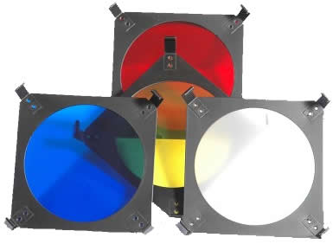
Image X: Gels in colour frames
Colours do convey emotions and feelings. For example, ‘cool’ colours are those in the blue-green-violet range while ‘warm’ colours are found in the red-yellow-orange range.
McCandleness believed that the frontlights, through the use of colour and intensity, provided definition and visibility to the performing area. He believed that using a warm colour in one front light and a cool colour in the other constructed a natural appearance and contrast with each other in turn leading to definition of performers. In lighting theory, the warm and cool colour should mix to white light, unless the lighting designer had another effect in mind!
Gels can be purchased in any one of hundreds of hues/colours. As you gain experience in lighting you will identify more easily what you can wish to use and what effects each will give to you – production lighting is a creative endeavour and relies on individual opinion and thought.
To start off, the following list of gels and effects will provide a starting point for preparing a lighting design:

Effect | Colour | Manufacturer Name/Gel Number
Warm front light | Bastard Amber | Apollo 7050, Lee 162, Roscolux 02
Cool front light | Special Lavender | Apollo 3350, Lee 702, Roscolux 54
Back light | Daylight Blue | Apollo 4500, Lee 196, Roscolux 65
Background lighting | Light Red | Apollo 8300, Lee 026, Roscolux 26
 | Primary Blue | Apollo 4250, Lee 079, Roscolux 80
 | Primary Green | Apollo 5300, Lee 139, Roscolux 91

Table Y: Different light effects associated with gel types and colours

Another effect of light that must be considered is how light (in its various colours) reacts with the colour pigments in the scenery, costumes and performer’s makeup. This reaction between light and colour pigments must be considered in any lighting design. Examples of these reactive compositions are provided in the summary table below:

 | Red pigment | Orange Pigment | Yellow pigment | Green pigment | Blue pigment | Violet pigment
Red Light | Fades and disappears | Becomes lighter | Becomes white | Becomes much darker | Becomes dark grey | Becomes black
Yellow Light | Remains red | Fades slightly | Fades and disappears | Becomes dark grey | Becomes dark grey | Becomes nearly black
Green Light | Becomes much darker | Darkens | Darkens | Becomes pale green | Becomes dark green | Becomes nearly black
Blue Light | Darkens | Becomes much darker | Becomes light mauve | Lightens | Becomes pale blue | Becomes light mauve
Violet Light | Becomes pale red | Lightens | Becomes pink | Becomes pale blue | Darkens | Becomes very pale
Neutral colours (black, brown and greys) remain almost the same under all lights though a slight change in depth of tone or shade may be noticed.

Table Y: Different coloured light reaction to different colour pigments

Texture
Light can be given the appearance of textures by disrupting it to form patterns. Such texturing of light is used to create special effects on a performance area, e.g. cloud type patterns added to an ellipsoidal gel or gobo may project the appearance of sunlight breaking through a cloudy sky. Similarly, a pattern of coloured light may give the impression of a stained glass window in church.
By texturing light a lighting team may project patterns onto cycloramas to add to the tone of the production. For example, projecting patterns of stars and building silhouettes gives the appearance of nightfall in a city; much simpler than preparing background drops and flying these in and out as well as the flexibility of changing scenes by simply moving a lighting board fader!
Technical Specification Sheets
Technical specification sheets are the summary of all ighting system elements within a live venue. These lists detail all the luminaires, dimmers, control boards, patching and any other part of the lighting system.
These technical specification sheets are made available to hirers of the venue, touring shows and directors of productions that will use the venue. This enables the users to plan around the available lighting resources.
Every theatre of permanent live venue will have a technical specifications sheet for their leighting elements. These specification sheets list all of the lighting equipment available at that venue. A sample venue specification sheet is on the next page.
Lighting – Technical Specification Sheet for XXX Theatre
Lighting Control Board  - Strand Tempus M 24 with FX unit  Dimmers  - L.S.C. Tour Series – 24 channels x 2.4 Kilowatt each channel  - L.S.C. Tour Series – 12 channels x 2.4 Kilowatt each channel  Power Supply  - 200 Amps 3 Phase  Lanterns  Fresnels  - 18x Selecon SF 1000 - 1kw  - 36 x Strand Pattern 123 - 500watt  - 8x Strand Pattern 45 - 500kw  - 8x Strand Pattern 743 - 1kw  - 4 x Strand Pattern 243 - 2kw  Profiles  - 10 x C.C.T. Axial 30' zoom-1kw  - 6 x Strand Pattern 264 -1kw  - 4 x Strand Pattern 263 - 1kw  - 20 x Strand 23 - 500watt  - 4 x Strand 23 square gobo- 500watt  - 18 x Strand 23N - 500watt  Flood Lights  - 6 x SB/63x8(Ground row Cyclorama) - 150watt  - 2 x SB/63x4(Ground row Cyclorama) - 500watt  - 28x Strand Pattern 60 - 500watt  Follow spots  - 2 x Strand Pattern 293 - 2kw  - 2 x Strand Pattern 93 - 2kw  PAR cans  - 12 x PAR 64 narrow - 1kw  - 6 x PAR 64 medium – 1 kw | Cables  - 2 x 1 metre extension leads  - 11 x 2 metre extension leads  - 4 x 3 metre extension leads  - 2 x 4.5 metre extension leads  - 12 x 5 metre extension leads  - 1 x 8 metre extension leads  - 4 x 9 metre extension leads  - 2 x 10 metre extension leads  Accessories  - 1 x Floor Stand  - 6 x power boards (4 outlets)  Patching System  US Well  12 outlets  Numbers: 45, 46, 47, 48, 49, 50, 51, 52, 53, 54, 55, 56  DS Well  12 outlets  Numbers: 25, 26, 27, 28, 29, 30, 31, 32, 33, 34, 35, 36  Floor Traps – DS Edge  6 outlets  Numbers: 15, 16, 17, 18, 19, 20
Sample of simple Technical Specifications Sheet for Lighting at a live venue

Lighting Plans
Lighting plns are the diagrammatic maps of where light fixtures are to be located during a live production. It is used to communicate to lighting staff where the lights are to be placed and how they are to be set to loght the performing area for the live production.
A lighting plan has the following characteristics:
- Uses symbols to represent luminaires
- Has a legend box to detail what the symbols mean
- Is drawn to scale
- Indicates what channel each luminaire is attached to
- Uses the correct technical language
- Describes the plan’s direction

Remember: In ‘theatre’ jargon, left and right refer to the directions as seen by the performer facing the the audience.

Sample lighting plans are provided over the next three pages.
Each of the sample lighting plans is different: these will range from the very simple to the technical. However each lighting plan will have the common characteristics listed above and provides sufficient detail for the lighting team to identify and fix the luminaires prior to rehearsals.

Remember: Each lighting plan may have differing symbols for the sample luminaire. Always check the required luminaire against that lighting plan’s legend.

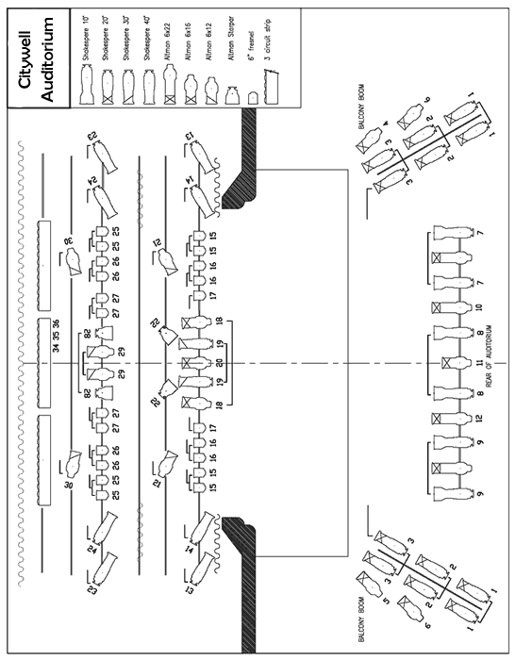

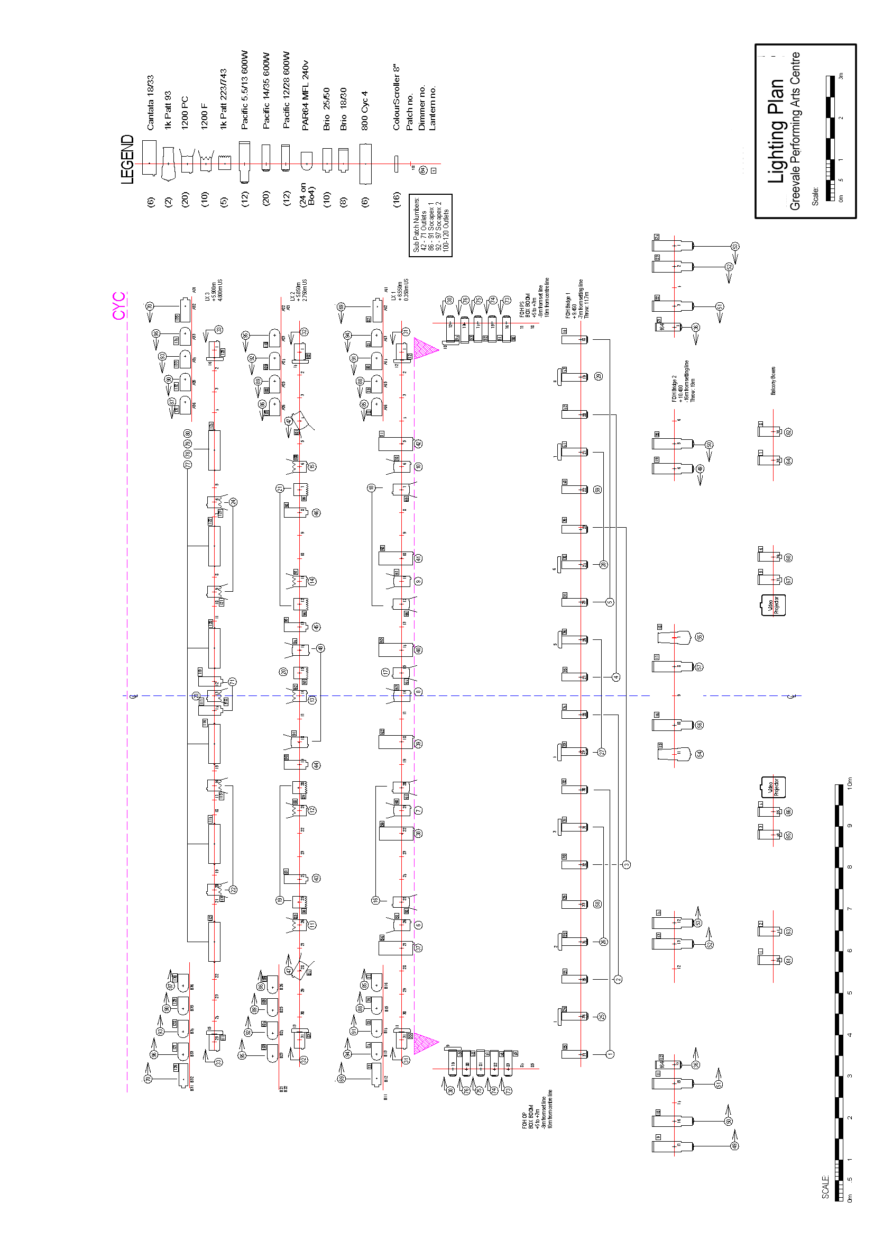
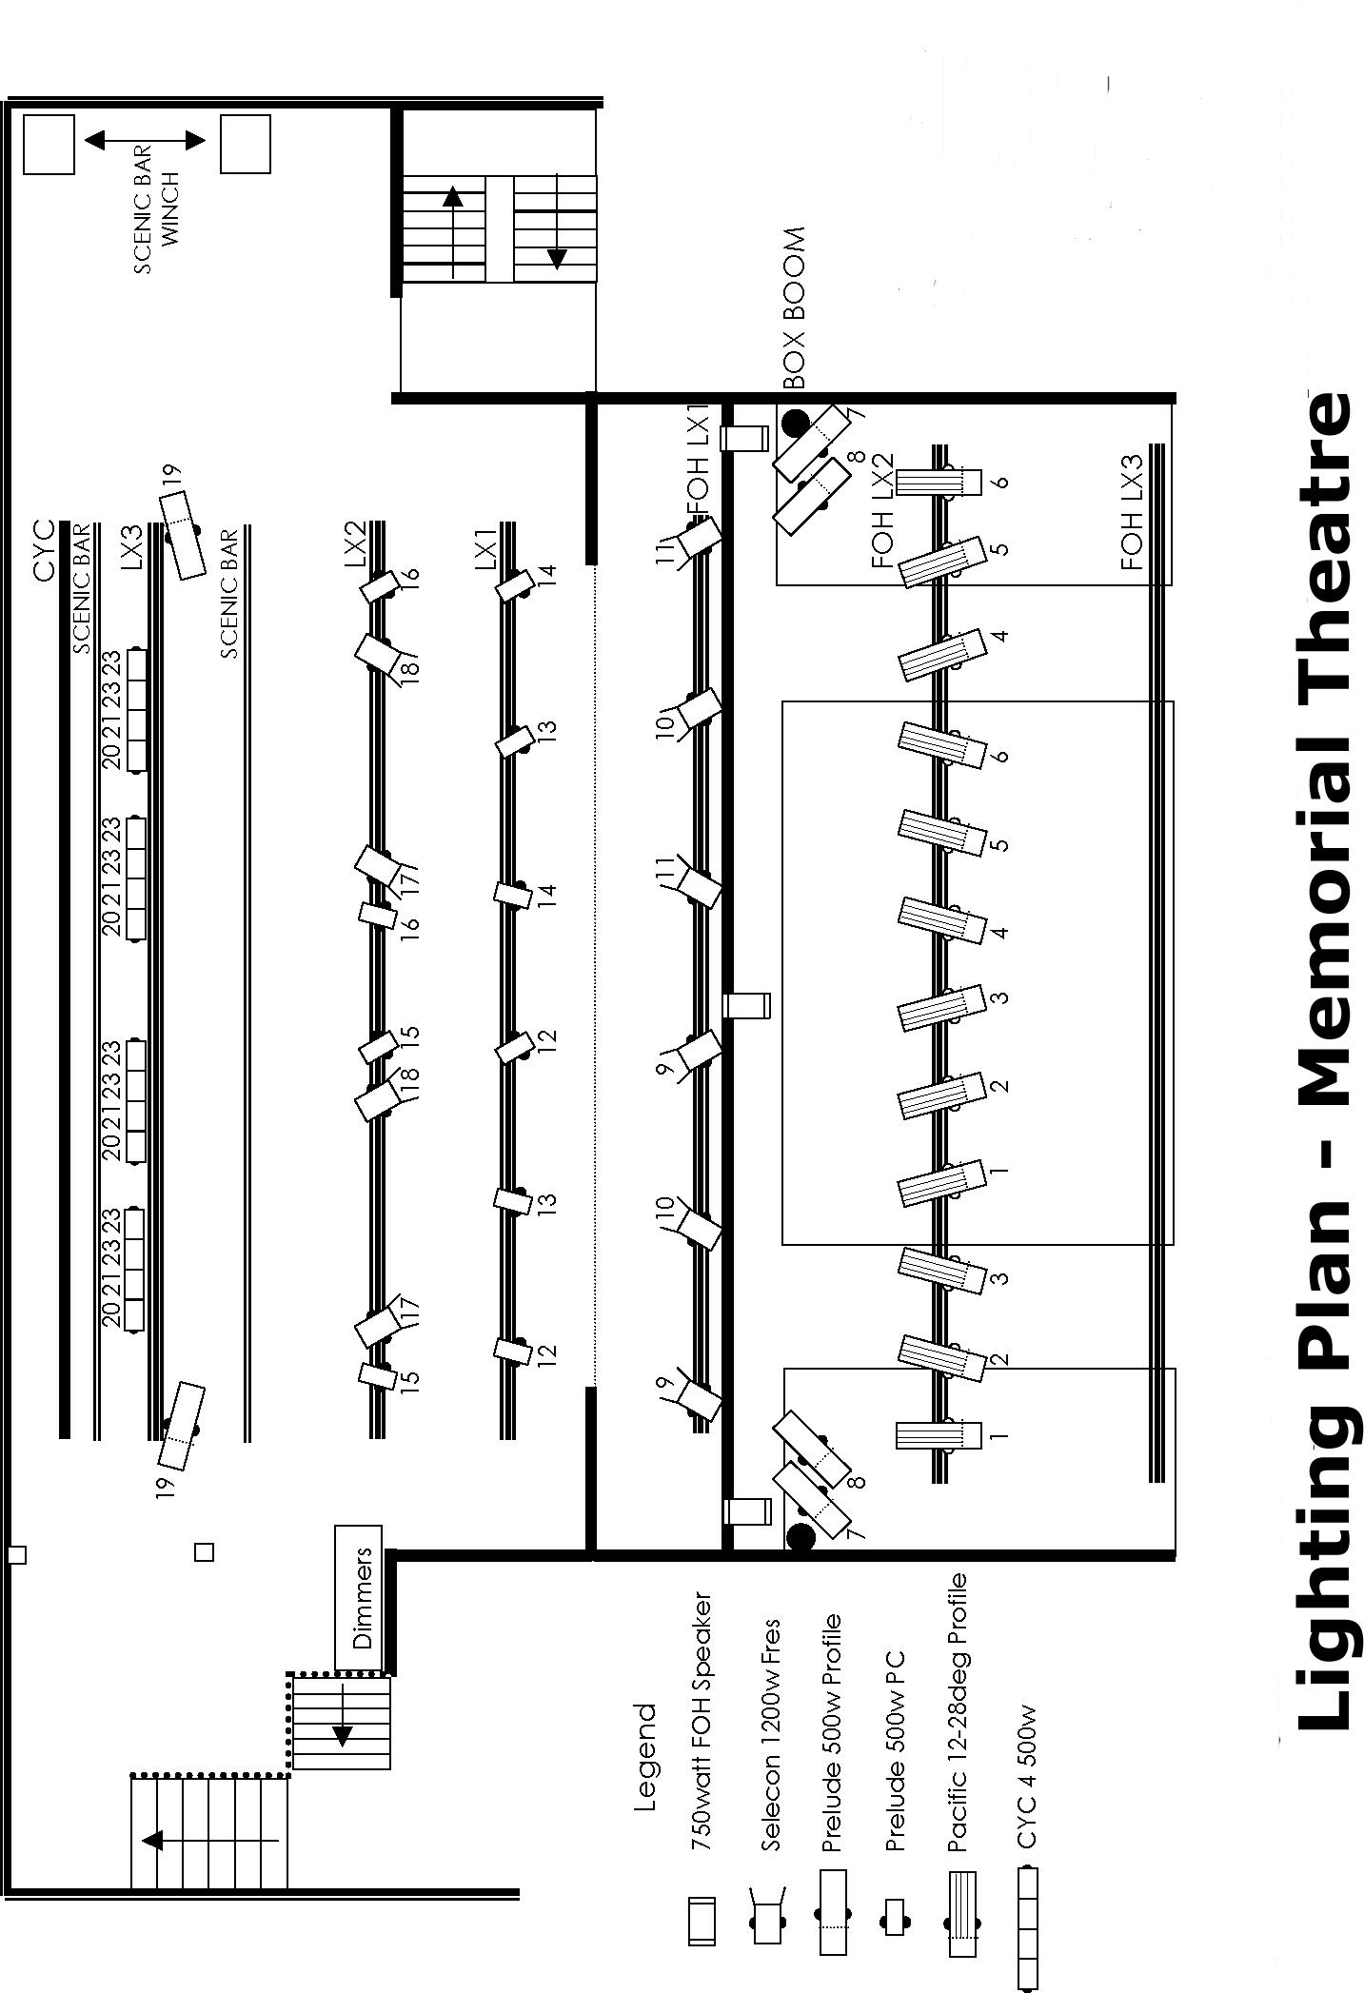

Health and Safety with Lighting
Live production lighting is an area where, due to the use of electrical power and high temperatures, there is greater risk to personal safety.
Here are some core messages that need to be followed when working with production lighting:

Placement of gear
- Never clutter the performance area or the back stage areas with unnecessary gear. Only have the gear required in place. Replacement gear should remain in its storage area away from the centre of production.
- Gear must not be placed near fire exits, extinguisher points. hose reels or in stair wells.

Cables
- After connecting cables and checking the final layout of fixtures and dimmers, tidy up the layout.
- Remove loops and piles of cables so as to lessen the opportunity to trip.
- Do not have coiled cables providing power. A coiled cable will heat up and can melt; it is just like an electrical element in the top of an electrical stove!
- Ensure cables are not strained or tight between connection points.
- Where cables lay across a traffic area, then tape down with gaffer tape or place under mats/carpet pieces and then tape down the edges of these coverings.

Electrical checks
Before each performance do a quick check of all electrical elements:
- Cables and their connections
- Loose connections
- Damaged elements
- There is not water near cables, dimmers or connectors.

Ladders
- Where possible use insulated ladders, e.g. a wooden ladder is safer though commercial equipment often is electrically isolated with rubber bases.
- Check ladders, walkways and rigging are safe before starting work.
- Do not carry fixtures up a ladder; climb the ladder then have some pass you the weight.
- Treat all ladder work as a two person task!

Lighting
- Do not place light fixtures near curtains or cloth props – fixture heat plus cloth equals fire!
- Elevated lighting stands or lighting supports should be weighted at the legs with ballast/sandbags and/or tied off to a permanent tie point in the performance area.
- Avoid placing light fixtures beside fire detector equipment – fixture heat could cause an embarrassing evacuation or drenching!
- Check fixtures and lamps for heat before grabbing them.
- Always switch off power before handling or repositioning fixtures.
- Any light fixtures to be hung above head height should have a secondary safety fitting. This is generally a chain that is fixed to the supporting bar.
- If a lamp explodes (and it does happen), duck your head and cover your eyes; wait for a few moments before looking at the fixture.
- Barndoors must be secured to the lamp fixture with a secondary safety chain.

Venue
- Only work on lighting rigs and battens when in the company of a qualified person, i.e. a lighting technician or electrician.

Personal protection
- Dress appropriately for this industrial environment. It is a creative industry but lighting is a creative and industrial element. Robust work clothes, low heeled footwear that cover the foot and of course, black is in fashion colour!
- If your production is outside, then remember the simple things: head covering, insect sprays, and a spray jacket.
- Light weight gloves are great for handling and recoiling cables.

Appendix One
Lighting Terms
The following are some common terms used in production lighting. These are the basic terms used; there are many more and these will become evident as you work in this area. Always use the correct terms for the equipment you use or the processes you are trying to achieve.

Active
A patch circuit is ‘live’, i.e. it has power being supplied to it.
Backlight
Light coming from upstage, behind scenery or performers. It is often used to separate performers from the background.
Bar
A horizontal metal tube hung from the rigging on which lighting equipment may be suspended. When vertical it is also know as a ‘boom’.
Barndoors
These are wings or hinged panels that are located on the outside of fixtures and are used to mask or cut out light from certain areas.
Blackout
The complete absence of light of stage lighting.
Boom
Vertical scaffolding which can carry luminaires. Often used in the wings of the performing area for side lighting.
Bounce
Light that has been diffused by being reflected from the stage, walls, cyc, etc.
Cables
All electrical components in a lighting system are interconnected with cables. Cables are the wiring that is temporarily rigged to carry electrical current. The size of the cable (i.e. the current carrying capacity) may vary depending on what load it is required to do. Cables are used to supply electricity to individual lanterns, whole dimmer racks, etc. Note the term cable is also used to describe the wiring used to support audio and audio-visual systems.
Channel
A control path for managing a luminaire, i.e. the electrical circuit from the control board to the lantern.
Cleaning, maintenance and storage of light equipment and accessories
The cleaning, maintenance and storage of lighting equipment is critical to its efficient use. One of the most common reasons for inefficient lighting is the build up of dust on lens; regular cleaning and maintenance is vital. Lanterns and accessories should be stored corrected in a dry and clean space. Testing and tagging of these electrical items must also occur within the legislated time periods, e.g. annually or half yearly.
Colour call sheets
Lists that are compiled from the lighting plan of all the colours needed for the lighting rig, and their size. This term also applies to the act of preparing colour filters and frames from these lists
Colour frame:
Two connected square pieces of metal or cardboard with a hollowed circle in the centre; this frame holds the gel in front of the fixture.
Communication or Comms
‘Comms’ or communication systems are used by lighting personnel so that each person can listen and speak to every other person using the system during a performance. ‘Comms” are usually wireless or wired systems. Personnel generally wear headsets with a small boom microphone when on ‘comms’.
Cyclorama:
Sometimes abbreviated to ‘cyc’ this is a curved piece of cloth or wall that serves as a back drop. It may be painted with performance scenery or be left plain in order to project light and/or images onto it.
Diffusion:
This is similar to gel and are sheets used to diffuse, or soften, the beam of light from a lantern. Generally diffusion does not change the colour of the light unless it is specifically a collared diffusion.
Dimmers
Dimmers are the devices that control the amount of electricity passed to a lantern, and therefore the intensity of the light from the lamp. Dimmers are simple active transformers, in that these equipment items respond to the instructions sent to them from lighting consoles and passing those power levels on to lanterns. Dimmers may often be grouped together into a housing or cabinet and this collection is called a “dimmer rack”.
Documentation
There are three core lighting documents:
- Lighting schedule: A list of available lanterns within a theatre or location
- Colour call sheets: The list of required colours for a live performance/production
- Lighting plan: A scale drawing detailing the exact location of each lantern used in a production as well as any other relevant information (e.g. its dimmer number, focus position and colour number).
Effects of colour
Depending on where this is used it will refer to special lighting effects (gobos or strobe).
Electrical safety
This refers to the precautions and safety measures taken when using electricity or electrical devices. Safety management to avoid danger, damage, injury or death is not only common sense; it is also a legislative (mandatory) requirement of workplaces.
Gel
Sometime known as colour media or filter, it is the plastic film placed in front of lights to change the colour of the light beam.
Intensity
This is the term for the level of light output emerging from the lantern, that is, the brightness of the light. It is often measured in percentages on the lighting control board.
Lanterns
This is the broad traditional term used to cover all types of lights. They may also be referred to as ‘fixtures’. Refer to the more recognised term of ‘luminaires’.
Lamps
These are the light bulbs that are used in lanterns or ‘fixtures’.
Lamp types
There are several different types of lamp (domestically called a light bulb): incandescent bulbs, fluorescent bulbs, LEDs (Light Emitting Diodes) but all of them turn electrical energy into light (and almost invariably heat as well).
Light beam accessories
These are devices added onto a lantern or inserted into a lantern that are used to alter or manipulate the beam of light emanating from the lantern.
Light theory
This is the theory that incorporates the physics of light waves/beams and colour mixing. Colour mixing of light is different to colour mixing of pigments or paint. The colour Primaries of Light are RED, GREEN, BLUE, which, when mixed tend towards white; the Secondaries of Light are Magenta (Purple), Cyan (Light Blue) and Amber (Yellow).
Lighting components
This is the generic term used to refer to all components of a lighting system including lanterns, dimmers, cables, and lighting control boards. It may also the supporting components such as lighting bars, stands and accessories.
Lighting control systems
These include lighting control boards, light controllers and any other device that is used to control the lanterns being used.
Lighting control board/desk
This is the main control for the production’s lighting. The lighting operator for an event is often said to be ‘on the board’.
Lighting equipment
This includes everything from the lanterns to dimmers, controllers, accessories such as colour frames, donuts, barn doors and gobos, cables, stands, lighting bars, safety chains, hooks, clamps, gels and bubbles. This is used in the same way as the term lighting components.
Lighting operations
The term is used by personnel when preparing or carrying out the job of production lightning.
Lighting personnel
Used to describe all the people involved in lighting operations: lighting hands, lighting technicians, lighting operators, lighting designers and lighting directors.
Lighting plan
This is a scale drawing detailing the exact location of each lantern used in a production, as well as any other relevant information, such as its dimmer number, focus position and colour. The lighting plan is often based on the theatre’s ground plan.
Lighting schedule
This is a list of lanterns, other lighting components and accessories, available for use at a particular venue.
Lighting technician
This is the title conferred on the person with the knowledge, skill and expertise to rig, set up, replace lamps, focus and basically operate professional lighting equipment. This person is assisted by other workers often known as ‘lighting hands’.
Luminaires
This is now the recognised international term that is used to describe the specialised lights used in theatres and other live productions. It is the replacement term for ‘lanterns’ or ‘fixtures’.
Occupational Health and Safety (OHS)
The relevant health and safety considerations for persons working in live production areas. These considerations are often set in standards that are mandatory and legally enforceable.
Open-face fixture
Any lighting fixture that has no lens, i.e. the blub is open to the environment.
Patch location
This is the specific location or position of a device as related to a patch panel to which it is connected. This is usually in the form of an alpha-numeric code such as B12.
Patching
This is the act of interconnecting devices in a lighting system, e.g. connecting lanterns to dimmers. Lighting circuits around the stage area can be cross-connected to a chosen dimmer to enable a lighting channel on the control desk to control any dimmer or group of dimmers.
Pattern holder
A rectangular, metal frame with a circular hole in the centre. This piece holds a pattern and slides into a slot in an ellipsoidal lantern.
Patterns
These are also known as gobos. They are thin, steel, circular pieces with a design cut-out so that when placed into a slot in the ellipsoidal lantern, it projects patterns of light onto the stage.
Positioning point
This is the physical position in which a lantern is hung or placed in a venue, whether on bars, stands or on the stage or floor.
Reporting
Reporting is the process of communicating within a team, crew, etc. All workers report to their supervisor.
Rigging
Rigging is the construction or arrangement of lighting equipment for a particular production as well as the act of installing lighting for that event.
Safe work practices
Safe work practices result from workers following the required OH&S procedures with the purpose of ensuring the safety of all workers on the site. Safe work practices include turning off power and disconnecting lanterns when installing or repairing, using correct lifting techniques, wearing protective clothing, harnesses, shoes, gloves etc., and following correct procedures.
Shutters
A moveable piece within the ellipsoidal lantern that can shut out part or all of the light coming out.
Snoot
Sometimes called a ‘top hat’ this is an attachable accessory for lanterns that consists of a long cylindrical tube used to reduce flare, i.e. stray light beams.
Subtractive and additive colour mixing
Colour mixing is combining the effects of two or more lighting gels and can be either subtractive or additive:
Subtractive: Placing two different gels in front of the same lantern. Subtractive mixing is used to obtain a colour effect that is not available from standard gels, although with the wide range of available colours the need for subtractive mixing is reducing. Combining colours in this way reduces the light towards blackness. The three primary colours of light - Red, Green and Blue - mix subtractively to form black or to block all the light.
Additive: This process is about focusing two differently coloured beams of light onto the same area. Combining colours in this way adds the colours together, eventually arriving at white.

