[How to Use a Circular Saw](http://www.wikihow.com/Use-a-Circular-Saw)

Edited by Bill Bradley, Ben Rubenstein, Travis Derouin, Kharri1073 and 14 others

[12](http://www.pinterest.com/pin/create/button/?url=http%3A%2F%2Fwww.wikihow.com%2FUse-a-Circular-Saw&media=http%3A%2F%2Fpad3.whstatic.com%2Fimages%2Fb%2Fb0%2FUse-a-Circular-Saw-Step-13.jpg&guid=tYDKzLbUU_7K-0&description=How+to+Use+a+Circular+Saw+--+via+wikiHow.com)

[**Article**](http://www.wikihow.com/Use-a-Circular-Saw)

**[Edit](http://www.wikihow.com/index.php?title=Use-a-Circular-Saw&action=edit" \o "Edit)** [**Discuss**](http://www.wikihow.com/Discussion:Use-a-Circular-Saw)

This type of hand held power saw is a basic tool in a carpenter, builder, or home renovator's tool kit. The one in the photo is a 160mm (6 1/2inch) blade size. The larger ones are 235mm blade size. Here are some basic tips and instructions on the proper use of circular saws.

**[Edit](http://www.wikihow.com/index.php?title=Use-a-Circular-Saw&action=edit&section=1" \o "Edit section: Steps)Steps**

1. 1

**Understand the different types and sizes of circular saws and their purposes**. Here a few examples:

[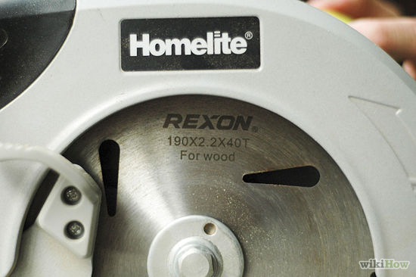](http://www.wikihow.com/Image:Use-a-Circular-Saw-Step-1.jpg)

* + 5 inch *trim* saws, usually with a fine-toothed blade and often with the blade located on the left side of the motor, for easy viewing of the blade path. These are available in 120V, AC models, and rechargeable battery models in various DC voltages.
  + 6 1/2 inch saws, as shown in the illustration above, used for cutting to length nominal lumber for construction, as well as ripping lumber, and cutting plywood or composite material.
  + 7 1/4 inch saws, often call *skilsaws*, from the name of a major circular saw manufacturer, *Skil*. These are the backbone of the construction industry, used for cutting lumber up to 2 1/4 inch thick. They are used for cutting framing lumber to length, and ripping lumber. They also have a number of optional blades which can be used for cutting composite materials, concrete, ferrous and nonferrous metal sheeting, pipe, tubing, and even cold-rolled steel bar stock.
  + 8 and 10 inch saws, used for cutting to length larger lumber or timbers, up to 4 inches thick. These are heavier, more cumbersome tools used mostly in industrial work.
  + Worm-drive saws have a gearbox with a *worm-gear*drive, and are found in 7 1/4 inch models which are most commonly used for ripping lumber or cutting plywood decking or sheathing. They typically have the blade on the left side of the machine, to make watching the blade path easier when cutting parallel to the edge of a wide sheet of plywood.

1. 2

**Look at the features of the saw you are planning to use**. The following are basic functions of some of these features.

[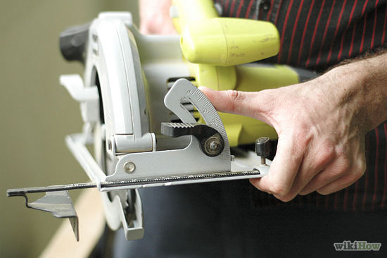](http://www.wikihow.com/Image:Use-a-Circular-Saw-Step-2.jpg)

The base plate can be tilted to make angled cuts. Most saws adjust from 90 degrees to slightly less than 45 degrees, making it possible to cut bevelled ends on boards for corning attachments, hip-roof rafter cuts, and even miters. Most saws are equipped with a *thumbscrew* or lever to loosen the bolt which keeps the saw blade on the correct angle for the cut you are making, located on the front of the saw. Some are also equipped with a scale which indicates the blade angle, from '0' (90 degrees, or *square* to the board surface) to 45 degrees.

The blade can be set to the depth required for individual cuts, from less than 1/8 inch to the full depth the blade is capable of penetrating. The lever or thumbscrew which locks the base plate at the desired height is usually located at the rear of the motor on the left side.

Many circular saws are equipped with a ripping fence, to guide the blade as you make a *rip* cut along the edge of a board, giving you a straighter, parallel cut.

Dust ejector. A few newer saws are equipped with a dust ejector to blow the sawdust away from the operator's face and from the mark where the cut is being made.

Laser tracking light. Some newer saws are equipped with a laser that projects a bright, red line down the path of the blade travel. These can also be purchased to retrofit on older units that are not factory equipped with them.

Blade guard. This should be considered a essential safety feature on any saw, and has two parts, the fixed guard over the top of the blade, and the floating guard, which rolls out of the way as the saw is pushed into the work piece. Some have a handle so the blade guard can manually be lifted for plunge cutting or easier viewing of the cutting mark.

1. 3

**Learn the basic types and uses for circular saw blades**. They range in blade composition, number of *teeth* (cutting bits or surfaces), the amount of *set* (the width of the kerf removed by the blade), and the blade quality.

[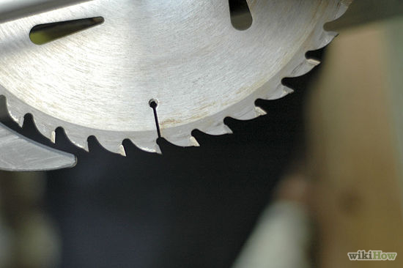](http://www.wikihow.com/Image:Use-a-Circular-Saw-Step-3.jpg)

* + One of these circular saws will probably have a plain HSS (high speed steel) saw blade in it when it is bought new.
  + TCT (tungsten carbide tipped) blades are much more durable, especially in tough hardwoods. Also plywood and composite boards are hard on blades so TCT blades are needed on them.
    - Blades with fewer teeth (say 28) and with less rake to the face of the teeth, are designed for ripping along the length of timber, with the grain. They typically give a quick rough cut. They are cheap to buy and cheap to sharpen, since they have fewer teeth.
    - Blades with more teeth (say 40) are designed for crosscut type work. They give a lot neater cut in most circumstances.
  + Abrasive blades are made from carborundum or other abrasive materials bonded together in a resin or other synthetic binding material, and are used for cutting concrete or metal. They tend to wear away rather quickly, but for small projects, they are inexpensive and make fast cuts.
  + Diamond rim blades. These blades are made of special alloy metals with industrial diamonds embedded in the *rim* (around the outside diameter of the blade), and are for cutting hard concrete, cement composite materials, and masonry products like block or brick.
  + Special tempered alloy blades. These blades have tempered carbon steel teeth, which are very *fine* (small, and closely spaced) for cutting sheet metal like galvanised roofing metal, or aluminum, copper, or brass tubing.
  + Dado blades. These are blades which can actually be adjusted to cut different width *kerfs* (the width of the material removed in the blade path). These blades make it much faster and easier for cutting *dados* and *rabbetts*, used for joining lumber.
  + Trim and panelling blades. These blades have fine teeth for making smooth, accurate cuts on finished materials like mouldings and panelling.

1. 4

**Support the material you are going to cut so that the blade will not react with anything underneath the cut as it is made**. For example, do not lay a board on a floor or concrete slab for cutting. Sawhorses or a saw table are normally used for this purpose.

[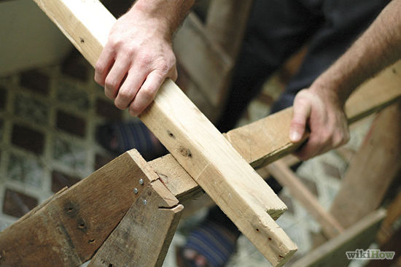](http://www.wikihow.com/Image:Use-a-Circular-Saw-Step-4.jpg)

1. 5

**Mark the lumber you are going to cut to length, using a measuring tape, scaled rule, or stick rule, then use a *square* (either a steel square, tri-square, or angle square) to mark the path of the blade travel for the length of your cut**.

[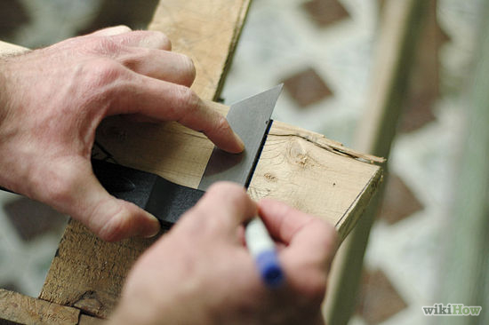](http://www.wikihow.com/Image:Use-a-Circular-Saw-Step-5.jpg)

1. 6

**Set the saw for the proper depth of cut**. Don't have much more of the blade showing than you really need for the job you are doing. So to cut 40mm thick timber, set your blade to about 45mm or 50mm. This helps to minimize kickback.

[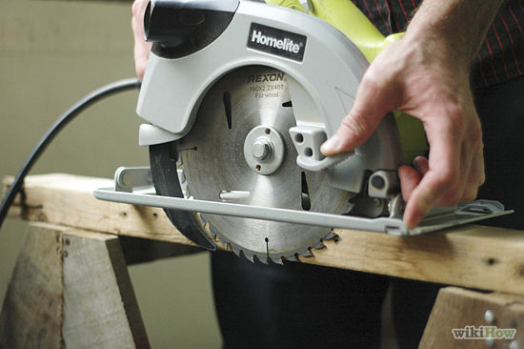](http://www.wikihow.com/Image:Use-a-Circular-Saw-Step-6.jpg)

1. 7

**Keep your saw guard in smooth running condition**. It should spring back in place as soon as you lift the saw off the work. It should slide up smoothly as you push onto the work. Make sure it's in the DOWN position before you put the saw down on the bench.

[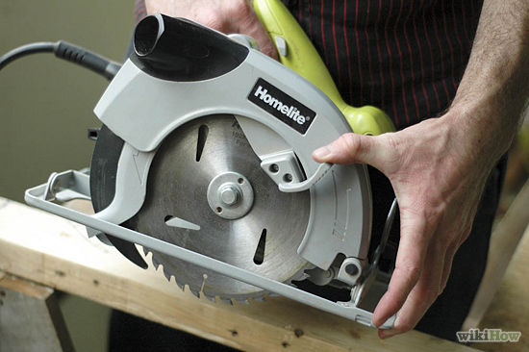](http://www.wikihow.com/Image:Use-a-Circular-Saw-Step-7.jpg)

1. 8

Look down the face of the right hand side of the blade and line it up to the pencil mark when beginning your cut.

[](http://www.wikihow.com/Image:Use-a-Circular-Saw-Step-8.jpg)

1. 9

**Look at the front of the saw to the two guide notches**. The right hand one is a guide for cutting with the blade set in the normal position, and the other one is for when the base angled at 45 deg. Line the notch up to the pencil line.

[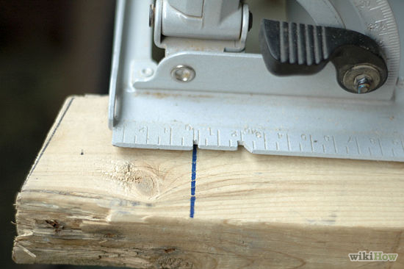](http://www.wikihow.com/Image:Use-a-Circular-Saw-Step-9.jpg)

1. 10

**Start cutting, after a quick check to the front of the blade**. (photo 1) Keep your eye on the guide (photo 2) all the time. This puts you in a natural position looking forward along the pencil line, and out of the way of any sawdust.

[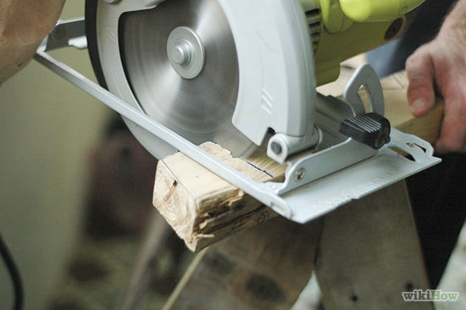](http://www.wikihow.com/Image:Use-a-Circular-Saw-Step-10.jpg)

1. 11

**Keep an eye on the saw base as you are into the cut**. Make sure that you are keeping the base of the circular saw flat on the timber being cut.

[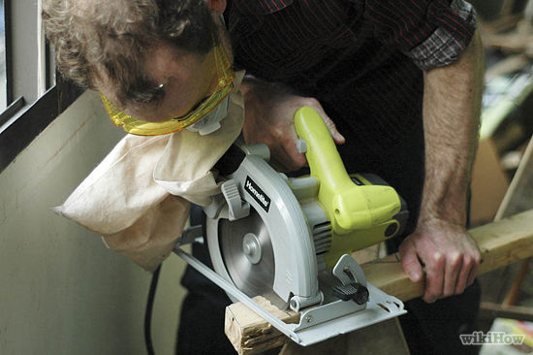](http://www.wikihow.com/Image:Use-a-Circular-Saw-Step-11.jpg)

1. 12

Push the saw into the material with enough force to keep the blade cutting, but avoid pushing so hard the motor speed seems to decrease, or binding occurs on the blade. A sharp blade should pass through any but the hardest materials with minimal effort.

[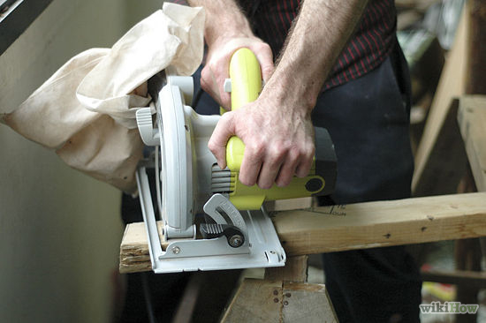](http://www.wikihow.com/Image:Use-a-Circular-Saw-Step-12.jpg)

1. 13

**Be sure the lower blade guard returns to its position when you exit the cut**. Even a blade guard in good condition will occasionally bind if a piece of debris from the cut becomes lodged in its mechanism.

[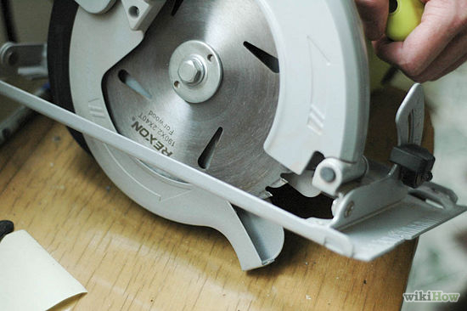](http://www.wikihow.com/Image:Use-a-Circular-Saw-Step-13.jpg)

**[Edit](http://www.wikihow.com/index.php?title=Use-a-Circular-Saw&action=edit&section=2" \o "Edit section: Video)Video**



|  |  |
| --- | --- |
|  | Safety is key when using power tools. Follow these steps to make the perfect cut while keeping all those fingers. |

**[Edit](http://www.wikihow.com/index.php?title=Use-a-Circular-Saw&action=edit&section=3" \o "Edit section: Tips)Tips**

* The HSS blade will be a lot thinner than a TCT one. If you have your saw set up in a bench and are ripping thin pieces out of a wide board or sheet, the thinner blade means less waste.
* Don't dismiss the HSS saw blade, though, as so many do, it may come in handy. It's a good standby. You can always sharpen it yourself, unlike TCT which has to be sent away.
* Keep your tools and work area clean.
* Use only the correct size extension cords with your circular saw. Most require a 15 amp cord, so a cord 100 feet in length should be 12 gauge, and *grounded* tools must be used with grounded (3 wire) extension cords. Failing to use the proper type and gauge of cord can shorten the life of the saw's motor.

**[Edit](http://www.wikihow.com/index.php?title=Use-a-Circular-Saw&action=edit&section=4" \o "Edit section: Warnings)Warnings**

Be aware of the location of any power cords when operating a saw, keeping them behind the path of the cut at all times.

Don't use dangerous power tools when there's nobody else there with you. They don't have to be right there next to you, just somewhere in the area. You want to make sure that, in case that you injure yourself, there is someone there who can call 911 for you.

A circular saw will almost always kick straight back. Watch your body position. Keep slightly to the side, and never keep a hand behind the blade.

Be aware of where cut off pieces of lumber will fall, to avoid injuries.

Most the saws in this category are designed for right handed use. That is, when you are sawing in the normal position, the blade guard is between your face and the saw blade. If you are a left hander be aware that any chips of sawdust, etc. are flying out on your side. Don't forget your safety gear. They do make saws for lefties.

Safety glasses or goggles are OK but a full face visor is better.

When you place your wood before cutting, make sure the excess wood (the smaller piece) is free to fall once cut. If you cut between two points of pressure, the wood is likely to squeeze the blade once cut, and your more likely to get a kickback.

**[Edit](http://www.wikihow.com/index.php?title=Use-a-Circular-Saw&action=edit&section=5" \o "Edit section: Things You'll Need)Things You'll Need**

* Saw benches or other means for supporting material you are cutting.
* Properly sized extension cords.
* Measuring and marking tools.(tape measure, pencil, combo square)
* Basic safety equipment.( safety glasses, dust mask, hearing protection)