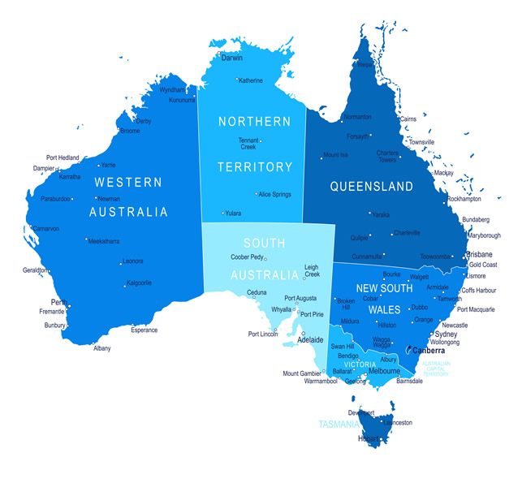

In this task you are to identify major tourist destinations in each state and list one attraction at each site.

Record your findings in table.

Hint:

Western Australia – 3

South Australia – 2

Norther territory – 3

Tasmania – 1

Victoria – 3

New South Wales – 3

Queensland – 3

Your responses are to be word processed and placed in your e-portfolio for this short course.