# Planning a digital presentation

The phases in preparing a digital presentation are:

1. Create an outline of the presentation
2. Develop a storyboard
3. Identify resources required
4. Establish a style guide and template
5. Construct the presentation
6. Test and review
7. Refine and release

## 1. Creating an Outline

An outline of a presentation is an important guide that shows how the multi-media display is going to proceed in a logical, structured way that fulfills all its’ objectives. It also provides a blueprint for developing content and can be used by developers to research and gather required resources before the development phase begins.

Outlines are generally just a numbered list developed from the project’s objectives. A more detailed plan like storyboarding will be developed from the outline. Outlines are set up to show an ordered listing of the topics and subtopics that will be contained in the presentation.

Here is an example of a presentation’s outline:

1. Topic

a. Subtopic

b. Subtopic

c. Subtopic

2. Topic

a. Subtopic

b. Subtopic

If we were to look at a presentation on Quality Customer Service, it might look like this:

1. What is Quality?

a. Quality definitions

b. How does this relate to customer service?

2. What are the various aspects of quality with respect to customer service?

a. Performance

b. Safety

## Storyboarding

Storyboarding is the process of sketching out the progression of a marketing video, animation, or film. Each scene or shot is assigned a panel, and each panel includes a visual sketch or a photo of the concept. You can include dialogue, notes, audio, and more in each panel.

The storyboard is a tool that helps to plan and organise the sequence of events in a story. It breaks a story into a set of circumstances and presents it as infinitesimal visual information. This information is then arranged linearly to communicate a story.

A storyboard helps you:

* Define the parameters of a story within available resources and time
* Organize and focus a story
* Figure out what medium to use for each part of the story

**How to Do a Rough Storyboard**

A multimedia presentation is some combination of video, text, still photos, audio, graphics and perhaps some interactivity presented in a nonlinear format in which the information in each medium is complementary, not redundant. So a storyboard should be put together with all those elements in mind.

The first thing to tackle is the part about the presentation being nonlinear.

Divide the story into its logical, nonlinear parts, such as:

* a lead or key paragraph, essentially addressing why the message in this presentation is important
* profiles of the main person, people or location
* the event or situation
* any process or how something works
* pros and cons
* other related issues that are to be addressed in the presentation.

Instead of thinking “first part,” “second part”, “third part”, “fourth part”, think “this part”, “that part”, “another part”, and “yet another part”. It helps to avoid linear thinking.

Next, divide the contents of the story among the media — video, still photos, audio, graphics and text.

Decide what pieces of the story work best in video. Video is the best medium to depict action, to take a reader to a place central to the ‘story’, or to hear and see a person central to the ‘story’.

Decide what pieces of the ‘story’ work best in still photos. Still photos are the best medium for emphasizing a strong emotion, for staying with an important point in a story, or to create a particular mood. They’re often more dramatic and don’t go by as quickly as video. Still photos used in combination with audio also highlight emotions. Panorama or 360-degree photos, especially combined with audio, also immerse a reader in the location of the story.

Does the audio work best with video, or will it be combined with still photos? Good audio with video is critical. Bad audio makes video seem worse than it is and detracts from the drama of still photos. Good audio makes still photos and video seem more intense and real. Avoid using audio alone.

What part of the ‘story’ works best in graphics? Animated graphics show how things work. Graphics go where cameras can’t go, into human cells or millions of miles into space. Sometimes graphics can be a story’s primary medium, with print, still photos and video in supporting roles.

Does the ‘story’ need a map? Is the map a location map, or layered with other information? GIS (geographic information systems) and satellite imaging are important tools for reporters. Interactive GIS can personalise the detail of the message in a way impossible with text by letting readers pinpoint things in their own cities or neighbourhoods.

What part of the ‘story’ belongs in text? Text can be used to describe the history behind parts of a presentation (sometimes in combination with photos); to describe a process (sometimes in combination with graphics), or to provide first-person accounts of an event. Often, text is what’s left over when you can’t convey the information with photos, video, audio or graphics.

Make sure the information in each medium is complementary, not redundant. A little overlap among the different media is okay. It’s also useful to have some overlap among the presentation’s parts. But try to match up each element of a presentation with the medium that best conveys it.

When you’re done breaking a presentation down into its elements – both in terms of its content and the different media you could use – you need to reassemble all that into a rough storyboard.

On a sheet of paper, sketch out what the main story page will look like and the elements it will include. How will each part link to the other sections of the ‘story’? What multimedia elements do you want to include on the main page as the establishing visuals, whether video or pictures?

Then do the same for the other “inside” pages that will be the other parts, or subtopics. What is the main element on each page and what other information should be included there? What video, audio, pictures or graphics would best tell this part of the story?

A rough storyboard doesn’t have to be high art – it’s just a sketch. And it isn’t written in stone – it’s just a guide. You may very well change things after you start construction.

What storyboarding does is help point out the holes in a presentation. It helps identify the resources (time, equipment, assistance) needed to complete the presentation or how it will have to be modified to adjust to available resources. A good way to learn storyboarding is to take a newspaper feature story and sketch out a storyboard of all the elements in it, the multimedia possibilities if it were more than a print story and how you might break it up into a nonlinear web presentation.

## The process

A storyboard looks like a comic strip. Each square represents a single shot. It shows who or what is in the scene, what’s being said, and any text or graphics that appear on the screen. As you read through a storyboard, you should be able to “see” the digital presentation playing in your head.

A good storyboard serves two main functions: ***planning*** and ***communication***.

**Planning**

When a digital presentation is ‘storyboarded’, you’re creating a plan for production. It is always a temptation to open PowerPoint and start building things, but without a road map you will simply waste time, money and energy.

A storyboard forces you to visualise each slide you will need, the order in which these will appear and how the visuals will interact with the script. It is much easier to hash out the details during pre-production than it is in the building/construction phase.

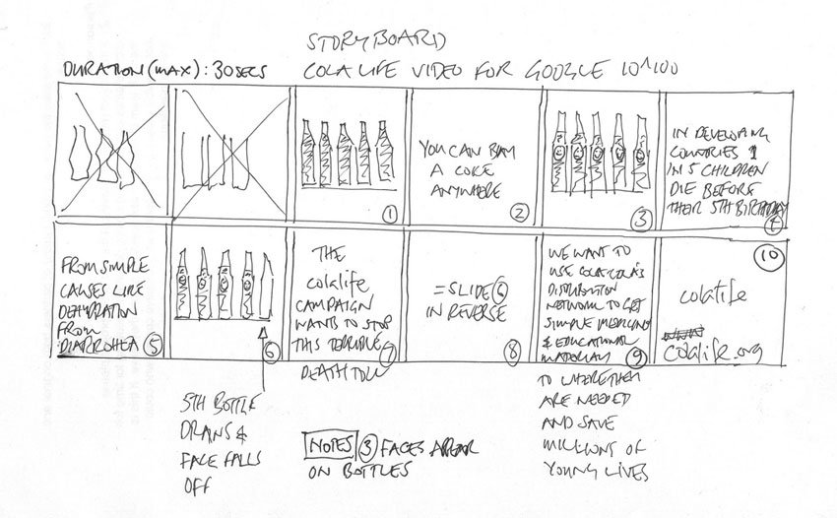

**Communication**

Another challenge is communication. With a storyboard, you can explain to a team or a supervisor exactly what is intended in the presentation. The storyboard may change as team members offer feedback, a supervisors re-directs the priorities or intent of the presentation and the project evolves. It's an essential tool for making sure everyone involved is on the same page.

**Making the storyboard**

A storyboard for a multi-media presentation doesn't have to be an elaborate work of art. Here’s how to make one:

***Step 1: Create a Storyboard Template***

The first step in learning how to create a storyboard for a video is a template. Draw a series of rectangles on a piece of paper, as if you were creating a comic strip. Make sure you leave room for notes or lines of script under each rectangle.

You can also download one of the many free video storyboard templates online, like this:

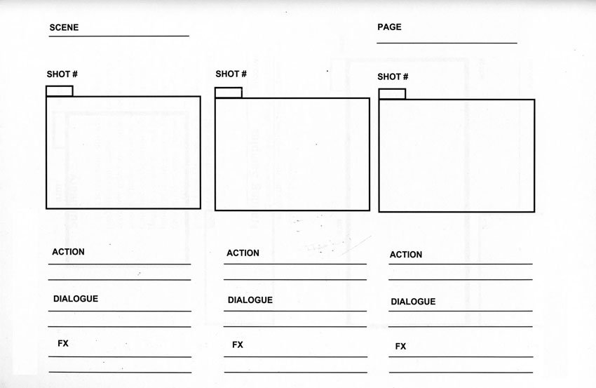

This storyboard template is available from <https://commons.wikimedia.org/wiki/File%3AStoryboard_Template.jpg>

***Step 2: Add the Script***

Under each rectangle, write the line of script or dialogue that corresponds to that scene. This becomes your narration within the presentation.

***Step 3: Sketch Out the Sequence***

Don’t worry if you’re not an artist - simple stick figures will do the trick. You can indicate movement with an arrow. Any drawing is better than no drawing!

If you don’t want to sketch the shots by hand, you can use photographs or images cut from a magazine. There are even storyboarding tools online where you can select characters and settings, add speech bubbles and text blocks, and even record audio. Be warned, though – they’re tons of fun, and you can waste a lot of time!

***Step 4: Add Notes***

Finally, add in any notes about each slide. This might include a description of what’s happening, movement, and any special effects such as animations and transitions. Don’t forget about audio like music or sound effects.

## A Few Storyboard Tips

Now you know how to create a storyboard for a presentation. Finally, don't be too cautious about storyboards. Take some chances. Draw quickly and sloppily if you feel inspired and need to get your ideas down on paper. You can go back and work on your storyboards. Have fun with your storyboards, they're the perfect tool for letting your imagination work.

Here are a few more storyboarding tips:

* Use rectangles that are the same aspect ratio as the default PowerPoint slide, 16:9.
* Number each rectangle for easy reference in discussions.
* Do research and try and find some resources (i.e. images, photographs, videos, etc.) during the planning.
* Think in 3D. Make subjects/objects in the background smaller, so they appear further away.
* Cut up and recombine your storyboards to play with sequencing and narrative.
* Use the finished storyboard to create a master resource list. This way nothing will get overlooked during production.
* Keep the storyboard simple so it can be understood by anyone who views it and be sure to share the finished product with everyone involved!

## Gathering Content and Developing Activities

Gathering content and developing activities is the most important and sometimes the most time-consuming part of developing a digital presentation. The first step is to collect all the materials and information you already have about the topic. You may already have course notes, reference materials, manuals, research papers, PowerPoint presentations, videos, and more.

Now that you have finalised the course flow through storyboarding, it is time to get all the necessary pieces together. This requires you to collect or create the relevant assets (graphics, photos, videos, audio, music, etc.) that you will use. Some of these will already be available but others will need to be created or purchased from vendors.

Once you have all your assets together, you will need to assemble them in PowerPoint.