Microsoft 365 Excel: Part 2
Function Categories
Every built-in function that is available in Excel has been categorized into one of 12 standard categories. These categories are available on the Formulas tab, with some categories available under the More Functions drop-down menu:
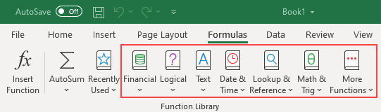
Financial functions can be used to calculate financial data such as compound interest, rates of return, and depreciation.
Logical functions are used to return values that are either true or false, typically in conjunction with other formulas.
Text functions are used to manipulate text. For example, to replace text or convert text to uppercase.
Date & Time functions can be as simple as calculating the current date to calculating the number of workdays in a year.
Lookup & Reference functions are used to find specific values in a specified range or table.
Math & Trig functions contain a variety of common mathematical functions.
Statistical functions are used to perform a variety of statistical analysis tasks.
Engineering functions are commonly used in engineering settings.
Cube functions are used to perform complex data analysis using OLAP (Online Analytical Processing) cubes.
Information functions give you information about the worksheets in your workbook and the data that they contain. For example, one function has the ability to determine the type of data in a cell.
Compatibility functions are unique in that they are actually older versions of functions that are still available. Such functions are useful if you are working with workbooks that were created in older versions of Excel.
Web functions are used to return data from web services, return data from XML content, and return URL-encoded string data.
Using Range Names in Formulas | Trendlines
After you have defined a cell or range name, you are able to use that name in place of the usual cell reference.  This makes formulas much more readable:  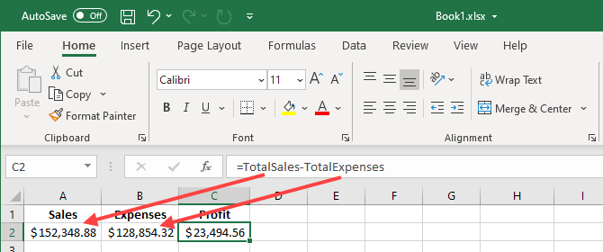 | Trendlines are used to graphically depict trends that exist within your data or show a forecast of future data in a chart. For example, here you can see a trendline that forecasts two years ahead that shows a trend towards increasing revenue:  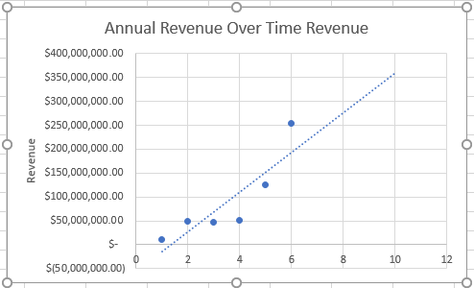
Table Components
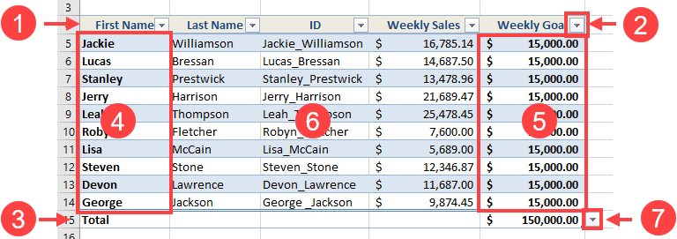 | - Header row  - Header row drop-down arrow  - Total row  - First Column  - Last column  - Banded rows  - Total row drop-down arrow
Themes
Themes are a combination of preset colors, fonts, and effects. Each theme includes 12 colors, two fonts (Header and Body), and colors and effects for shapes and SmartArt. Much of the formatting that you apply to elements of your workbook can be changed, simply by changing the theme of the workbook. To change a workbook’s theme, click Page Layout → Themes.
On the Home tab, in the Font group, you can see the Theme Fonts of the currently selected theme:  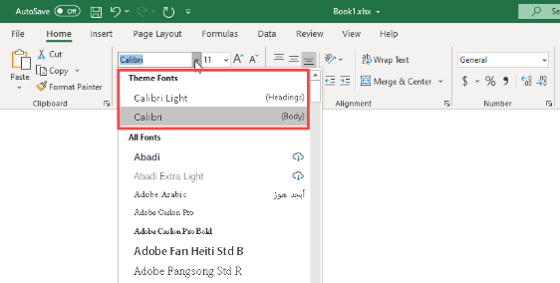 | You can also see the Theme Colors:  