**Improving a Business’s Environmental Sustainability**

## What policies and practices can be operated in an office workplace that assist in environmental sustainability?

## **Environmentally sustainable work practices**

Environmental sustainability is about improving a business’s productivity without reducing the quality of the environment.

The area where greatest change towards sustainability can occur is in resource use. Any business that ensures it is using its resources in an effective and efficient manner must do so with the longer-term view – the resources must continue to exist for future use – in mind. The reduction of waste is an important part of this.

In a previous learning activity, you considered an example using the resource, paper. Paper is made from wood pulp harvested from plantation and native forests. Paper is one of the resources found in every office and is often used in unthinking ways leading to excessive waste. This in turn creates a demand for more paper leading to greater harvesting of trees and a diminishing habitat for animals and a reduction of land cover. Future generations of Australians may be affected by our actions now.

Many of our resources we use, like wood, renewable resources. That is, the resources can be grown again and again if our society plans for this. Some resources are, however, non-renewable meaning that it cannot be replaced. An example of a non-renewable resource would be oil – the raw product from which petrol is manufactured. When non-renewable resources are fully consumed these resources will be gone. Society may develop substitutes for the non-renewable resources, but the non-renewable resources need to be carefully managed.

Environmental sustainability is about using resources so that future generations can use the same natural resources that are used today.

## Activity 1

What is the difference between a renewable and a non-renewable resource? Give an example of each (that is not given in these notes) and record the work for your portfolio.

## Reduction of Waste

In your business workplace it is essential that you consider how you may reduce the amount of waste that is generated in the workplace. Here are four examples:

### Paper

Generally, trees are planted in plantations for the purpose of harvesting for the paper production process. Sometimes native forests may be used though this is less common than some years ago.

The underpinning issue with the wastage of paper is that the wood pulp required to manufacture paper comes from trees which grow in forests. The use of cultivated plantations to grow appropriate trees is one way of preserving native forests, but much of the world’s paper still comes from harvesting native forests. Forests are vital as these living organisms have a major role in keeping our air and water clean; forests are also an essential component of the ecosystem in that they provide habitats for native animals across the world. As you could infer, the decline and removal of forests would have a corresponding negative impact on animal life, and water and quality.

Because of this, it is important that society undertakes a two pronged approach to managing its use of paper: move away from the use of native forests to plantation grown trees for paper production and to reduce the wastage of paper in all its forms. Some of the following guidelines may prove to be useful in reducing the wastage of paper in office situations:

* Photocopy only the pages you need. Do not produce unnecessary copies unless specifically asked to do so.
* Use the Print Preview feature on your computer’s software applications to check a document before printing it. If a mistake is evident you can correct it without wasting paper by printing draft copies.
* Send messages by email instead of a paper memo or fax.
* Print and/or photocopy on both sides of the page if appropriate.
* Reuse paper that has only been printed on one side; it can be used for notetaking or for printing draft documents.
* Place used paper, cardboard, boxes and newspapers in a recycle bin.

Remember, also using paper from specially cultivated planation forests of soft timber focuses your environmental sustainability towards preserving native forests. Plantation timbers are re-grown quite quickly and are sustainable.

### Energy

Administrative services and the office spaces these occupy use energy (electricity and perhaps gas) for lighting, heating and cooling, as well as operating equipment such as computers, printers, photocopiers and even the coffee machines! In Australia, most energy is produced by burning oil, coal or gas – all of these are non-renewable resources. By reducing our electricity consumption, offices can save more (i.e. increase profit) and contribute to environmental sustainability. All workers (in any business or organisation) have a role in conserving energy in the workplace by simply turning off computer monitors, general equipment and any lights when these are not in use. Of course, this simple strategy to conserve energy and save money can also occur in people’ homes.

### Water

The majority of Australia is a dry. The energy and effort to catch, store and transport water to homes and workplaces is massive. It is important that the use of water is considered and efficient. Business, organisations and individuals should get into the habit of using water carefully. Most workplaces do not use water to produce a product. Rather the water used in most business is for the purpose of keeping the workers comfortable, i.e. air-conditioning, drinking water, toilets, ablutions, etc.

Tips on using water more efficiently include:

* Ensure taps and water valves are turned off fully.
* Water leaks are repaired immediately.
* Use appropriate amounts of water to wash items – do not go overboard.
* Establish toilet systems that are ‘water wise’ and have half flush options.
* Sweep large areas rather than hose these down.
* Recycle rain and wastewater for garden use.

### Rubbish and Other Waste

Waste can be considered as everything that is disposed from the business or organisation through dumping, rubbish collection or recycling. The amount of waste produced by a typical office is extraordinary! Every day a business is likely to throw away paper, plastic packaging, food scraps, drink containers, pens, disposable cups, paper towels, ink cartridges, toner, damaged office equipment, boxes and much more. For the most part this waster is collected and deposited as land fill. Landfill is the term that describes a large hole used generally by local government to store waste material; when the hole is full it is capped with soil and left for many years as the waste decomposes.

Landfills are not efficient. Landfills filled with waste take up land which could be using for housing, farming or industrial uses. As this waster material starts to decompose it produces some greenhouse gases such as carbon dioxide and carbon monoxide. Often the landfill area will smell for an extended period producing concern amongst the community. A final issue is that often the waste materials may contain materials that have some toxicity – as these materials decompose the toxic components are released into the soil and local water table. AS our communities produce massive amounts of waste for disposal, landfills become more common and are filled at a rapid pace.

One means of reducing waste to landfills is to establish effective recycling processes where waste is reused to produce new, but different products and services. Paper, mobile phones, batteries, glass and soft drink cans are all able to be reused rather than being placed into landfills. In some colder countries, nearly all organic waste is diverted to fuel huge furnaces which generate heat to keep communities warm or produce electricity.

A further means of reducing waste is to simply use less of some materials or to use these items more carefully and reduce the left-overs - use only what is needed.

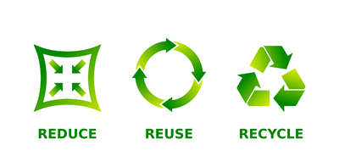

## Minimisation of Risks

Consider how offices and business workplaces could minimise the risks associated with the consumption of resources. Here are a few examples:

### Chemicals

Often such workplaces may have a range of chemicals stored that perhaps in larger quantities would be called toxic or hazardous materials. All hazardous materials need to be carefully stored in accordance with instructions provided by the manufacturer but often this is overlooked when only small quantities are being held, e.g. specific cleaning products.

Well planned and operated businesses will have separate storage areas for such chemicals and their associated products. Remember that even things like cleaning liquids and solvents need to be stored carefully as in certain circumstances they can be dangerous. The storage areas of such items should be identified using signage.

### Cleaning Materials

The cleaning materials that a business uses to clean up the workplace has the potential to harm the environment. Cleaners and detergents made of toxic chemicals can cause damage to those using them as well as the environment. Many responsible business owners are moving from the traditional cleaning products that may contain toxic or environmentally damaging components to more environmentally friendly products.

All workers within an office situation should be aware of the workplace’s environmental policy and procedures and ensure they adhere to these requirements. These policies and procedures may be found in the workplace manual, the broad company’s policies and procedures or as directives issued by the local supervisor. Knowing where to find these documents is important, as all workers will need to refer to them at some point in time. Workers are expected to follow the directives and policy of their employers in terms of protecting the environment.

Reminder: A policy statement comes in two distinct parts: the policy and the procedure. The policy outlines the overall goals that the organisation wishes to achieve and the procedure states how it is to be achieved. While it is important to be familiar with both, it is the procedures on which workers are expected to will act. The procedures will state how it is you are to act, and what you are to do.

## Contributing Positively

There are several ways each worker in a business can actively contribute to environmental sustainability. Listed below are some of these ways:

### Making Suggestions

All workers can and should contribute to the betterment of their workplace through the making of suggestions. This process is encouraged in Workplace Health and Safety areas and the same rationale applies in environmental sustainability. Generally, businesses and organisations encourage all employees to offer suggestions. How can constructive suggestions be structured or organised? Consider the following ways on how to maximise effectiveness in making suggestions at work:

* Have workers review or audit their own work areas and tasks

Workers should know their own work area and work duties best so have them look for ways of improving their own work processes and practices. Have them look for ways to reduce wastage, save time and improve the work processes. Consider the range of suggestions and even trial those that seem workable.

When trialling such potential changes always do so to a detailed plan build a plan for each first. Include such things as change management, costs and benefits/challenges in these plans. This will ensure that the trial is seriously considered by other workers and supervisors.

* Continuous improvement focus

All jobs in any business should have a continuous improvement focus. This is a crucial part of any job in business as without a continuous improvement agenda, businesses will fall behind their competition. Always encourage workers to focus on ways of improving their jobs and the business generally; one of these areas is of course making the business more environmentally efficient and effective.

* Work as a team

Working within a business means that everyone is part of the large team. Competition may have its place in smaller, internal activity, but the reality is every person in the business is a member of the larger team. There is a place and time for the workers to work co-operatively and collaboratively in finding ways of improving the business’ work systems. Remember, in this context, the common purpose of all workers in the business is to improve its’ overall environmental well-being.

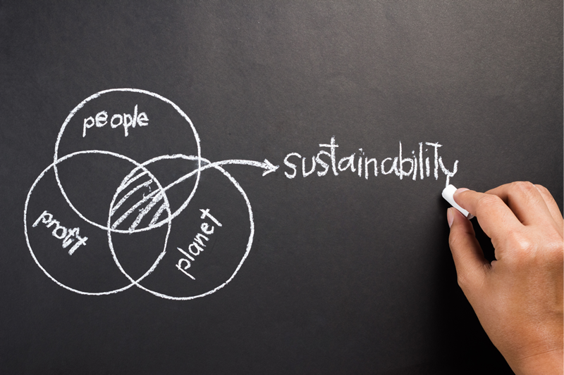

## Activity 2

Anjark Services is looking for new ways of reducing waste in its office work areas.

Working in groups of two (you may use virtual classrooms, email, etc. to communicate), identify possible solutions. Agree on the selection of one of that you each feel is most effective. Construct the following:

1. A brief statement explaining what benefits such a solution could have for the business.
2. Make a dot point list on how this solution could be presented to the business manager for her consideration.

## Conclusion

Concerns about environmental damage and sustainability are now part of the social conversations as evident in both media and politics. This importance flows into all workplaces as these places endeavour to both address the laws focused on environmental protection/sustainability and to reassure the public that the business is responsible and can be supported.

However, a focus on environmental sustainability can also have more specific benefits for businesses and organisations. A continuous improvement focus on environmental responsibility can lead a business to reduce its costs, improve its profits and make the workplace a healthier and safer place.