Microsoft 365 Excel: Part 1
The Excel Interface
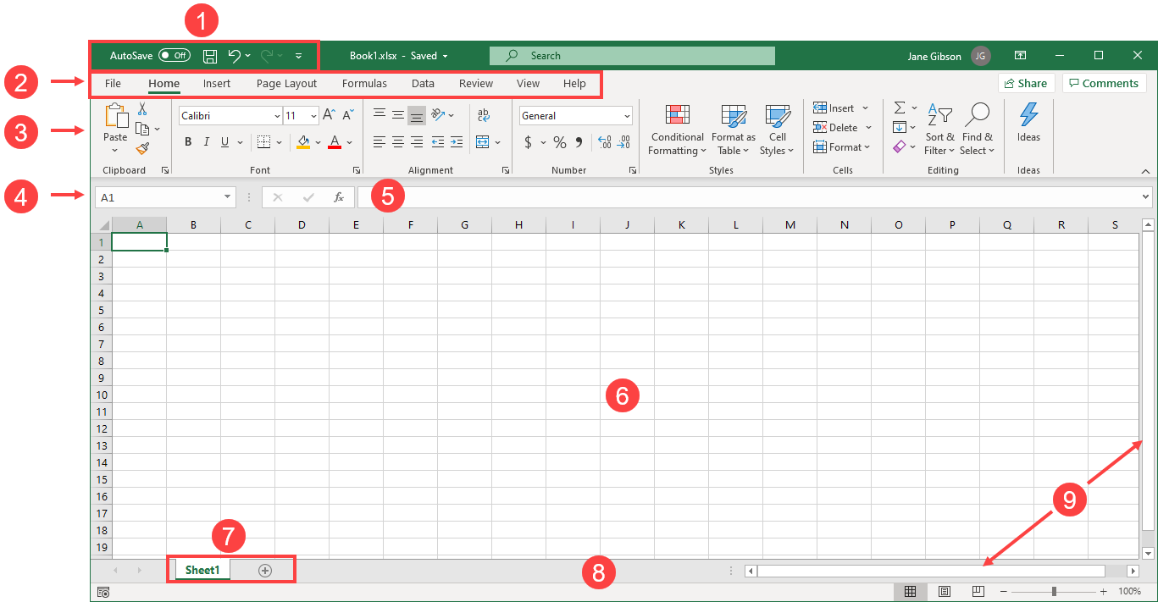 |  | Sub-title  - Quick Access Toolbar  - Tabs  - Ribbon Interface  - Name Box  - Formula Bar  - Working Area  - Worksheet Tabs  - Status Bar  - Scroll Bars
Grouped Worksheets | Worksheets and Spreadsheets
To group two or more worksheets together, hold down the Ctrl key on your keyboard and then click on the tabs for each worksheet that you would like to include in the group:  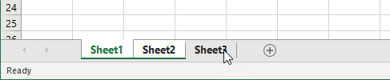  Once you have selected all of the worksheets that you would like to include, release the Ctrl key. Each worksheet tab you selected will change from gray to white:  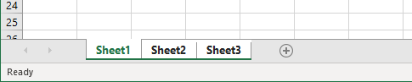  Additionally, the title bar will show the workbook name following by [Group]. | A spreadsheet is essentially a large flexible grid that is used to store information, typically numerical data. In Excel, data is stored in a worksheet, which is made up of rows (1) and columns (2). The intersection of a row and column is called a cell (3), and can contain may types of data: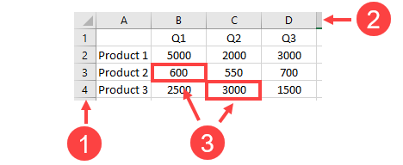

Elements of an Excel Formula | The Order of Operations
Formulas are always preceded by an equals sign (=). Formulas can contain cell references (like A1), numbers (like 23), or functions (like SUM(B2:B9)). Enter a formula by typing directly into a cell or into the Formula Bar:  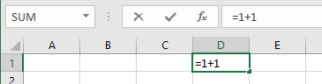  =A1+23, = d2-c2, and =B10+b11/C6 are all valid formulas; cell references are not case-sensitive. |  | One easy way to remember precedence order is to remember the word “BEDMAS,” which stands for Brackets (Parentheses), Exponents, Division, Multiplication, Addition, and Subtraction. Note that:  - Division and Multiplication have equal precedence, calculated from left to right.  - Addition and Subtraction have equal precedence, calculated from left to right.
Mathematical Operators |  | The Transpose Feature
Name Symbol Example  Exponent ^ 10^2 = 100  Division / 10/2 = 5  Multiplication * 10*2 = 20  Addition + 10+2 = 12  Subtraction - 10-2 = 8  Equivalence = 10 = 10  Greater Than > 10>2  Less Than < 2<10 |  | You can transpose columns and rows by copying a data range and then placing your cursor on the worksheet where you want the copied data to be pasted. Next, click Home → Paste → Transpose:  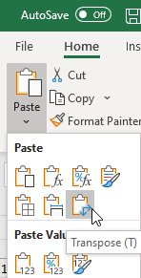  The result will flip the row and columns:  