Staff Questionnaire | 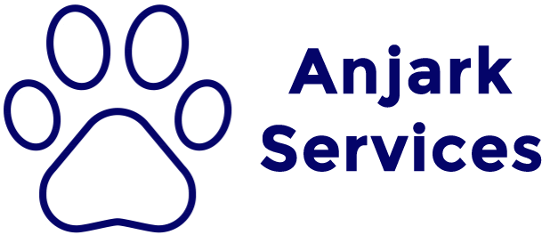
The purpose of this questionnaire is to identify where we as an organisation stand in terms of our staff’s knowledge of workplace dynamics. Please answer each question below to the best of your ability. Return your responses to your supervisor (Mitchell).

Question 1
What are the WHS responsibilities of employers and employees at work?

Question 2
How do the Privacy Laws impact on your how you work?

Question 3
Give an example of ethical behaviour in our organisation?

Question 4
How does the anti-discrimination legislation impact on your organisation?

Question 5
How do you encourage others to provide you with feedback on your work performance? How do you use it to improve your work knowledge, skills and performance? Give examples please.

Question 6
You have a range of responsibilities and duties in your job. What personal attributes or characteristics do you bring to work each day that help you complete your duties?

Question 7
How do you contribute positively to your workplace?

Question 8
How do you manage time and resource constraints when working?

Question 9
Provide three examples of differing values or cultural practices that you know exist in your workplace (or team)? How do you deal with these? How have you sought assistance? Give some examples of how you have done this, and if you feel this has positively contributed to your work.

Question 10
Have you experienced a situation where you have encountered difficulties in communication due to cross-cultural issues? How did you resolve these problems? If you have not, what difficulties could you expect to encounter in the future and how would you resolve these?

Question 11
Give three examples of situations in your workplace/team where you have encountered conflict. What was the cause (remembering your Working Effectively With Others booklet) was responsible and state how you resolved it? Did you consult with other team members to resolve the conflict?

