Environmental Risk
In order to establish if there are environmental issues within your office setting, it is essential that risk analysis is carried out. This risk analysis is also called a risk assessment. The areas that must be examined include:
- Chemicals that are being used and stored at the work place
- Safety equipment that is in place
- Working conditions
- Work procedures and work processes
- Appropriate hygiene and health procedures and actions
- Protecting other workers

Determining what you need to do or procedures to follow so as to ensure that you meet the regulations associated with environmental practices is critical.
The process to follow to conduct a risk analysis is outlined below:

Risk
Risk is the possibility that harm (death, injury or illness) might occur when exposed to a hazard. Risk control means taking action to eliminate health and safety risks so far as is reasonably practicable, and if that is not possible, minimising the risks so far as is reasonably practicable.
Risk is a natural part of all businesses, and in order for each person in the workplace to manage it effectively, it is important that an awareness of risk is understood by all staff and that a set of procedures are in place to manage identified risks
A risk management plan is a plan focused on considering the types of events that could occur, unexpectedly, within the business. These events often have major impacts on a business’s operation so contingency plans need to be in place. These contingency help the workers to be aware of what they need to do when an event may occur.
There are two major parts of risk that need to be considered when dealing with environmental issues. These are:
- The toxicity of the effect: What ability does the risk itself have to cause harm to property, humans or other living things?
- Exposure: How much danger has the individual worker, or animal or building been exposed to – how much they come into contact with. There are three major components:
- Severity of contact: The volume or quantity of material that the worker has come into contact with.
- Length of contact: The actual length of time the worker is exposed to the materials.
- Pathway for exposure: What method of exposure occured.
Because the major risks associated with environmental concerns are likely to be chemicals, the major pathways for exposure that you need to consider are:
- Inhalation
- Touching
- Ingesting.

Rank the impact of the event occurring
With the risk identified the risk analysis needs to consider and then rank the impact of the potential event based on the available information. Some of the information that you will need to gather may come from other sources. There is no single reference point for this information so you may need to refer to multiple sources in order to fully understand the impact of the materials or event.
Sources of this information may include:
Safety Data Sheets (SDSs): This mandatory documentation is supplied by the manufacturer of the material or chemical that you are using. You should receive these from your supplier and need to ensure these are stored in a location that is easy to find and access. You can also access these on manufacturer’s websites.
Suppliers: The suppliers to the business should be able to supply any information that may be needed.
Experts and specialists: There are a number of specialist personnel who could be used to assist in these areas. These may be physiotherapists through to chemical engineer consultants.

When analysing exposure, you have already consider the length, amount and method of exposure to dangerous substances. However danger may also come from the effect of long-term exposure. Often you may find that exposure is not immediate; it may occur after an extended period of time with it leaching out of a product or some such incidental method. Always consider the longer term effects of any chemical issue.
Personal Protective Equipment
Even in office situations there may be some need for types of Personal Protective Equipment (PPE). Examples of this type of office equipment would include:
- Gloves and aprons for handling printing or cleaning equipment
- Gloves and face masks for handling air borne infections from clients/customers
.

Rank the significant environmental impacts
You should now be able to rank the various environmental impacts that may occur based on the information that you have gathered. Factors that need to be considered include:
Regulatory Concerns – Consider each of the following:
- Whether you are exempt from regulation
- Whether the regulation is low in terms of impact on operations
- The ease of maintaining compliance
- The cost of maintaining compliance.

Other Issues – What impact does your workplace have on the surrounding communities? You also need to consider how the people outside of your business workplace may be impacted. You will need to consider:
- Pollution
- Noise
- Smell
- Increased traffic.
Natural Resources – What use, excessive or otherwise, does your workplace and actions have on natural resources? Examples of natural resource use would include:
- Water used by the business
- Energy use
- Carbon emissions
- Land
- Impact on wildlife.

Each of these may play a role in your analysis of risk. Where issues are identified as being significant, action against that level of use should be considered.
Some businesses take a ‘supply chain’ perspective to environmental sustainability. This means that as a business issue not just the end business but all of that organization’s supply chain or logistics network is assessed to identify and take action against environmental hazards, risk and waste costs.
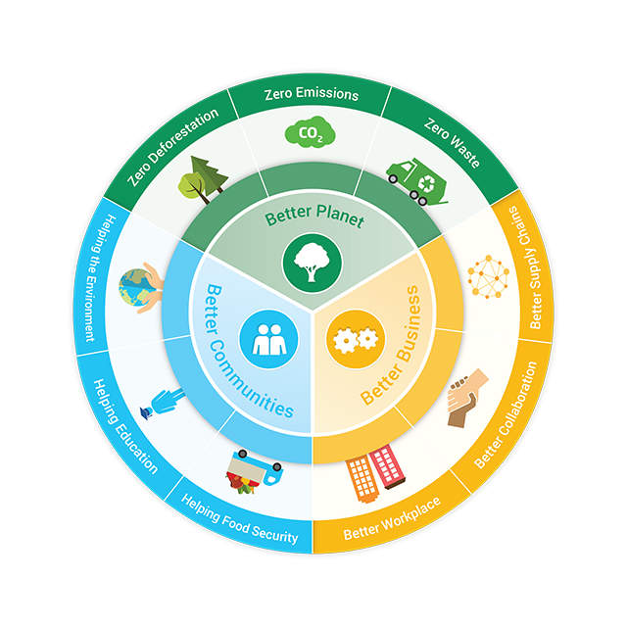
Diagram: The benefits of environmental sustainability
Measuring and recording your organisation’s resource usage is an important part of any investigation process or risk analysis. Measuring and recording resource usage allows the business to determine what resources are being used. This helps identifies where efficiencies can be introduced.
In addition to the measuring and recording process, it is essential that the business also documents its resource and stores this in such a way that it can be easily retrieved for use by others, i.e. employees, decision makers, etc. This information on the use of resources may be drawn, for example, from the invoices of expenditures that the business had paid for the previous twelve months; this could be used for such expenditures as water, gas, electricity, waste collection and office supplies. Invoices or account statements may show the amount to be paid and unit of measurement (e.g. litres or kilowatts). Some invoices specify energy efficiency information such as the volume of greenhouse gas emissions or the amount of water that has been saved.
A business can measure and record their resource usage by:
Conducting desktop or practical audits
This is where the business examines its current use of resource on the business’s records (e.g. invoices, finance reports and work procedures) to identify how its’ products or services purchased are made. It can also be used to review the level that the ‘supply chain’ is operating at, i.e. what environmental factors are the business’s suppliers considering.
Secondly the business takes measurements of the resource use and analyses the information gained to identify what materials or procedures create barriers or support best practice over a specific timeframe. The purpose of this stage is to review the business’s administrative processes or ‘way of doing things.’
Auditing Supply Chain
This stage is a practical method of gaining information to compare against data collected from the desktop audit; either against the business itself or its suppliers in the ‘supply chain’. A practical audit will help the business identify what work practices are carried out at its workplace/s. Waste materials and inefficient work practices can be identified and effective recycling practices can be determined or reviewed.
The above three stages of review methods will help any business to gather, measure and eventually record the amount of resources that are used.
If you are involved in this process, always check to ensure the information you are using to make decisions is correct before moving forward. Find a few people to be ‘critical friends’ to check y=the validity of your information sources, how the information was analysed and the resulting decisions to change business practice. It is always better to check your work before formally making a report then finding out later, in the glare of your work mates and employers, that you may have made a mistake.
Business may also survey the suppliers that provide its’ office equipment and materials about environmentally sustainable aspects of their products and services. You will commonly see electrical goods now marketed on the electricity consumption (5 star ratings) and environmental sustainability. This review of data prior to purchasing allows the business to compare suppliers and identify products and services that that prioritises environmentally sustainable work practices.
A business’s resource usage can be recorded in a simple table.
Substance used | Cost per unit of substance | Number of units consumed | Level of environmental impact  (1 smallest to 5 highest) | Amount of emissions/waste saved
Example of a table used to record resource usage and environmental benefit

Recording resource usage information assists a business to keep track of their operations and potential environmental benefits.
By gathering and recording information on current resource usage, businesses can start to identify opportunities for resource efficient practices. The importance of tracking actual costs and resource usage in general operations or specific projects will be dependent upon each situation’s unique circumstances.

Activity
Identify two major environmental hazards present in a general office situation.
Rank the hazards in terms of risk each poses to the environment (in the broadest possible sense taking into account the supply chains) and, in a paragraph explain why you have assigned these priorities.

