Physical Domain - Frequently Asked Questions about Gross Motor Skills

Introduction

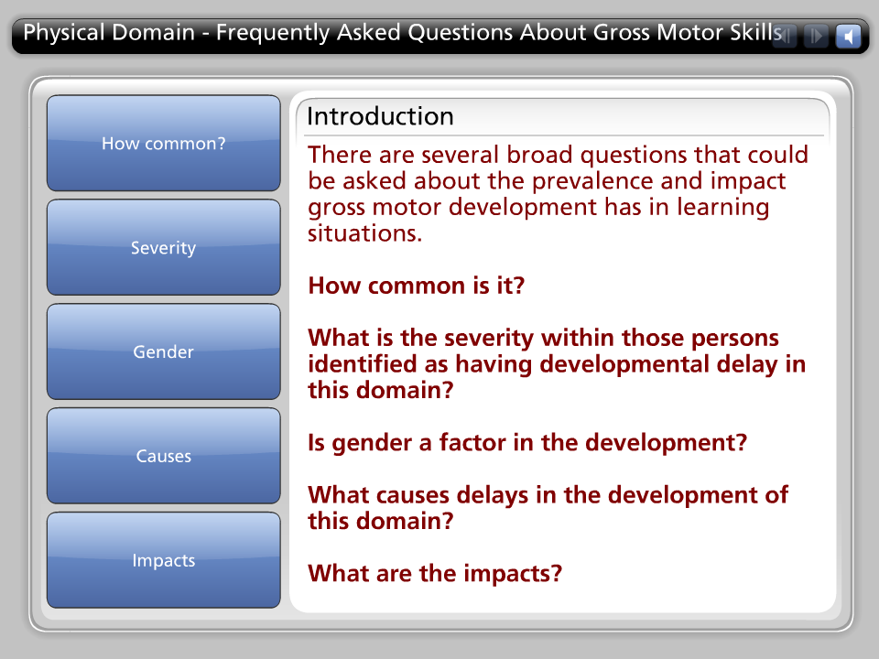
There are several broad questions that could be asked about the prevalence and impact gross motor development has in learning situations.

How common is it?

What is the severity within those persons identified as having developmental delay in this domain?

Is gender a factor in the development?

What causes delays in the development of this domain?

What are the impacts?

How common?

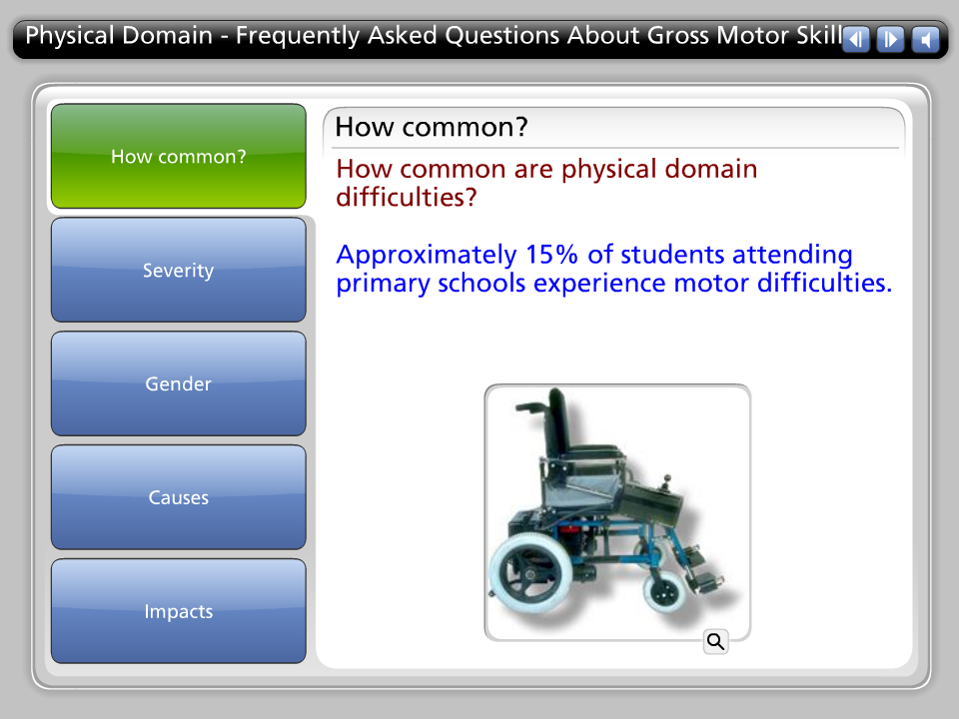

How common are physical domain difficulties?

Approximately 15% of students attending primary schools experience motor difficulties.

Severity

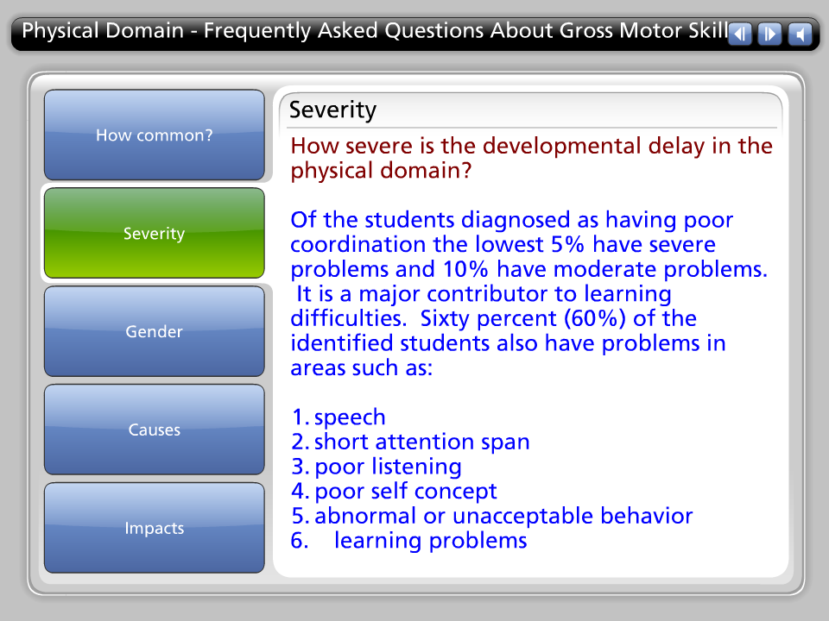

How severe is the developmental delay in the physical domain?

Of the students diagnosed as having poor coordination the lowest 5% have severe problems and 10% have moderate problems. It is a major contributor to learning difficulties. Sixty percent (60%) of the identified students also have problems in areas such as:

1. speech
2. short attention span
3. poor listening
4. poor self concept
5. abnormal or unacceptable behavior
6. learning problems

Gender

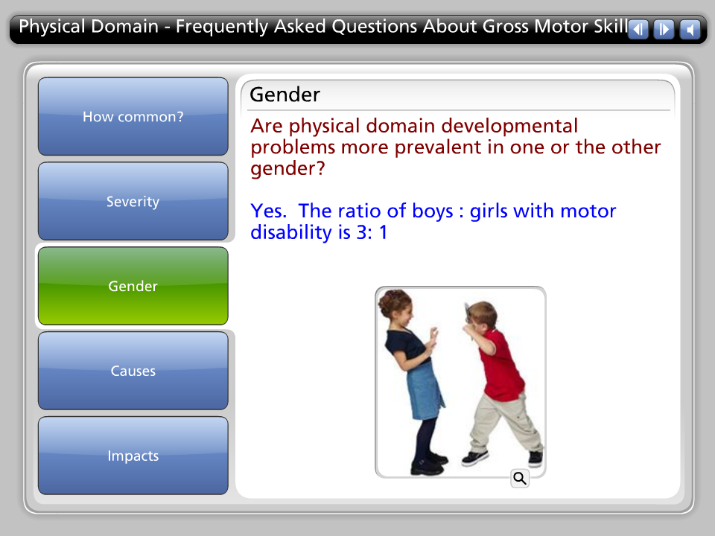

Are physical domain developmental problems more prevalent in one or the other gender?

Yes. The ratio of boys : girls with motor disability is 3: 1

Causes

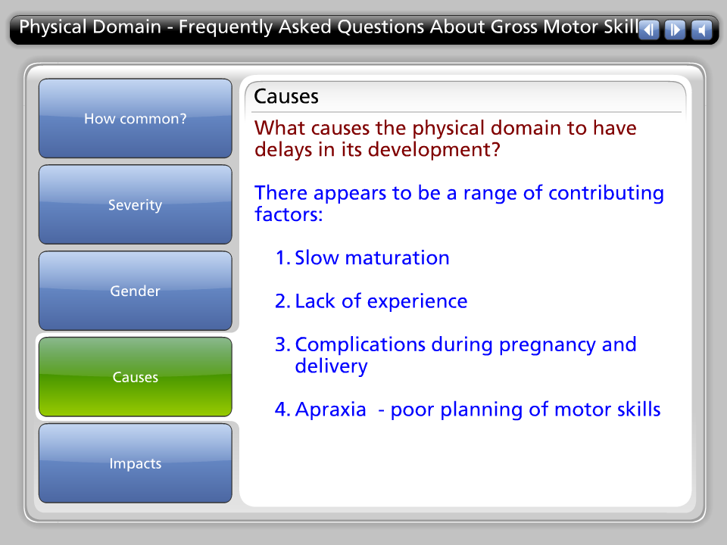

What causes the physical domain to have delays in its development?

There appears to be a range of contributing factors:

1. Slow maturation

2. Lack of experience

3. Complications during pregnancy and delivery

4. Apraxia - poor planning of motor skills

Impacts

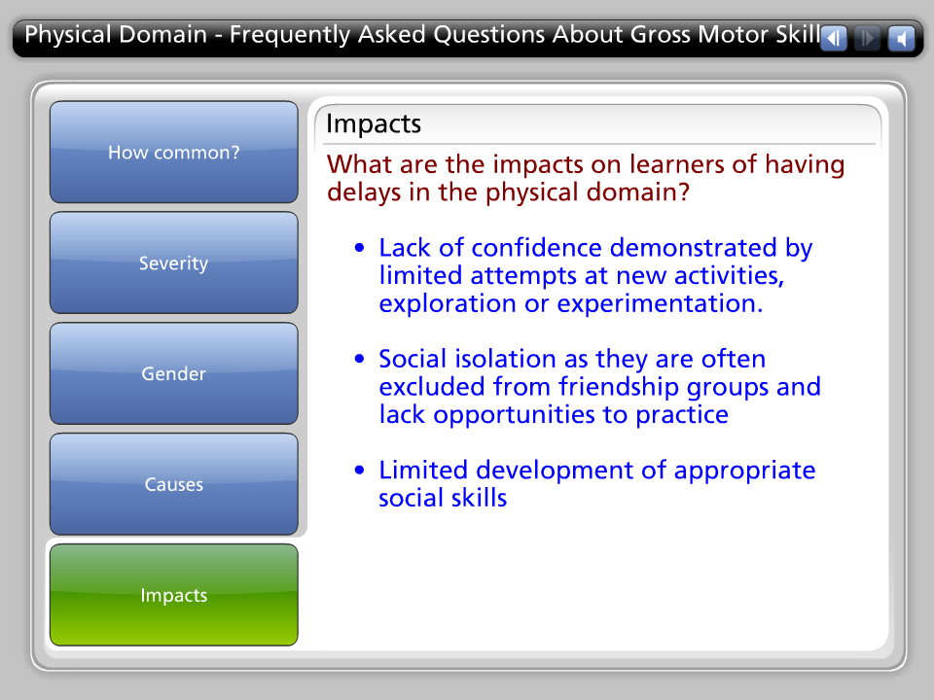

What are the impacts on learners of having delays in the physical domain?

• Lack of confidence demonstrated by limited attempts at new activities, exploration or experimentation.

• Social isolation as they are often excluded from friendship groups and lack opportunities to practice

• Limited development of appropriate social skills

