Critical review of the Dihydrogen Monoxide site
Initially, this website appears to be a valid source of information.
Its layout and presentation is readable, of reasonable quality and easy to navigate.
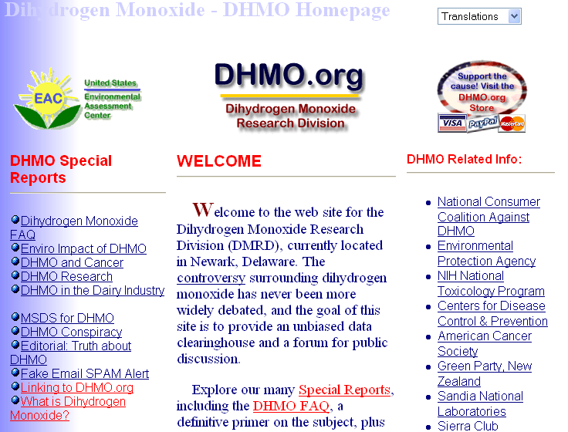
Your review of the site may be similar to this:
- Who owns or operates the website?
  - Is it an organisation or an individual?
The site does not say who owns it. It avoids the issue and infers it is a scientific group.
- What type of organisation operates the website?
No clear indication given.
2. When was the website constructed or renewed?
- Is it up to date?
Yes – it appears so.
- Does it provide details of when it was last checked?
No
3. Who has written or provided the information?
- Is it an organisation or an individual?
It does not provide clear and specific information.
- Is the author known widely for their skill or knowledge in this field?
No – a web search of the site’s name and inferred organisation identified several areas of concern. A search of the term Dihydrogen Monoxide on the Internet provides many sites that refute the www.dymo.org site and list it as a hoax.
Check the Urban Legends site for the story of this hoax.
4. Are the purposes of the website clear?
- Does the site do what it says it does?
No – it appears to warn about a chemical, but does not explicitly describe the chemical, uses its common name, etc.
- Is the information biased in any way?
A range of biased approaches are evident – the chemical is always referred to in a negative manner.
- Does the website promote one way of thinking about a topic?
Yes
- Does it provide a balanced opinion?
No
5. Can the information be checked for accuracy and currency?
- Has anyone else said the same things elsewhere?
See Section Three
- Are there other sites that provide similar information?
See Section Three
- If information is new, have they provided reasons or evidence to support their statements?
- Does the site direct you to other websites that may support their information?
See Section Three
6. Other Issues
Although first impressions are that the site may be reliable and authoritative, critical reading of the site should raise some questions. One area of the site that should raise concerns is the link associated with the graphic:

This link takes you to a series of nonsensical questions: ‘Need a zero-volume bottle?’, ‘Searching for a one-sided surface?’ and ‘Want the ultimate in non-orientability?’
The site is cleverly constructed and a perception of reliability is provided by the use of hyperlinks to reputable organisations. However, many of the site’s internal links simply present facts taken out of context and do not really explain what Dihydrogen Monoxide is. Rather it uses emotive terms to build up a prejudicial case against an unknown item.
The disclaimer at the bottom of the page should also give warning: Note: content veracity not implied. Check the meaning of veracity.
The term Dihydrogen Monoxide can be decoded using the chemical equation process (i.e. 2 atoms of hydrogen to one atom of oxygen) to H₂O or water!
This is a hoax site set up to confuse people.

