Critical review of the World Trade Organization site
The layout of this site is not as professional as you would expect for a top-level international organisation that works with the majority of world’s nations.
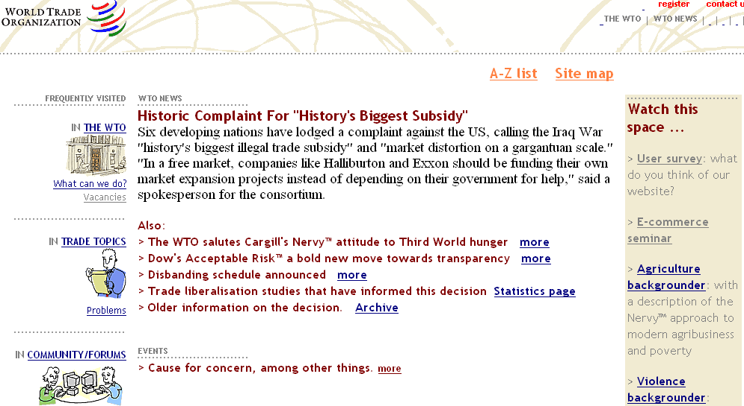
- Who owns or operates the website?
- Is it an organisation or an individual?
The site indicates it is an organisation but it does not provide contact details or a physical address.
- What type of organisation operates the website?
No clear indication given.
2. When was the website constructed or renewed?
- Is it up to date?
No – it seems to be some time since it was updated.
The stories contained in this site are satirical in nature and do not reflect current news trends. The lead story is an excellent example of this.
- Does it provide details of when it was last checked?
No
3. Who has written or provided the information?
- Is it an organisation or an individual?
It does not provide clear and specific information about the authors. It calls itself the World Trade Organisation yet this organisation has a different web URL, i.e. http://www.gatt.org.au
- Is the author known widely for their skill or knowledge in this field?
No – a web search of the site’s name and inferred organisation identified several areas of concern. This appears to be a website that is attacking the World Trade Organization. A web search finds that this site is not official for the WTO that deals in international trade and the world’s economy.
4. Are the purposes of the website clear?
- Does the site do what it says it does?
No – it appears to have a range of articles attacking prominent people, especially those involved in trade.
- Is the information biased in any way?
A range of biased approaches are evident – the use of emotive language is evident.
- Does the website promote one way of thinking about a topic?
Yes. The stories all appear to be providing a bias against the World Trade Organization.
- Does it provide a balanced opinion?
No
5. Can the information be checked for accuracy and currency?
- Has anyone else said the same things elsewhere?
Not under the same heading of World Trade Organization. There are some sites that are critical but not in such a covert way as this site.
- Are there other sites that provide similar information?
Limited
- If information is new, have they provided reasons or evidence to support their statements?
No – information is quite old.
- Does the site direct you to other websites that may support their information?
No. The site’s copyright notice does not provide any information, but directs the user to the United States of America’s Copyright Office site. Many of the site’s hyperlinks go to the www.gatt.org/homewto.html page where further more biased articles are located. The last article clearly outlines its opposition to World Trade Organization and provides a set of links to ‘underground’ organisations that are active in opposing the world body.
A web search could not find any other sites verifying the site’s value.
6. Other Issues
The layout and graphics are adequate, but not what would be expected of a professional production.
The site cannot be relied upon to provide unbiased information or be used as a general reference site. It may be appropriate to use to seek alternative perspective.

