

Numeracy

Cluster 2

FSKNUM014 Calculate with whole numbers and familiar fractions, decimals and percentages for work

FSKNUM015 Estimate, measure and calculate routine metric measurements for work

All websites referred to in this resource were accessed and deemed appropriate at time of publication.
TEIA Ltd apologises unreservedly for any copyright infringement that may have unintentionally occurred and invites copyright owners to contact TEIA so any violation may be rectified.
© 2018 TEIA
www.teia.edu.au

Ver. 1-4

Contents

Contents 1

Introduction 3

Section 1: Assessment process deinitions 4

Section 2 - Marking guide 7
Solutions – Summative assessment 8
Part A – Task Booklet 8
Part B 18
Part C 55
Part D - A typical work day 58

Introduction
This is the marking guide for the cluster of units of competency FSKNUM014 Calculate with whole numbers and familiar fractions, decimals and percentages for work and FSKNUM015 Estimate, measure and calculate routine metric measurements for work.
As the trainer/assessor, you are in the best position to judge the full training and assessment requirements of a unit of competency. The judgments that you make in this regard should form part of your broader training and assessment strategy.
Refer to the assessment requirements of the relevant unit of competency, for details of assessment conditions.
This Marking Guide includes acceptable answers to the assessment tasks as well as a guide to assessors on the process of assessment.
Assessors should also make use of the following resources:
- Cluster Mapping - Mapping of assessment tasks to the unit requirements
- Training and Assessment Strategies: The cluster has a training and assessment strategy which outlines the assessment tools that are to be used in the assessment of that module of work. All assessors will access a copy of the Training and Assessment Strategies related to the modules which they assess from their secure on-line repository. Assessors must ensure they work within the parameters and guidelines of the Training and Assessment Strategy and identify any areas that may need improvement or updating as they become aware of them.

Assessment Process
Students must complete the tasks provided and submit each one on the due date prescribed by the assessor (if applicable).
The assessor should use the Assessment Record Tools to record the assessment decision of the summative assessment. The Record of Assessment Outcomes on the final page of this booklet should be completed by the assessor and then signed and dated by both the assessor and the student (where possible).

Assessment Attempts
Students have up to three attempts to complete assessment task satisfactorily. If after the third attempt, the student has not completed the task satisfactorily, the assessor must make alternative arrangements for assessment.

Assessment Appeals
All students have the right to appeal an assessment decision. To make an appeal about an assessment decision, students must follow the process outlined in the Student Handbook.
Section 1: Assessment process deinitions
The following definitions underpin the assessment process that students are to participate in and assessors are to follow and manage.
Assessment
Assessment means the process of collecting evidence and making judgements on whether competency has been achieved, to confirm that an individual can perform to the standard required in the workplace, as specified in a Training Package or VET accredited course.

Dimensions of Competency
To be competent, a person must show their ability to perform effectively in a broad capacity. The dimensions of competency ensure the person being assessed has the skills to perform competently in variety of different circumstances. To be competent, a person must demonstrate the following:
- Task Skills: The skills needed to perform a task at an acceptable level. They include knowledge and practical skills; these are usually described in the performance criteria.
- Task Management Skills: These are skills in organising and coordinating, which are needed to be able to work competently while managing a number of tasks or activities within a job.
- Contingency Skills: The skills needed to respond and react appropriately to unexpected problems, changes in routine and breakdowns while also performing competently.
- Job Role/Environment Skills: The skills needed to perform as expected in a set job, position, location and with others. These skills may be described in the range of variables and underpinning skills and knowledge.
- Transfer Skills: The ability to transfer skills and knowledge to new situations and contexts.
Assessors need to ensure that the range of assessment instruments developed for this unit adequately explore the dimensions of competency.

Principles of Assessment
To ensure quality outcomes, assessment should ensure:
Fairness
The individual learner’s needs are considered in the assessment process.
Where appropriate, reasonable adjustments are applied by the RTO to address the individual learner’s needs.
The RTO informs the learner about the assessment process and provides the learner with the opportunity to challenge the result of the assessment and be reassessed if necessary.
Flexibility
Assessment is flexible to the individual learner by:
- reflecting the learner’s needs;
- assessing competencies held by the learner no matter how or where they have been acquired; and
- drawing from a range of assessment methods and using those that are appropriate to the context, the unit of competency and associated assessment requirements, and the individual.
Validity
Any assessment decision of the RTO is justified, based on the evidence of performance of the individual learner. Validity requires:
- assessment against the unit/s of competency and the associated assessment requirements covers the broad range of skills and knowledge that are essential to competent performance;
- assessment of knowledge and skills is integrated with their practical application;
- assessment to be based on evidence that demonstrates that a learner could demonstrate these skills and knowledge in other similar situations; and
- judgement of competence is based on evidence of learner performance that is aligned to the unit/s of competency and associated assessment requirements.
Reliability
Evidence presented for assessment is consistently interpreted and assessment results are comparable irrespective of the assessor conducting the assessment.

Rules of Evidence
Authenticity
The assessor is assured that the evidence presented for assessment is the learner’s own work.
Currency
The assessor is assured that the assessment evidence demonstrates current competency. This requires the assessment evidence to be from the present or the very recent past.
Sufficiency
The assessor is assured that the quality, quantity and relevance of the assessment evidence enables a judgement to be made of a learner’s competency.
Validity
The assessor is assured that the learner has the skills, knowledge and attributes as described in the module or unit of competency and associated assessment requirements.

Reasonable Adjustment
This refers to adjustments that can be made to the way in which evidence of candidate performance can be collected. While reasonable adjustments can be made in terms of the way in which evidence of performance is gathered, the evidence criteria for making competent/not yet competent decisions (and/or awarding grades) should not be altered in any way, i.e. the standards expected should be the same irrespective of the group and/or individual being assessed; otherwise comparability of standards will be compromised.
Assessors are to record any reasonable adjustments made in the assessment process in the Assessment Record Tools.

Types of evidence
Types of evidence that can be collected, sighted or validated include:
- work records such as position descriptions, performance reviews, products and processes followed and/or implemented
- third-party reports from customers, managers and/or supervisors
- training records and other recognised qualifications
- skills and knowledge assessments
- volunteer work.

Gathering evidence
Evidence can be gathered through:
- real work/real-time activities through observation and third-party reports
- structured activities.
Evidence can also be gathered through:
- formative assessments: where assessment is progressive throughout the learning process and validated along the way by the trainer – also known as assessment for learning
- summative assessment: where assessment is an exercise or simulation at the end of the learning process – also known as assessment of learning.

Evaluating evidence
The following steps may help you evaluate evidence.

Step 1: Evidence is gathered.

Step 2: Rules of evidence are applied – evidence is valid, sufficient, current and authentic.

Step 3: Evidence meets the full requirements of the unit/s of competency.

Step 4: The assessment process is valid, reliable, fair and flexible.

Step 5: The trainer or assessor makes a straightforward and informed judgment about the candidate and completes assessment records.

Section 2 - Marking guide

General guidance
Assessors should review the solutions provided and adapt and/or contextualise them (and assessment activities themselves where necessary) to suit the training and assessment context as part of their moderation activities. This will ensure consistency of assessment.
The solutions to assessment activities serve as a reliable guide to the type of information that should be included in the assessment candidate’s response. Refer to the assessment activities when assessing learner responses or evaluating assessment evidence. The answers provided by the assessment candidate will vary due to a number of factors, including the:
- candidate’ s own experiences
- candidate’ s workplace experiences
- training situations and strategies presented by the trainer
- interpretation of the assessment activity by the assessment candidate/assessor
- type of organisation, work practices, processes and systems encountered by the candidate.
The nature and variety of the tasks presented means that in some cases there will be numerous correct responses, and the solutions provided cannot cater for all contexts and eventualities.
In general terms:
- For questions with a single answer, this guide provides the correct answer.
- For questions that do not have a single answer, it is understood that answers will vary within certain parameters.
- For questions where the candidate has to list a certain number of items, the RTO has provided a more comprehensive listing from which candidate responses may be drawn. This list may not in all cases be definitive, and assessors should account for other possible correct responses.
- For activities that involve responding to a case study, the RTO has provided an example of how the candidate may respond. Depending on the question, the terminology used will indicate either what the candidate should have included in their response or may have included. However, different phrasing may be used by the candidate, or different responses that may be equally correct are also possible.
- For activities that take place in the workplace or involve workplace documentation, the RTO can only provide an example response. Assessors should consider whether the candidate has achieved the intent of the activity within the candidate’s workplace context.
- For activities that involve writing reports or completing documentation provided, the RTO can only provide an example response. Assessors should again consider whether the candidate’s response is appropriate to the task within the context of the candidate’s training and/or workplace.

2.1 Solutions – Summative assessment
The following section of this booklet is to be used as a guide to marking the assessment tasks required for this cluster. Sample/benchmark answers are provided. This document also includes a guide to the assessment process. Trainers/assessors should also refer to the Mapping documentation for this unit.
This cluster is assessed in the following ways:
- Answering all questions in the Learner’s Workbook
- Completing a range of mathematical tasks
- Completing a range of measurement tasks
- Completing a project.
Students must complete all assessment tasks satisfactorily in order to achieve competency in the units in this cluster.

Part A – Task Booklet
Instructions to assessor/trainer
This task is to an open book assessment that is to be completed during class time. Students must submit this task (i.e. their workbook) prior to the end of the course.
Students are to complete all tasks and answer them correctly. If incorrect answers are provided, identify the gaps in their knowledge and understanding and work with them to arrange reassessment.
Monitor students as they complete the task and assist those who may be finding the questions difficult. Consideration of students’ LLN needs should be given – adjustments may be required in some cases, such as allowing students to answer verbally and also reading the questions to students to ensure their understanding.
Make sure there are plenty of resources available for students to refer to while working.

Task Booklet Responses
- Write down five occasions that you would use maths and numbers in your day-to-day activities.
- Student is to provide five responses, which are deemed suitable by the trainer/assessor. Examples are provided below:
- Counting money
- Calculating time
- Calculating distance
- How many items you need to do something
- Taking measurements
- Working out area, volume, perimeter
- Cooking food (i.e. following recipes)
- Paying bills
- Counting items
- Temperature
- Driving (speedometer, speed limits, purchasing petrol)
- Public transport timetables
- Using calendars.

- In the passage below use the highlighter tool to mark all the references to maths and using numbers.
It is important to have maths skills at work – depending on the job you choose, maths may be a main part of the work you do. For example, people who work in the construction industry need to know math so they can take measurements, add up how many supplies they will need to do a job, mix materials like concrete, mortar and so on. Other workplaces may need you to order items, give change to customers, work out budgets and so on.

- Select a job you would like to do. Think about how a person working in this job would use maths in their daily work activities. List the person’s job and then provide four examples of maths and using numbers are involved in that work.
- Student provides three responses, which may include three of those below or others as deemed suitable by the trainer/assessor:
- A builder measuring construction items
- A builder working out area and volume
- An administration person putting calculations into an Excel spreadsheet
- An accountant using a calculator or spreadsheet
- A student or other worker using a timetable/schedule/timesheet, amount of time spent on a job
- A retail worker counting out change
- A retail worker working out the cost of a sale
- A worker calculating GST on an item

- Place the right operation symbol in each number sentence to solve the maths problems below:

6 X 7 = 42 85 - 15 = 70
10 ÷ 5 = 2 14 X 2 = 28
108 + 31 = 139 274 - 10 = 264

- Work out each of these math problems using the correct order of operations. You do not need to show working this activity:

7 × ( 7 + 2 ) = 8 2 + 2 × 7 = 16
( 2 + 6 ) × 8 = 64 95 - ( 2 × 8 ) = 79
70 - ( 2 × 6 ) = 58 4 × ( 6 + 2 ) = 32
4 × ( 3 + 1 ) = 16 ( 9 - 1 ) × 7 = 56

- Complete the questions below.
  - For the number 1045, what value does the 4 stand for? Four tens or forty
  - For the number 1,352,207 what value does the 1 stand for? One million
  - Write down the number for ‘ten thousand, three hundred and forty-two’. 10,342
  - Highlight the number that has a five in the hundred-thousand place.
800,692
30,567
9,564,123
e. Highlight the number that has an 9 in the ten-thousand place.
386
71,672
298,971

- Round off the following figures.
To two decimal places
155.6579 | 155.66
30.149 | 30.15
9.6412 | 9.64

To three decimal places
930.09314 | 930.093
2.6736 | 2.674
0.0056 | 0.006

To the nearest 1000
7505 | 8000
3546 | 4000
1205 | 1000

To the nearest 100
95 | 100
320 | 300
455 | 500
To the nearest 10
83 | 80
14 | 10
59 | 60
To the nearest 1
765.90 | 766
8.4 | 8
10.75 | 11

- Work out the equivalent fractions in these sequences:
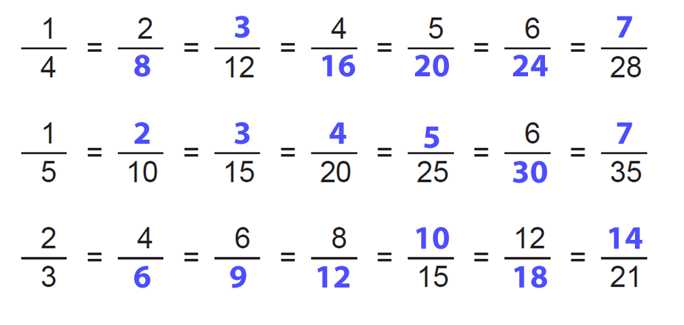

- Convert each improper fraction to mixed number or whole number.
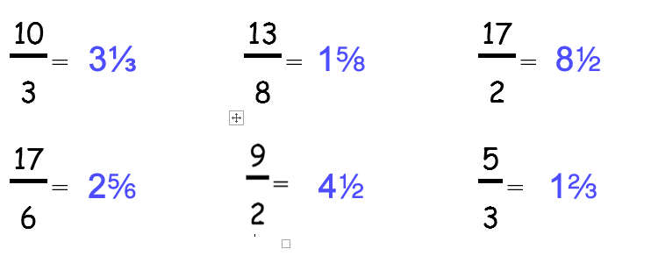

Convert each mixed number to improper fraction.
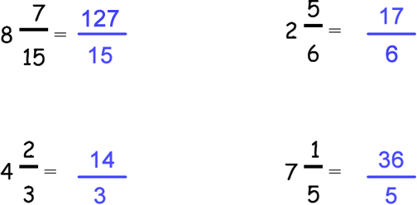

- Complete the following problems. Show all of your working.
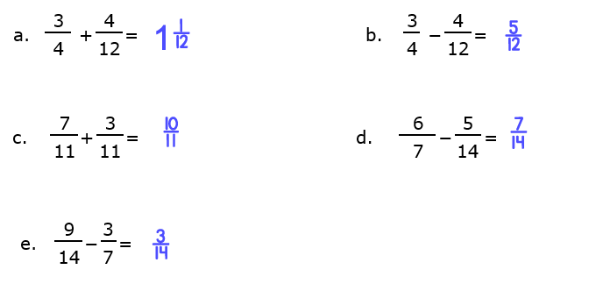
- Find the answers to the following:
a) six metres equals | 600 cm
b) a quarter of a metre equals | 25 cm
c) seven thousand grams equals | 7 kg
d) four and a half centimetres equals | 45 mm
e) two thousand millilitres equals | 2 m
f) half a centimetre equals | 5 mm
g) four kilolitres equals | 4000 L
h) two thousand, five hundred centimetres equals | 25,000 mm
- one and a half litres equals | 1500 mL

- Estimate the capacity of each object. Tick which answer is most correct.
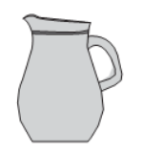  20 L  1 L 200 mL |   3 L 30 mL  300 mL
  3 L 30 mL  300 mL |   50 mL  500 mL 5 L
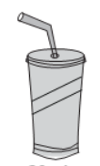   200 mL 20 mL 2 L | 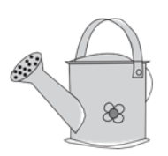  300mL 30 L  3 L
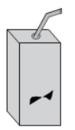   250mL 25L 2.5 mL |   10 L 10 mL  100 mL

- Write the reading shown by each graduated cylinder.
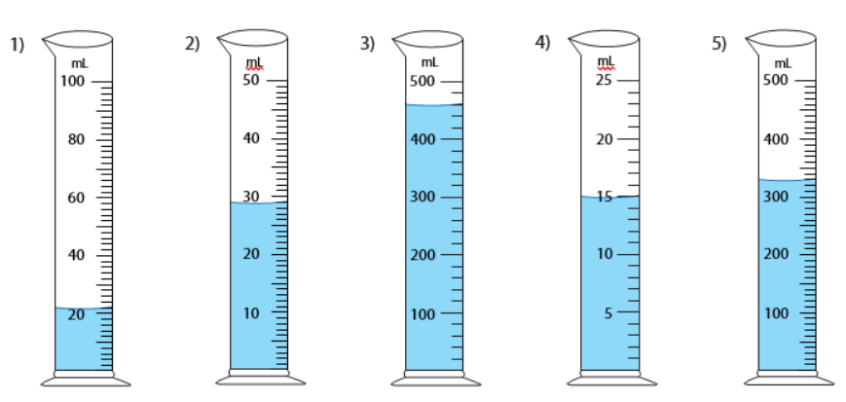
22 mL | 29 mL | 460 mL | 15 mL | 330 mL

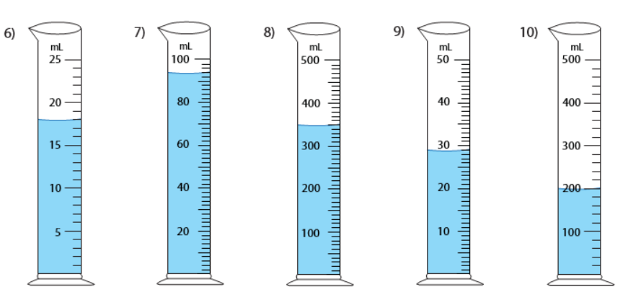
18 mL |  | 94 mL | 350 mL |  |  | 29 mL |  | 200 mL

- Record the weight of each item.
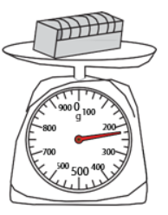  225 g | 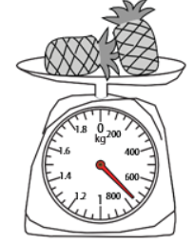  0.65 kg | 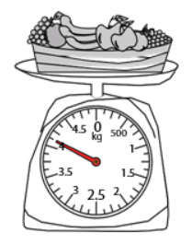  4.125 kg
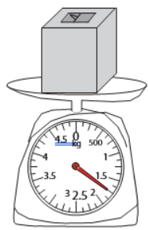  1.75 kg | 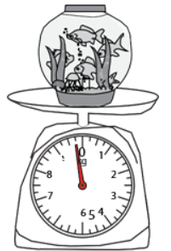  9.75 kg | 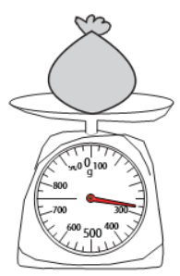  0.275 kg
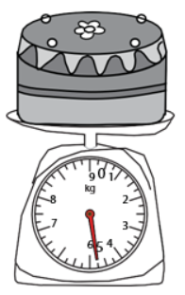  4.75 kg | 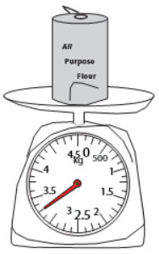  3.25 kg | 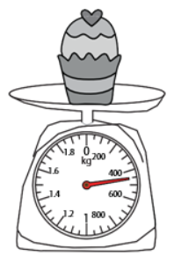  0.45 kg

- Write the measurement shown by the pointer in each problem.
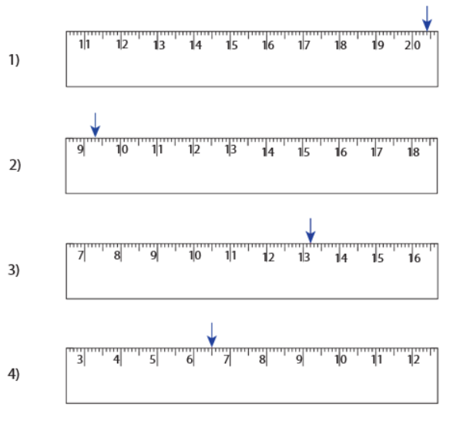 | 20 cm 4 mm
 | 9 cm 3 mm
 | 13 cm 2 mm
 | 6 cm 5 mm

- Draw the pointer to show the measurement in each problem.
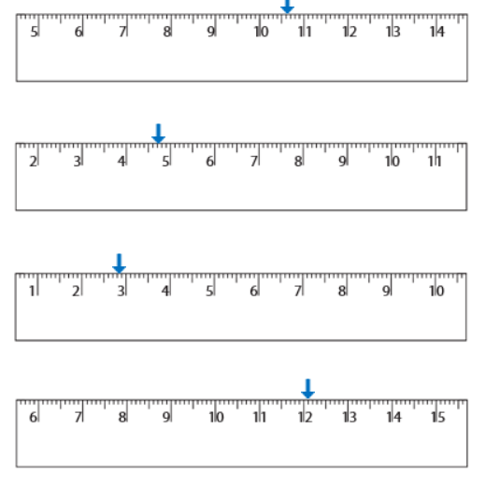

- Answer the following questions. Use the correct unit of measurement each time.
A piece of wood is 900 millimetres long. How many centimetres is it? | 90 cm
What is 55 centimetres converted to metres? | 0.55 m
You have walked 1.25 kilometres. How many metres have you walked? | 1,250 m
Your goal was to cycle 2.0 kilometres. You ended up cycling for 2.4 kilometres. How many metres over your goal did you go? | 400 m
You have to measure out half a litre. How many millimetres do you need to measure? | 500 mL

- Find the perimeter of each rectangle.
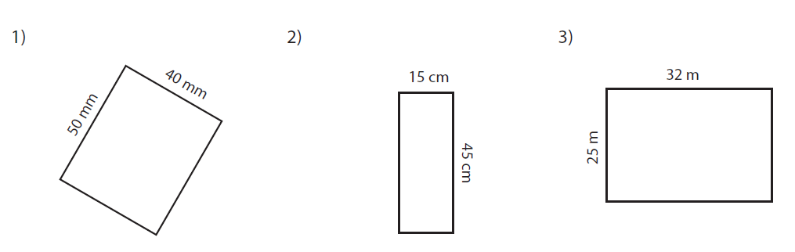
Perimeter = 180 mm | Perimeter = 120 cm | Perimeter = 114 m
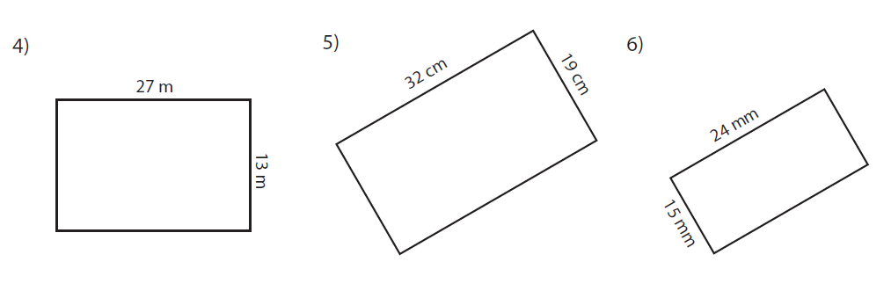
Perimeter = 80 m | Perimeter = 102 cm | Perimeter = 78 mm
- Find the area of each rectangle.
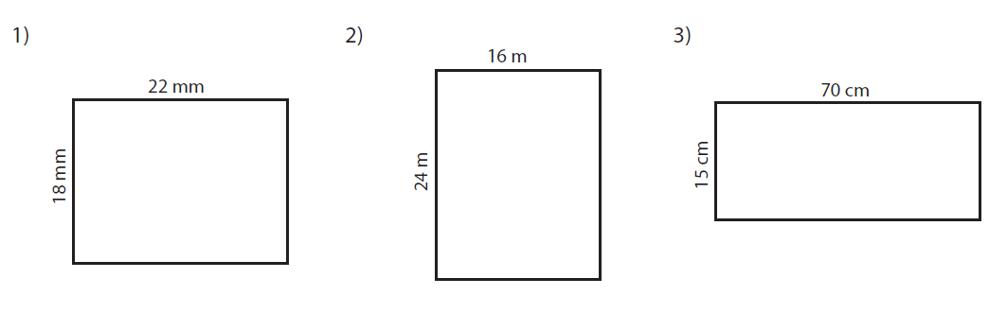
Area = 396 mm² | Area = 384 m² | Area = 1,050 cm²
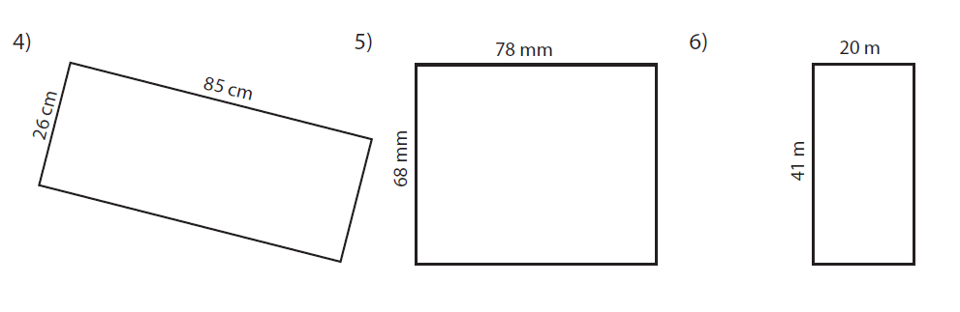
Area = 2,210 cm² | Area = 5,304 mm² | Area = 820 m²

Part B

Instructions to the trainer/assessor
This task is an open book assessment that can be completed under supervision if required. Students must submit this task prior to the final class.
Students are to complete all questions below and answer them correctly. If incorrect answers are provided, identify the gaps in their knowledge and understanding and work with them to make arrangements for reassessment.
You are able to provide assistance to those students who may be finding the questions difficult. Consideration of students’ LLN needs should be given – adjustments may be required in some cases, such as allowing students to answer verbally and reading the questions to students to ensure their understanding.
- What are whole numbers? Whole numbers are 0, 1, 2, 3, 4, 5, 6, 7, 8, 9
- What are fractions? Provide three examples. Fractions are a part of a whole. Sample answers below…
Example 1 | Example 2 | Example 3
¼ | ½ | 0.3
- What are decimals? Provide three examples.
A decimal is a different way of displaying fractions. A decimal consists of two parts, the integer and the fractional part. The fractional part is after the decimal point. The decimal point is in between the unit and the tenths. Examples may include 0.025, 0.5, 0.75, 1.5, 2.0, etc.

- What are percentages? Provide three examples.
A percentage is a number expressed as a fraction of 100. It has percent sign % at the end. Examples include 10%, 25%, 50%, 75% etc.
- What are the four common mathematical operators?
The four common mathematical operations are: addition, subtraction, multiplication and division.
- Complete the following problems.
35 × 7 | 245 | 55 ÷ 5 | 11
3 + 10 + 18 + 23 | 54 | 104 – 10 – 56 | 38
56 ÷ 7 | 8 | 6 × 6 | 36
213 – 15 | 198 | 17 + 9 + 32 | 58
220 × 3 | 660 | 144 ÷ 12 | 12
- What is meant by the order of operations? What is the rule when completing problems that have multiple operations?
Order of operations refers to the way in which you solve a mathematical problem that contains multiple operations. The rule is BODMAS – brackets of division, multiplication, addition and subtraction. The problem is solved from left to right.

- When do you use brackets when solving a problem?
The part that needs to be solved first is placed in the brackets showing it is required to be done before any other operations.
- Use the order of operations to complete the following problems. Show your workings where you need to use BODMAS.
33 + 20 ÷ 5 | 33 + (20 ÷ 5)  20 ÷ 5 = 4  33 + 4 = 37
10 × 3 – 6 + 30 | 30 – 6 + 30 = 54
45 ÷ 5 + 81 | 9 + 81 = 90
20 – 13 + 45 | 52
6 × 6 + 20 + 14 – 11 | 59
55 – 17 × 3 | 55 – (17 × 3)  17 × 3 = 51  55 – 51 = 4
- Show your knowledge of place value by completing the following:
Write down the number:
Three thousands, seven hundreds and two ones | 3702
Fourteen thousands, two hundreds | 14,200
Eight tens and 7 ones | 87
Five hundreds and one ten | 510
Three ones | 3
- Fill out the place value table by putting in the correct headings for each place value and the number written in words below.
Four million, three hundred and sixty six thousand, two hundred thirty seven.
Millions | Hundred thousands | Ten thousands | Thousands | Hundreds | Tens | Ones
4 | 3 | 6 | 6 | 2 | 3 | 7
- Fill out the place value table by putting the zero in the correct spot.
Twenty-seven million, six hundred and twenty seven thousand and fourteen.
Millions | Hundred thousands | Ten thousands | Thousands | Hundreds | Tens | Ones
 |  |  |  | 0
- How does zero affect the number 25.0?
It does not affect it. The zero is in the decimal position of tenths indicating no value.
- Fill out the table below to show how fractions, percentages and decimals can be converted to each other.
Percentages to decimals
60% | 0.6 | 35% | 0.35

Percentages to fractions
27% | 27/100 | 36% | 36/100 = 9/25

Fractions to percentages
4 | 25% | t | 80%

Fractions to decimals
r | 0.6 | w | 0.75

Decimals to percentages
0.32 | 32% | 0.086 | 8.6%
Decimals to fractions
0.75 | w | 0.25 | 4
- Round these numbers to two decimal places.
90.8643 | 90.86 | 335.419 | 335.42
20.2525 | 20.25 | 100.0749873 | 100.07
- Round 45.597 to the nearest:
One hundred | 100 | Ten | 50
One | 46
- Complete the following calculations with fractions. Simplify them where necessary.

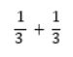 | q
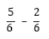 | Q = A
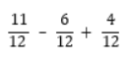 | T = H
- Complete the following calculations with decimals.
0.25 + 0.75 | 1.00 | 1.5 × 2.0 | 3.0
1.3 – 0.25 | 1.05 | 6 + 0.75 – 1.25 | 5.5

- Complete the following calculations with percentages.
20% + 35% | 55%
65% – 25% | 40%
An item is on sale – it has 10% off. The retail price is $34.00. How much will you save if you buy this product?
$3.40
An item is on sale – it has 25% off. The retail price is $180.00. How much will you save if you buy this product?
$45
- Fill out the order form below using the information provided. Put your own details at the top of the form.
First name: | Student’s first name
Last name: | Student’s last name
Address: | Student’s address
Phone: | Student’s phone number |  |  | Date:
Item |  | Qty | Cost ex GST ($) | GST ($) |  | Total items inc GST ($)
Pkt of ball point pens, red/black/blue |  | 1 | 3.97 | .40 |  | 4.37
Document tray |  | 1 | 8.50 | .85 |  | 9.35
Manilla folders |  | 1 | 17.83 | 1.78 |  | 19.61
Box of staples |  | 1 | 8.07 | .81 |  | 8.88
Stapler |  | 1 | 5.32 | .53 |  | 5.85
40cm ruler |  | 1 | 1.03 | .10 |  | 1.13
Total GST: |  |  |  | 4.47
Total order: |  |  |  |  |  | 49.19

- Write down what each item below is called.
+ | Plus/addition
× | Multiplication/times
1, 2, 3, 4, 5, 6, 7, 8, 9 | Whole number
50% | Percentage
= | Equals
– | Minus/subtraction
÷ | Division/divide
.056 | Decimal
¾ | Fraction
$ | Dollar/dollar sign

Part C
In this part of the assessment you will be given a variety of short activities to complete to demonstrate your understanding of what you have learned about measurements.
Complete the following questions.
- For each activity listed below, write down the type of measuring equipment you would use.
Measuring out cough medicine | Measuring cup/medicine cup
Putting 200 ml of water into a mixing bowl | Measuring jug
Adding 250 grams of flour to a mixing bowl | Weighing scales (kitchen scales)
Checking your weight | Weighing scales (bathroom/personal weighing scales)
Checking your speed while driving | Speedometer
Checking how far you have travelled | Odometer
Drawing a square that is 5cm by 5cm | Ruler
Measuring your waist | Tape measure (dressmaking tape measure)
Measuring a 3 metre length of wood to cut it to 2.5 metres | Tape measure (builder’s tape measure)
- Robert is a landscaper and works with plants. He has a flower bed that is 10 metres long. He has 9 rose bushes. He wants to plant them an equal distance apart.
Each vertical (upright) line on the picture below indicates where a plant will be placed.
How far apart should Robert plant each rose bush? Use the correct unit of measurement in your answer.
Robert should plant them 1 metre apart.
- Write down the time on each clock below as you would see it on a digital clock.
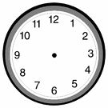
7.45 | 5.00 | 11.30 | 2.15
- Draw the hands on the analogue clock to make the right time.
10.25 | 1.40 | 9.50 | 6.05
- Lee needs to buy some wood to build a decking in his backyard. The wood he wants comes in 3.0 metre lengths. He tries to fit one piece of decking into his car and finds he can only fit 1.8 metres in. How much decking is hanging out the back of the car? Use the correct unit of measurement in your answer.
1.2 metres

- Here is a basic drawing of Lee’s decking:
6 metres long
2 metres wide
How many millimetres wide is the decking?
2000 millimetres
Have a look at the drawing above. How many times longer is the decking than it is wider?
It is 3 times longer than it is wide.
Lee decides he wants to add an extra 1200mm in length to the decking. How long will the deck now be in metres?
7.2 metres
- What does each of the following mean?
m | Metre | mm |  | Millimetre
kg | Kilogram | mL |  | Millilitre
4:00 | Digital time
- Gina is cooking dinner for her guests. She is cooking three different things, but each one requires a different amount of butter. She has a stick of butter in her fridge. Gina needs the following for each dish:
- Dish 1: 30 grams of butter
- Dish 2: 120 grams of butter
- Dish 3: 60 grams of butter
How much butter will Gina need to cut from the stick? Use the correct unit of measurement.
210 grams
- Gina needs to measure out 1 litre of milk. She only has a 250 litre measuring jug. How many times will she need to fill the jug before she gets 1 litre of milk?
4 times
- What do the following prefixes mean:
- Milli- means a factor of one thousandth
- Centi- means a factor of one hundredth
- Kilo- means multiplication by one thousand
- What one common word can you add to the end of each of these prefixes to make words that measure length?
Metre – millimetre, centimetre, kilometre.

Part D - A typical work day
The following activity will show you how regularly maths and measurements are used in a day.
Scenario:
It is Sunday. Angelo Brunetti remembers he needs to set his alarm for the next morning.
Angelo has to get to work at 8.30 am so he can prepare for a meeting that starts at 10.30 am. He drives 25 kms to work. This generally takes him 45 mins in peak hour traffic.
What is the latest time that Angelo needs to leave home, so he can get to work at 8.30am? Draw the time on the clock below.
Angelo likes to get 8.0 hours sleep each night. He wants to wake up no later than 6.30 am on Monday morning.
What time does he need to go to sleep? Draw the time on the clock.
Look at the time that Angelo will wake up. Now look at the time that Angelo will leave for work. How much time has Angelo given himself to get ready on Monday morning?
1 hour and 15 mins
Angelo gets to work and finds out he needs to print 5 different documents for each person that is attending the meeting. There are 8 people attending the meeting, including Angelo.
How many documents does Angelo have to print?
40 documents

Angelo wants to make sure he has enough paper in the printer before he goes off to order some lunch for everyone attending the meeting. The table below shows how many pages each document in Microsoft Word is (i.e. single sided).
Angelo will be printing the documents double sided to save paper.
Each person will get a set of 5 documents.
How much paper (i.e. how many sheets) does Angelo need to put into the printer?
400 sheets – documents total 100 pages single sided = 50 pages double sided
There 8 people attending the meeting, each person gets 5 documents = 400 pages required.
Angelo has a $200 budget for lunch.
How much per person can he afford to spend on lunch?
$25
Angelo has worked out a deal with the café downstairs. They will charge him one price for sandwiches and one price for soft drinks. Coffee and tea will also be charged at the same cost. There are also cakes and biscuits provided for the afternoon – each person will get the choice of two cakes or biscuits. All cakes and biscuits cost the same price.
Prices are as follows (assume all prices include GST):
Sandwiches | $7.00 each
Soft drinks | $3.50 each
Tea and coffee | $3.50 each
Cakes and biscuits | $3.20 each
How much will food cost for each person?
$20.40
Look at Angelo’s budget. How much money per person will Angelo save?
$4.60
How much money will Angelo save overall, based on his $200 budget?
$36.80
Angelo needs to quickly set up a basic outline for those coming to the meeting.
Listed below is the information he needs. Create the outline for him using the template below. (Use today’s date.)
- The meeting will start at 10.30 and it will finish at 3.00 pm.
- Item 1 is the welcome and introductions part of the meeting. It will go for 20 minutes.
- Item 2 is the review and discussion of Document 1 and 2. It will go for 1 hour and 10 minutes.
- Item 3 is lunch. Lunch will take 1 hour.
- Item 4 is the review and discussion of Documents 3 and 4. This will take 45 minutes.
- Item 5 is the review and discussion of Document 5. This will take 30 minutes.
- Item 6 is a general discussion in which people can put forth suggestions/comments/ recommendations.
- Item 7 is the wrap up/end of the meeting.
Add the correct timeframes (ie 12.30pm–12.45pm) to the Time column. Put appropriate descriptions in the ‘Description’ column.
Topic: | Review of marketing materials
Date: | Insert appropriate date
Times: | 10.30–3.00pm
Chair: | Angelo Brunetti
Item | Time | Description
1 | 10.30am–10.50am | Welcome and introductions
2 | 10.50am–12.00pm | Discussion and review of Documents 1 and 2
3 | 12.00pm–1.00pm | Lunch
4 | 1.00–1.45pm | Discussion and review of Documents 3 and 4
5 | 1.45–2.15 | Discussion and review of Document 5
6 | 2.15–2.45 | Further comments, suggestions etc
7 | 2.45pm–3.00pm | Wrap up, end meeting
After the meeting Angelo goes back to his computer and finds that he has 30 emails. At a glance he decides that 40% of those emails are junk emails and can be deleted.
How many emails will Angelo delete?
12 emails

Angelo gets a call from the finance department. He filled out a petty cash form the week before and forgot to calculate GST on the items.
Complete the table below to show the GST amounts for each item, and then calculate the total cost for each item.

Cost (ex GST) | GST | Total
$11.50 | $1.15 | $12.65
$7.60 | $0.76 | $8.36
$5.00 | $0.50 | $5.50
$2.40 | $0.24 | $2.64

Joan, Angelo’s office mate, asks him to help her measure their office because they are getting new furniture soon.
The room is 3.5 metres wide and 6 metres long.
What is the area of the room?
21m²
How many millimetres wide is the room?
3500 mm
How many millimetres long is the room?
6000 mm

Angelo looks through his feedback sheets and finds that around three quarters of his meeting attendees found the meeting useful.
In percentage form, how any found the meeting useful (i.e. convert the fraction to a percentage)?
Approximately 75% found it useful.
Angelo’s girlfriend calls to tell him she has made dinner plans with friends that night. The restaurant is just around the corner from where they live. Angelo needs to be there at 6.30. What is the latest time he will need to leave work, assuming evening traffic is roughly the same as morning traffic?
5.45pm at the latest.

