Task Booklet



Numeracy Module

FSKNUM14 - Calculate with whole numbers and familiar fractions, decimals and percentages for work

FSKNUM15 - Estimate, measure and calculate with routine metric measurements for work.

## Instructions

These tasks are to be completed in one of two ways:

**Method One**

Using a word processing software (e.g. Microsoft Word) and creating a digital booklet with your responses to each tsk. Ensure you use correct spelling, punctuation and grammar.

Always check that you have saved your work before editing. It is a good idea to save as a different version each time you complete a task as this way you are unlikely to lose work already completed.

To save as a different version simply add a version number at the end of the file’s name, i.e. Numeracy Booklet 1-0, next time it would be Numeracy Booklet 1-1.

*or*

**Method Two**

Print out the Task Booklet, complete it in your handwriting ensuring your writing is neat and legible. When all tasks are completed, scan the whole booklet into a PDF file.

Regardless of which method you choose, when you have completed all tasks, you need to email the booklet to your trainer/assessor.

## Task 1

Write down five occasions that you would use maths and numbers in your day-to-day activities.



## Task 2

In the passage below use the highlighter tool to mark all the references to maths and using numbers.

It is important to have maths skills at work – depending on the job you choose, maths may be a main part of the work you do. For example, people who work in the construction industry need to know math so they can take measurements, add up how many supplies they will need to do a job, mix materials like concrete, mortar and so on. Other workplaces may need you to order items, give change to customers, work out budgets and so on.

## Task 3

Select a job you would like to do. Think about how a person working in this job would use maths in their daily work activities. List the person’s job and then provide four examples of maths and using numbers are involved in that work.

Job:

Examples of how math is used in that job:



## Task 4

Place the right operation symbol in each number sentence to solve the maths problems below:

6       7 = 42 85       15 = 70

10       5 = 2 14       2 = 28

108       31 = 139 274       10 = 264

## Task 5

Work out each of these math problems using the correct order of operations. You do not need to show working this activity:

7 × ( 7 + 2 ) =       2 + 2 × 7 =

( 2 + 6 ) × 8 =       95 - ( 2 × 8 ) =

70 - ( 2 × 6 ) =       4 × ( 6 + 2 ) =

4 × ( 3 + 1 ) =       ( 9 - 1 ) × 7 =

## Task 6

Complete the questions below.

1. For the number 1045, what value does the 4 stand for?
2. For the number 1,352,207 what value does the 1 stand for?
3. Write down the number for ‘ten thousand, three hundred and forty-two’.

1. Highlight the number that has a five in the hundred-thousand place.

800,692

30,567

9,564,123

1. Highlight the number that has an 9 in the ten-thousand place.

386

71,672

298,971

## Task 7

Round off the following figures.

|  |  |
| --- | --- |
| **To two decimal places** | |
| 155.6579 |  |
| 30.149 |  |
| 9.6412 |  |

|  |  |
| --- | --- |
| **To three decimal places** | |
| 930.09314 |  |
| 2.6736 |  |
| 0.0056 |  |

|  |  |
| --- | --- |
| **To the nearest 1000** | |
| 7505 |  |
| 3546 |  |
| 1205 |  |

|  |  |
| --- | --- |
| **To the nearest 100** | |
| 95 |  |
| 320 |  |
| 455 |  |
| **To the nearest 10** | |
| 83 |  |
| 14 |  |
| 59 |  |
| **To the nearest 1** | |
| 765.90 |  |
| 8.4 |  |
| 10.75 |  |

## Task 8

Work out the equivalent fractions in these sequences:

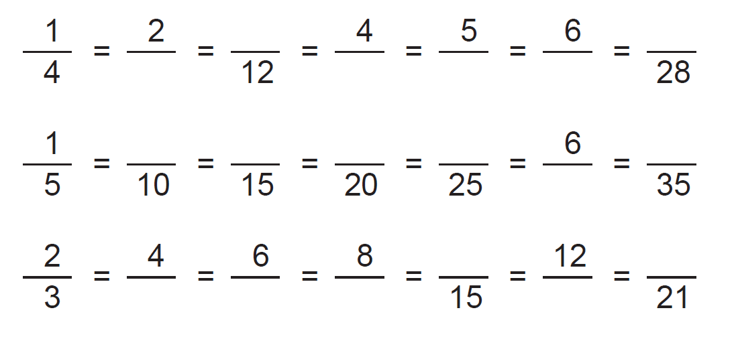

## Task 9

|  |
| --- |
| Convert each improper fraction to mixed number or whole number. |

|  |  |  |  |  |  |  |  |  |  |  |  |  |  |  |
| --- | --- | --- | --- | --- | --- | --- | --- | --- | --- | --- | --- | --- | --- | --- |
| |  |  |  |  | | --- | --- | --- | --- | | |  | | --- | | 10 | | 3 | | = | | |  |  |  |  | | --- | --- | --- | --- | | |  | | --- | | 13 | | 8 | | = | | |  |  |  |  | | --- | --- | --- | --- | | |  | | --- | | 17 | | 2 | | = | |
| |  |  |  |  | | --- | --- | --- | --- | | |  | | --- | | 17 | | 6 | | = | | |  |  |  |  | | --- | --- | --- | --- | | |  | | --- | | 9 | | 2 | | = | | |  |  |  |  | | --- | --- | --- | --- | | |  | | --- | | 5 | | 3 | | = | |

Convert each mixed number to improper fraction.

|  |  |  |  |  |  |  |  |  |  |  |  |  |  |  |  |  |  |  |  |  |
| --- | --- | --- | --- | --- | --- | --- | --- | --- | --- | --- | --- | --- | --- | --- | --- | --- | --- | --- | --- | --- |
| |  |  |  |  |  |  |  |  | | --- | --- | --- | --- | --- | --- | --- | --- | |  | |  |  |  |  |  | | --- | --- | --- | --- | --- | | |  | | --- | | 8 | | |  | | --- | | 7 | | 15 | | | = | | |  |  |  |  |  |  |  |  | | --- | --- | --- | --- | --- | --- | --- | --- | |  | |  |  |  |  |  | | --- | --- | --- | --- | --- | | |  | | --- | | 2 | | |  | | --- | | 5 | | 6 | | | = | |  |  |  | |
| |  |  |  |  |  |  |  |  | | --- | --- | --- | --- | --- | --- | --- | --- | |  | |  |  |  |  |  | | --- | --- | --- | --- | --- | | |  | | --- | | 4 | | |  | | --- | | 2 | | 3 | | | = | | |  |  |  |  |  |  |  |  | | --- | --- | --- | --- | --- | --- | --- | --- | |  | |  |  |  |  |  | | --- | --- | --- | --- | --- | | |  | | --- | | 7 | | |  | | --- | | 1 | | 5 | | | = | |

## Task 10

|  |
| --- |
| Complete the following problems. Show your working. |

|  |  |  |  |  |  |  |  |  |  |  |  |  |  |  |  |  |  |  |  |
| --- | --- | --- | --- | --- | --- | --- | --- | --- | --- | --- | --- | --- | --- | --- | --- | --- | --- | --- | --- |
| |  |  |  |  |  |  |  |  |  | | --- | --- | --- | --- | --- | --- | --- | --- | --- | | a. | |  |  |  |  | | --- | --- | --- | --- | | 3 | + | 4 | = | | 4 | 12 |  | | | |  |  |  |  |  |  |  |  |  | | --- | --- | --- | --- | --- | --- | --- | --- | --- | | b. | |  |  |  |  | | --- | --- | --- | --- | | 3 | − | 4 | = | | 4 | 12 |  | | |
| |  |  |  |  |  |  |  |  |  | | --- | --- | --- | --- | --- | --- | --- | --- | --- | | c. | |  |  |  |  | | --- | --- | --- | --- | | 7 | + | 3 | = | | 11 | 11 |  | | | |  |  |  |  |  |  |  |  |  | | --- | --- | --- | --- | --- | --- | --- | --- | --- | | d. | |  |  |  |  | | --- | --- | --- | --- | | 6 | − | 5 | = | | 7 | 14 |  | | |

|  |  |  |  |  |  |  |  |  |  |  |  |  |
| --- | --- | --- | --- | --- | --- | --- | --- | --- | --- | --- | --- | --- |
| |  |  |  |  |  |  |  |  |  | | --- | --- | --- | --- | --- | --- | --- | --- | --- | | e. | |  |  |  |  | | --- | --- | --- | --- | | 9 | − | 3 | = | | 14 | 7 |  | | | |  |  | | --- | --- | |  |  | |

## Task 11

Find the answers to the following:

|  |  |
| --- | --- |
| **a)** six metres equals | cm |
| **b)** a quarter of a metre equals | cm |
| **c)** seven thousand grams equals | kg |
| **d)** four and a half centimetres equals | mm |
| **e)** two thousand millilitres equals | m |
| **f)** half a centimetre equals | mm |
| **g)** four kilolitres equals | L |
| **h)** two thousand, five hundred centimetres equals | mm |
| **i)** one and a half litres equals | mL |

## Task 12

Estimate the capacity of each object. Tick which answer is most correct.

|  |  |
| --- | --- |
| 20 L  1 L  200 mL | 3 L  30 mL  300 mL |
| 3 L  30 mL  300 mL | 50 mL  500 mL  5 L |
| 200 mL  20 mL  2 L | 300mL  30 L  3 L |
| 250mL  25L  2.5 mL | 10 L  10 mL  100 mL |

## Task 13

Write the reading shown by each graduated cylinder.

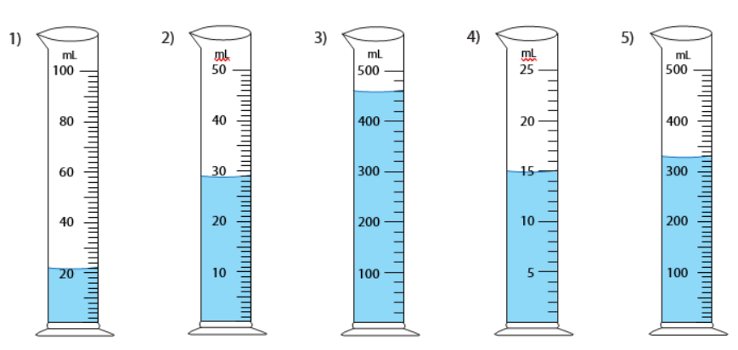

|  |  |  |  |  |
| --- | --- | --- | --- | --- |
| mL | mL | mL | mL | mL |

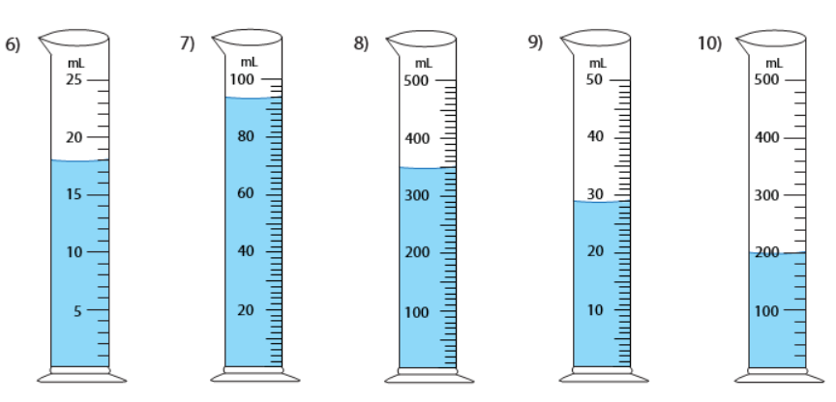

|  |  |  |  |  |  |
| --- | --- | --- | --- | --- | --- |
| mL | mL | mL | mL | | mL |
|  |  |  |  |  | |

## Task 14

Record the weight of each item.

|  |  |  |
| --- | --- | --- |
| g | kg | kg |
| kg | kg | g |
| kg | kg | kg |

## Task 15

Write the measurement shown by the pointer in each problem.

|  |  |
| --- | --- |
|  | cm       mm |
| cm       mm |
| cm       mm |
| cm       mm |

## Task 16

Draw the pointer to show the measurement in each problem.

|  |  |
| --- | --- |
| 10 cm 6 mm |  |
| 4 cm 7 mm |
| 2 cm 8 mm |
| 12 cm 1 mm |

## Task 17

Answer the following questions. Use the correct unit of measurement each time.

|  |  |
| --- | --- |
| A piece of wood is 900 millimetres long. How many centimetres is it? | cm |
| What is 55 centimetres converted to metres? | m |
| You have walked 1.25 kilometres. How many metres have you walked? | m |
| Your goal was to cycle 2.0 kilometres. You ended up cycling for 2.4 kilometres. How many metres over your goal did you go? | m |
| You have to measure out half a litre. How many millimetres do you need to measure? | mL |

## Task 18

Find the perimeter of each rectangle.

|  |  |  |
| --- | --- | --- |
|  | | |
| Perimeter = | Perimeter = | Perimeter = |
|  | | |
|  | | |
|  | | |
|  | | |
| Perimeter = | Perimeter = | Perimeter = |

## Task 19

Find the area of each rectangle.

|  |  |  |
| --- | --- | --- |
|  | | |
| Area = | Area = | Area = |
|  | | |
|  | | |
| Area = | Area = | Area = |