ICTICT215

Operate digital media technology packages

Assessment Tool for ICT20120

All websites referred to in this resource were accessed and deemed appropriate at time of publication.
TEIA Ltd apologises unreservedly for any copyright infringement that may have occurred and invites copyright owners to contact TEIA so any violation may be rectified.
© 2021 TEIA
www.teia.edu.au

Ver. 1-1

Contents
ICTICT215 Operate digital media technology packages

Introduction 1

Section 1 - Unit of competency 2
1.1 Elements of competency and performance criteria 3
1.2 Assessment requirements 3
1.3 Dimensions of competency 5
1.4 Foundation skills 6
1.5 Skill sets 7
1.6 Recognition of prior learning (RPL) 7
1.7 Glossary of terms 8

Section 2 - Assessment tools 13
2.1 Summative assessment 14
2.2 Solutions - General guidance 22
2.3 Solutions – Summative assessment 23
2.4 Evidence of competency 40
2.5 Assessment records 42
Assessment instructions – ICTICT215 43
Pre-assessment checklist – ICTICT215 44
Self-assessment record – ICTICT215 45
Performance evidence checklist – ICTICT215 46
Knowledge evidence checklist – ICTICT215 47
Portfolio of evidence checklist – ICTICT215 48
Workplace assessment checklist – ICTICT215 49
Observation Checklist/Third Party Report 50
Record of Assessment 53
Request for Qualification Issue 55

Glossary 57

Introduction
This set of assessment tools is for the unit of competency ICTICT215 Operate digital media technology packages.
The guide is divided into three sections:
Section 1: Unit of competency
Section 2: Assessment resources
Glossary (VET sector terminology)

As the trainer/assessor, you are in the best position to judge the full training and assessment requirements of a unit of competency. The judgments that you make in this regard should form part of your broader training and assessment strategy.
Learners may or may not be employed in the workplace. Where a learner is currently employed, you should endeavour to use relevant workplace documents and resources. Where learners are not currently employed, you must provide example documentation and a simulated environment wherever possible. Encourage classroom learners to take every opportunity to observe a real working environment and discuss what they have seen. Note that observation and assessment in the workplace is mandatory for some units of competency. Refer to section 1.2 of this guide, or to the assessment requirements of the relevant unit of competency, for details of assessment conditions.

Section 1 - Unit of competency
The Information and Communications Technology Training Package (ICT) was developed by the PwC’s Skills for Australia in consultation with industry stakeholders including employers, unions, peak bodies, professional associations, regulatory bodies, registered training organisations (RTOs) and other relevant parties. The training package specifies the skills and knowledge required to perform effectively in the workplace.
This unit, ICTICT215 Operate digital media technology packages, is drawn from Release 7.2 of this Training Package.
This section outlines the requirements of the unit of competency ICTICT215 Operate digital media technology packages and other information relevant to it.
It contains the following information:
1.1 Elements of competency and performance criteria
1.2 Assessment requirements
1.3 Dimensions of competency
1.4 Foundation skills
1.5 Skill sets
1.6 Recognition of prior learning (RPL)
1.7 Glossary of terms

1.1 Elements of competency and performance criteria
The elements of competency define the skills required to perform a work activity. They describe the required outcomes that need to be assessed.
The performance criteria define the level of skill necessary to achieve the requirements of the element.
The following table maps the content in the on-line course ICTICT215 Operate digital media technology packages to the unit of competency.
ICTICT215 Operate digital media technology packages | Where covered in on-line course
Element 1: Prepare to operate a digital media package
1.1 Set up workstation according to work health and safety standards and organisational requirements | Task 8, Task 9, Task 10
1.2 Identify requirements of design brief and user environment | Task 8, Task 9, Task 10
1.3 Determine required digital media package | Task 8, Task 9, Task 10
1.4 Determine required data set according to task requirements | Task 8, Task 9, Task 10
Element 2: Operate digital media package
2.1 Manipulate and adapt data according to task requirements | Task 8, Task 9, Task 10
2.2 Incorporate graphics, moving images and sound according to task requirements | Task 8, Task 9, Task 10
2.3 Name and save document in file and folder | Task 8, Task 9, Task 10
Element 3: Review digital media design
3.1 Test digital media presentation incorporated graphics, moving images and sound | Task 8, Task 9, Task 10
3.2 Present digital media package to required personnel | Task 8, Task 9, Task 10
3.3 Seek and respond to digital media package presentation feedback from required personnel | Task 8, Task 9, Task 10
3.4 Review final product against design brief and obtain final sign off from required personnel | Task 8, Task 9, Task 10

1.2 Assessment requirements
ICTICT215 Operate digital media technology packages covers the outcomes, skills and knowledge required to identify, select and use a digital media package and supporting technologies to produce a variety of media rich documents.

It applies to individuals who work under supervision within a small to large office environment and have responsibility in completing designated tasks, using a range of practical skills and basic technical knowledge.
The assessment requirements consist of three criteria:
- Performance evidence: details the skills to be demonstrated, the consistency of performance (for example, on how many occasions, in what range of situations, using what range of equipment) and any licensing, regulatory or registration requirements
- Knowledge evidence: the scope and depth of knowledge required
- Assessment conditions: specify where assessment can take place, what resources are required and what interactions with other people are required

Performance evidence
The performance evidence for the unit ICTICT215 Operate digital media technology packages consists of at least one event where the candidate can identify and define data set, incorporate data set into media technology package and present output on one occasion.
During the above, the candidate must:
- interpret basic requirements of a design brief
- meet organisational requirements using digital media package
- apply workplace health and safety (WHS) principles and responsibilities
- use help manuals and online support.

Knowledge evidence
The knowledge evidence within the unit ICTICT215 Operate digital media technology packages consists of:
- basic principles of visual design
- functions and features of digital media packages and technologies
- graphic design and stylistic language conventions
- WHS principles and responsibilities
- principles of digital imaging and file formats, video and sound file formats, file management and transfer systems
- vendor product directions in digital media hardware and software
- creative information, scripts (text) and images
- basic principles of legal and regulatory requirements that apply to operating digital media technology packages.

Assessment conditions
Skills must be demonstrated in a safe environment where evidence gathered demonstrates consistent performance of typical activities experienced by individuals using interpersonal communication skills in the workplace.
Simulations and scenarios are acceptable. Simulated assessment environments must simulate the real-life working environment where these skills and knowledge would be performed, with all the relevant equipment and resources of that working environment.
The assessment environment must include access to:
- required industry standard hardware and software
- documents detailing organisational style guide and policy
- data required in developing software application documents.
Assessment must ensure use of relevant legislation, policies and procedures and industrial awards.
Assessors must satisfy the NVR/AQTF mandatory competency requirements for assessors.

1.3 Dimensions of competency
The dimensions of competency relate to all aspects of work performance. The following table explores the four dimensions of competency in more detail.
Dimensions of competency | What it means
Task skills | The candidate must perform the individual skills required to complete a work activity to the required standard.
Task management skills | The candidate must manage several different tasks to complete a whole work activity, such as working to meet deadlines.
Contingency management skills | The candidate must use their problem-solving skills to resolve issues that arise when performing a work activity.
Job/role environment skills | The candidate must perform effectively in the workplace when undertaking a work activity by working well with all stakeholders and following workplace policies and procedures.

Assessors and/or their training organisations need to ensure that the range of assessment instruments developed for this unit adequately explore the dimensions of competency.

1.4 Foundation skills
Underpinning all job roles is a set of skills that are essential if learners are to participate successfully in work and be valuable and productive employees.
The foundation skills embedded in this unit of competency are outlined below:
Skill | Performance  Criteria | Description
Numeracy | 2.1, 2.2, 3.1 | - Adds and subtracts whole numbers, fractions and decimals in calculating time, audio output, graphic dimensions and file size
Oral communication | 3.2, 3.3, 3.4 | - Uses plain English, listening and questioning techniques  - Presents information to audience using tone, grammar and syntax
Reading | 1.1, 1.2, 1.5, 2.1, 3.3, | - Interprets textual and diagrammatic information  - Interprets systems related icons, text and diagram
Writing | 1.4, 1.5, 2.1, 3.1, 3.3, | - Enters written and verbally received information and data into a format required by digital media package  - Selects vocabulary, syntax, terminology, labelling and naming conventions in program and design requirements
Planning and organising | 1.1, 1.2, 1.3, 2.2, 3.1, | - Plans routine tasks with goals and outcomes, taking some limited responsibility in decisions regarding sequencing
Self-management | 1.1, 1.4, 1.5, 2.1, 2.2, 2.3, 3.1, 3.2 | - Takes personnel responsibility in adhering to legal and regulatory requirements  - Follows routine procedures in using digital technology and enters, stores and retrieves information directly applicable to own role
Technology | 1.1, 1.2, 1.4, 1.5, 2.1, 2.2, 2.3, 3.1, 3.2 | - Identifies and evaluates purposes, specific functions and key features of basic digital systems and tools  - Operates basic digital systems and tools in completing routine tasks and adapting some functions

Do not assume that learners already have these skills; for example, even if you believe they have good writing skills, they may never have written a specific type of report before.
Remember that the learner may not necessarily need all these skills for a specific task, nor be required to develop them to a high level. This will depend on the nature of the task and the context in which they are working.
Your role is to:
- when planning your assessment program, identify where foundation skills are embedded in the unit of competency and how learners can demonstrate they have acquired the skills
- encourage learners to record in the template that follows the Final Assessment the activities they have performed that demonstrate specific foundation skills; they can do this after completing each chapter in the learner guide.

1.5 Skill sets
Skill sets are single units of competency or combinations of units of competency that link to a licence, regulatory requirement or defined industry need.
Skill sets do not replace qualifications as the foundation for undertaking work in the community sector. Skill sets build on a relevant qualification and enable a qualified worker to move laterally into work areas addressed by the skill set or to broaden their skill base in relation to the services they provide.

1.6 Recognition of prior learning (RPL)
Recognition of prior learning (RPL) is an assessment process that assesses an individual’ s non-formal and informal learning to determine the extent to which that individual has achieved the required learning outcomes, competency outcomes, or standards for entry to, and/or partial or total completion of, a qualification.
To have skills and knowledge formally acknowledged, a learner must supply a range of evidence to verify competency. The trainer then needs to assess this evidence against the criteria for the qualification.
Evidence of competency may include work samples, journals and third-party testimonials. Learners may also need to be observed undertaking set tasks and/or answer set questions.
The full RPL Kit for this qualification is available. The kit consists of four parts:
- Assessor’s Guide
- Candidate’s Guide
- Forms
- Workplace Guide

1.7 Glossary of terms
This section provides some general understanding to many of the terms and concepts used in the Information Technology qualifications.
Wherever possible and appropriate, knowledge should be contextualised to the learner’s workplace. For example, when dealing with organisational policies and procedures, look at the actual policies and procedures of the workplace.

Accessibility: Consideration given to ensure that a service (web site etc.) is made available to users whether they have a disability.
Ad banner: A graphic message or other media used as an advertisement.
Aspect ratio: Refers to the relationship between the width and height of an image or screen - e.g. 4:3 means for every 4 units the screen is wide, it will be 3 units high. Common aspect ratios are 4:3 and 16:9 (video); 4:3 and 3:2 (photography); 1.85:1 and 2.39:1 (cinema).
Assistive technology: Assistive technology is furniture, hardware and software which can be used to make sure that anyone who needs assistance to use either the equipment or the digital content itself can do so with ease. For example, to support those with a visual impairment or dyslexia, text-to-speech readers are available, or for people who find a conventional mouse hard to manipulate, tracker-balls can be installed instead.
Archival image: A digital image taken at the highest practicable resolution and stored securely.
Banner: A graphic advertising image displayed on a Web page.
batch processing: As opposed to processing a data file individually, in batch processing several files are collected and sent for processing at the same time (perhaps overnight), thus requiring less operator attention.
Benchmark: A sample of the file or job which can be used as a reference to measure subsequent work against.
Bit rate: Bit rate refers to the rate at which digital data is transferred or processed (most commonly bits per second). In audio and video, it refers to the amount of information (number of bits) stored per second, e.g. 192 kilobits per second (typical mp3 audio) or 10 megabits per second (typical DVD video).
Blended learning: The combination of established methods of teaching and learning, with methods supported by digital technology - online learning, e-learning, mobile learning, remote learning.
Blog: Generic name for any Web site featuring regular posts arranged chronologically. Blog postings are generally short and informal, and blog software is generally free and very easy for individual users, making it a popular tool for online diaries, as well as more professional publications.
Browser: A software program that can request, download, cache and display documents available on the World Wide Web.
Capture: The acquisition of data in a digital form, be it a digital recording, image or moving image.
Channel: A band of similar content.
Chroma: The colour component of an image.
CD-ROM: Compact disk read-only memory, a system for recording, storing, and retrieving data on a compact disk. This can then be read using an optical drive. A CD-ROM can only be written once
Codec: Abbreviation of coder-decoder: a program which encodes or decodes data. Codecs are most encountered in the digital audio and video domains, where they are used in the manipulation of audio and video data.
Compression: Reduction in size of data. Compression of images, audio and video is provided by a wealth of different compression algorithms, which can be classified as either lossy or lossless.
Cookie: A small piece of information (i.e., program code) that is stored on a browser for the purpose of identifying that browser during audience activity and between visits or sessions.
Copyright: Copyright is an intellectual property right that protects the creator or owner of a work by regulating the use of that work.
Creative Commons: Creative Commons licences (also referred to as CC licences), permit the copying, the reuse, the distribution, and in some cases, the modification of the original owner’s creative work without having to get permission every single time from the rights holder.
Cropping: Reduction in the dimensions of an image or video, possibly to remove artefacts created during digitisation (e.g. borders created during the scanning process) or simply to change the content of the image or video.
De-skewing: The correction of distortion caused by image capture from a viewpoint other than on the perpendicular.
Device driver: A piece of software on a computer which enables it to communicate with and control a device connected to it such as a scanner or printer.
Digital: Any method of storing information where the changes in value of characteristics of the source are converted into numerical data which is then recorded.
Digital capture: The process of obtaining a digital representation of an analogue file.
Domain name: The unique name that identifies an Internet site.
dpi: Dots per inch, a measure of the spatial resolution of a digital image or a capture device.
Flash: Adobe’s vector-based rich media file format, which is used to display interactive animations on a Web page.
File format: The way that data is represented and organised in a computer file.
Fold: The line below which a user must scroll to see content not immediately visible when a Web page loads in a browser.
Frequency: The number of times an advertisement is delivered to the same browser in a single session or time.
GIF: Graphic Interchange Format, a bitmap file format widely used on the Web. It has a limited colour palette (256 colours) which makes it more suited to graphics rather than photographs. It can also be used for limited animation.
Gigabyte: One gigabyte equals 1,000 megabytes.
Greyscale: Several greys ranging from black to white. An 8 bit greyscale image could have 254 greys plus black and white for a total of 256 possible values.
Home page: The page designated as the main point of entry of a Web site (or main page) or the starting point when a browser first connects to the Internet. Typically, it welcomes visitors and introduces the purpose of the site, or the organization sponsoring it and then provides links to other pages within the site.
HTML (Hypertext Markup Language): A set of codes called markup tags in a plain text file that determine what information is retrieved and how it is rendered by a browser.
HTTP (Hyper-Text Transfer Protocol): The format most used to transfer documents on the World Wide Web.
Hyperlink: A clickable link, e.g., on a Web page or within an e-mail, that sends the user to a new URL when activated.
Image capture: Process of obtaining a digital representation of an original through scanning, digital photography.
Internet: The worldwide system of computer networks providing reliable and redundant connectivity between disparate computers and systems by using common transport and data protocols known as TCP/IP.
IP Address: Internet protocol numerical address assigned to each computer on the Internet so that its location and activities can be distinguished from those of other computers.
Interoperability: The ability of content, a subsystem or system to seamlessly work with other systems, subsystems or content via the use of agreed specifications / standards. This is achieved through semantic interoperability and/or syntactic interoperability.
JPEG (Joint Photographic Experts Group): Standard Web graphic file format that uses a compression technique to reduce graphic file sizes.
Keyword: Specific word(s) entered a search engine by the user that result(s) in a list of Web sites related to the keyword.
Link: A clickable connection between two Web sites. It is formally referred to as a hyperlink.
Lossless compression: A compression algorithm that reduces a file size but does not lose any information. The uncompressed image is identical to the original.
Lossy compression: A compression algorithm that reduces file size by removing information from the image, audio or video signal. The media object reconstituted from a lossy compressed file is different from the original uncompressed object, even though they may look or sound identical (visually lossless).
Metadata: Descriptive textual data associated with a data file.
Monochrome: Descriptive of an image which is made up of only one colour in varying brightness. Conventional black and white photographic images are monochrome: the single colour which is varied is most often grey or sepia, but any colour could be used and the result will still be monochrome.
Opt-in: Refers to an individual giving a company permission to use data collected from or about the individual for a particular reason, such as to market the company’s products and services.
Opt-out: When a company states that it plans to market its products and services to an individual unless the individual asks to be removed from the company’s mailing list.
Pixel: Picture element (single illuminated dot) on a computer monitor. The metric is used to indicate the size of Internet ads.
Posting: An entry on a message board, blog or other chronological online forum.
Query: A request for information, usually to a search engine.
Red-eye: This is a common problem when using a camera mounted flash under low ambient lighting. The bright flash passes through the dilated pupils and illuminates the tissue at the back of the eye which glows red.
Repository: A repository is literally a container or, in a digital environment, a virtual library of materials that are digital in construction.
Search engine: An application that helps Web users find information on the Internet.
Server: A computer that distributes files shared across a LAN, WAN or the Internet; also known as a “host.”
Social network: An online destination that gives users a chance to connect with one or more groups of friends, facilitating sharing of content, news and information among them.
Spam: Unsolicited commercial e-mail.
Splash page: A preliminary page that precedes the user-requested page of a Web site that usually promotes a particular site feature or provides advertising.
Target audience: The intended audience for the media.
TIFF: Tagged Image File Format, a widely used file format particularly suited to the storage of high-quality archive images.
Traffic: The flow of data over a network or visitors to a Web site.
URL (Uniform Resource Locator): The unique identifying address of any page on the Web. It contains all the information required to locate a resource, including its protocol (usually HTTP), server domain name (or IP address), file path (directory and name) and format (usually HTML or CGI).
User: An individual that access the digital media or website.
Vector image: An image that is composed of individual elements e.g. arc, line, polygon, that have their own attributes. These attributes can be individually edited.
WAP (Wireless Application Protocol): A specification for a set of communication protocols to standardize the way that wireless devices, such as mobile phones and others access and browse Internet-based content.
Web site: The virtual location (domain) for an organisation’s or individual’s presence on the World Wide Web.
Widget: A small application designed to reside on a PC desktop or within a Web-based portal or social network site offering useful or entertaining functionality to the end user.
Wi-Fi: Any of a family of wireless LAN data standards used for corporate and home connectivity.

Section 2 - Assessment tools
Assessment is all about collecting evidence and making decisions as to whether a learner has achieved competency. Assessment confirms that the learner can perform to the expected workplace standard, as outlined in the units of competency.
This section contains the summative assessment tools that are to be used in assessing this unit of competency. The assessment tools have also been mapped against the requirements of unit assessment; these may be reviewed in the TEIA document ICT20120 Mapping Guide. Assessors can use this mapping information to complete required assessment records.
It is an important responsibility of assessors to complete the assessment records themselves. This ensures all additional assessment activities deemed appropriate or required by the assessor, in addition to those within this document, are included in these records.
Section Two contains the following information:
2.1 Summative assessment
2.2 Solutions – general guidance
2.3 Solutions – summative assessment
2.4 Evidence of competency
2.5 Assessment records

2.1 Summative assessment
Separate each assessment tool as required in the assessment process.

Task Overview
The assessment for this unit is distributed across Task 8, Task 9 and Task 10 within the virtual scenario.

Task 8
In this task, you are asked to organise and support digital communication with a client body ensuring their digital security and efficiency.

Preparation:
- Access, read and print as necessary the Learning Resources and Your Task (Bookcase folders).
- Complete the e-learning course on Protecting Your Devices (Learning Resources in Bookcase folders).
- Collect your completed course tasks into an e-portfolio. This must be sent to your manager (Teacher).
- End of course project consists of three screen capture videos:
  - Demonstrate your ability to update the antivirus software and if in use, spam filtering software. You are also required to check and adjust the settings of a computer to ensure these are set to provide maximum security and protection to the computer. The areas to be covered are included in this short course.
  - Detect and remove at least one piece of spam from a computing device; and,
  - Detect and remove malware (which could be a virus) from a different computing device.

What to submit | Problems encountered and strategies used to overcome these
Course tasks into an e-portfolio
End of course project videos (3) in e-portfolio

Field’s Accountancy – Issue 1:
- Read and print email attachment from Mark Hamden (Computer).
- Access, read and print as necessary the Learning Resources and Your Task (Bookcase folders)
- You are encouraged to research information to support your work in developing a policy position for the Field’s Accountancy company (internet).
- An example of a policy document for Field’s Accountancy can be found in the Learning Resources area – it is called Policies and Procedures: Digital Security (Learning Resources).
- Construct policy positions of no more than 2 A4 pages for Safe Internet Use.

What to submit | Problems encountered and strategies used to overcome these
Policy document outlining correct processes for the topics of Safe Internet Use.

Field’s Accountancy – Issue 2:
- Read and print email attachment from Mark Hamden (Computer).
- Access, read and print as necessary the Learning Resources and Your Task (Bookcase folders). You will need to become familiar with the style guide for a Short Report (Learning Resources).
- You are encouraged to research information to support your work in developing policy positions for the Field’s Accountancy company (Internet).
- Your recommendations with explanations are to form a short report to Field’s Accountancy management team. The report is to cover the issues of:
  - The protocols and methods of digital communication by Field’s staff not being consist over time or across different staff members.
  - The security of the information being shared by staff clients.
  - The lack of records of this communication which will cause difficulties and vulnerabilities in the future.
  - A lack of understanding or clarity as the purpose and methods of official company digital communication.

What to submit | Problems encountered and strategies used to overcome these
Short report providing recommendations and explanations as to how these addresses each of the following issues:
- The protocols and methods of digital communication by Field’s staff not being consist over time or across different staff members.
- The security of the information being shared by staff clients.
- The lack of records of this communication which will cause difficulties and vulnerabilities in the future.
- A lack of understanding or clarity as the purpose and methods of official company digital communication.

Field’s Accountancy – Issue 3:
- Read and print email attachment from Mark Hamden (Computer).
- Access, read and print as necessary the Learning Resources and Your Task (Bookcase folders)
- You are encouraged to research information to support your work in providing advice to the Field’s Accountancy company (Internet).
- You are to prepare a short instruction checklist that informs and provides direction on how to set up a company email account. It must cover the style to be used, core parts of an email and the signature block.

What to submit | Problems encountered and strategies used to overcome these
- Brochure detailing the setting areas and their configuration within the computer’s Operating System that maximises the security of that workstation.

- Presentation (minimum 4 slides) showing how to identify possible spam and how to set Outlook settings to minimise its collection in worker intrays.

Field’s Accountancy – Issue 4:
- Read and print email attachment from Mark Hamden (Computer).
- Access, read and print as necessary the Learning Resources and Your Task (Bookcase folders)
- You are encouraged to research information to support your work in providing recommendations to the Field’s Accountancy company (Internet).
- You are to prepare a recommendation on what antivirus software to install on each of the Field’s Accountancy workstations. Also provide an explanation of why this software package is the best for that company.

What to submit | Problems encountered and strategies used to overcome these
Correspondence detailing the recommendation and the supporting explanation.

Task 9
In this task, you will need to develop your knowledge of PhotoFiltre to enhance your photo editing skills. You will need to download and install PhotoFiltre and use the help files as required to develop your skills. You will need to edit a series of images to meet the needs of a client and share these with other team members (classmates) for their feedback and comments via a common social media site. This task may best be done as a collaborative project.

NOTES: 1. This task may be done in conjunction with the image editing component of Task 8. Please discuss this option with your teacher.
2. While this task specifically makes use of PhotoFiltre, you may wish to use an alternative image editing program. Please discuss this with your teacher.

Develop a social media site:

- You are to work in a team of no less than three for this part of the task. If this is not possible, you will need to gain special approval from your teacher for independent work.
- Assess social sites considering the project goal.
- Review social media learning object from Task 5.
- Access and select preferred social media site as a share workspace.
- Register and create site and establish presence (either individually or as a group).
- Establish security parameters for site in consultation with your teacher.
- Later in the task, you are to upload your images to the site and seek feedback from others.
- Prepare a series of screenshots (3) of social media site at key points in the project.

What to submit | Problems encountered and strategies used to overcome these
Screenshots of social media site

Locate, download and install PhotoFiltre:
- Read and print email from Andrew Reid. (Computer)
- Access, read and print as necessary the Learning Resources and Your Task. (Bookcase folders)
- Locate and save PhotoFiltre installation file. (Internet)
- Using a screen capture video app, record your installation of PhotoFiltre, with an audio commentary, onto your computer.
- Install PhotoFiltre to your computer.

What to submit | Problems encountered and strategies used to overcome these
Video clip of PhotoFiltre installation

Edit digital images:
- Access email from Andrew Reid. (Computer)
- Access the digital images from Andrew Reid. (Camera)
- Refer to the image adjustments required by the client. (Andrew’s email)
- Adjust images to meet client requirements.
- List steps that you used to edit each image on the accompanying Digital Image Adjustment Record Sheet. (Bookcase folders)
- Upload your edited images to the shared social media page and seek feedback on your work If you can improve your work based on the feedback, do so.
- Print final images and submit to your supervisor (i.e. teacher).

What to submit | Problems encountered and strategies used to overcome these
Edited images – digital format
Printed copy of each image
Digital Image Adjustment Record Sheet

Prepare an invoice and email:
- Access an invoice template from the Internet. (Internet)
- Construct a company Invoice template adding the company logo to the invoice. (Logo – Camera)
- Complete the invoice charging for the number of hours this task has taken at $65.00 per hour with a 10% GST on the total amount being charged.
- Prepare an email to Andrew informing him what action you have taken to edit each image. Add the invoice to the email as an attachment. You do not need to send the email, simply prepare as a draft and take a screenshot of it.

What to submit | Problems encountered and strategies used to overcome these
Completed invoice for Andrew
Screenshot of the email to Andrew ensuring all the text is readable.

Task 10
In this task, you will need to clarify and follow client briefs, prepare photographic shoots, capture digital images, adjust and edit photographic images and arrange delivery to clients.

NOTE: While it is recommended that the editing occurs with either PhotoFiltre or GIMP, you may wish to use an alternative image editing program. Please discuss this with your teacher.
Preparation:
- Access, read and print as necessary the Learning Resources and Your Task (Bookcase folders).
- Complete the e-learning course on Capturing Digital Images (Learning Resources in Bookcase folders).
- Collect your completed course tasks into an e-portfolio. This must be sent to your manager (Teacher).

Local Promotion Group:
- Read the email from Melissa Brady seeking you to complete a small photography project for a local promotions group. Download and read the Photo Brief she has provided (Email).
- Analyse the brief and plan you shoot in your local area.
- After conducting the shoot select the eight images you are going to work on and submit to the client.
- Using the photo editing software, you have negotiated to use, edit and adjust the images to make these the best that they can be and address the standards provided by the client, e.g. size, file format, balance, and other factors in the composition of the images.
- Record your adjustments and edits that you make to each image in the Digital Image Adjustment Record Sheet (Learning Resources in Bookcase folders).
- When images are ready, negotiate with your supervisor on how the client’s requested images along with the Digital Image Adjustment Record Sheets are delivered to the client. Your supervisor (i.e. your teacher) will inform you of the delivery process.

What to submit | Problems encountered and strategies used to overcome these
There are eight images – 2 different images from 4 different locations/different scenes
Each image is to be provided in the following formats:
Original download - Images to be raw state directly from camera download.
Edited jpg - to be high quality suitable for use in a wide range of media; cropping and adjustments to occur; 3 sizes to be provided:
- 1024 x 768 pixels.
- 1080 x 1080 pixels.
- 1280 x 720 pixels.
Edited png - reduced in size to 400 pixel x 400 pixel for future use in Twitter; images will need to be adjusted and cropped to fit size and remain viable as an image.
A Digital Image Adjustment Record Sheet for each image recording the various adjustments that were made to achieve the final results.

Chocydodah request:
- Read and print email from Robin Nesbett at Chocydodah. (Computer)
- Download and complete a Photo Brief based on his email (Learning Resources in Bookcase folders). You will need to do some research on what appropriate sizes for use in a poster (A2 size) and for websites/social media outlets are and work to these recommendations.
- Send Photo Brief for Chocydodah to your supervisor (i.e. teacher) for comment and review.
- On return of the supervisor’s comments adjust, if necessary, your Photo Brief.
- Gather the necessary equipment and items and conduct a studio style shoot on three chocolate products.
- Using a photo editing software package, you have negotiated with your teacher, edit the images to the specifications set in the Photo Brief.
- Record your adjustments and edits that you make to each image in the Digital Image Adjustment Record Sheet (Learning Resources in Bookcase folders).
- When images are ready, negotiate with your supervisor on how the client’s requested images along with the Digital Image Adjustment Record Sheets are delivered to the client. Your supervisor (i.e. your teacher) will inform you of the delivery process.
- Prepare a business document to Chocydodah explaining why you selected the three products provided in the accompany package and thanking them for the business.

What to submit | Problems encountered and strategies used to overcome these
There are three images of chocolate products.
Each image is to be provided on a transparent background in the following formats:
Image suitable for a A2 size poster using the image format commonly used for in-house printing by businesses.
Image suitable for use in a webpage and social media using the image format commonly used for in-house printing by businesses.
Note that no Digital Image Adjustment Record Sheets need be provided.
Business correspondence thanking them for the business and explaining why you selected the three chocolate products.

2.2 Solutions - General guidance
Assessors should review the solutions provided and adapt and/or contextualise them (and assessment activities themselves where necessary) to suit the training and assessment context as part of their moderation activities. This will ensure consistency of assessment.
The solutions to assessment activities serve as a reliable guide to the type of information that should be included in the assessment candidate’s response. Refer to the assessment activities when assessing learner responses or evaluating assessment evidence. The answers provided by the assessment candidate will vary due to several factors, including the:
- candidate’ s own experiences
- candidate’ s workplace experiences
- training situations and strategies presented by the trainer
- interpretation of the assessment activity by the assessment candidate/assessor
- type of organisation, work practices, processes and systems encountered by the candidate.
The nature and variety of the tasks presented means that in some cases there will be numerous correct responses, and the solutions provided cannot cater for all contexts and eventualities.
In general terms:
- For questions with a single answer, this guide provides the correct answer.
- For questions that do not have a single answer, it is understood that answers will vary within certain parameters.
- For questions where the candidate must list a certain number of items, the RTO has provided a more comprehensive listing from which candidate responses may be drawn. This list may not in all cases be definitive, and assessors should account for other possible correct responses.
- For activities that involve responding to a case study, the RTO has provided an example of how the candidate may respond. Depending on the question, the terminology used will indicate either what the candidate should have included in their response or may have included. However, different phrasing may be used by the candidate, or different responses that may be equally correct are also possible.
- For activities that take place in the workplace or involve workplace documentation, the RTO can only provide an example response. Assessors should consider whether the candidate has achieved the intent of the activity within the candidate’s workplace context.
- For activities that involve writing reports or completing documentation provided, the RTO can only provide an example response. Assessors should again consider whether the candidate’s response is appropriate to the task within the context of the candidate’s training and/or workplace.

2.3 Solutions – Summative assessment

Task 8
In this task, the candidates are to organise and support digital communication with a client body ensuring their digital security and efficiency.

Preparation:
- Access, read and print as necessary the Learning Resources and Your Task (Bookcase folders).
- Complete the e-learning course on Protecting Your Devices (Learning Resources in Bookcase folders).
- Collect your completed course tasks into an e-portfolio. This must be sent to your manager (Teacher).
- End of course project consists of three screen capture videos:
  - Demonstrate your ability to update the antivirus software and if in use, spam filtering software. You are also required to check and adjust the settings of a computer to ensure these are set to provide maximum security and protection to the computer. The areas to be covered are included in this short course.
  - Detect and remove at least one piece of spam from a computing device; and,
  - Detect and remove malware (which could be a virus) from a different computing device.

Assessor judgement required.
The following must be present in the response:
- E-portfolio responses would include:
- A survey of six people recorded on this template:
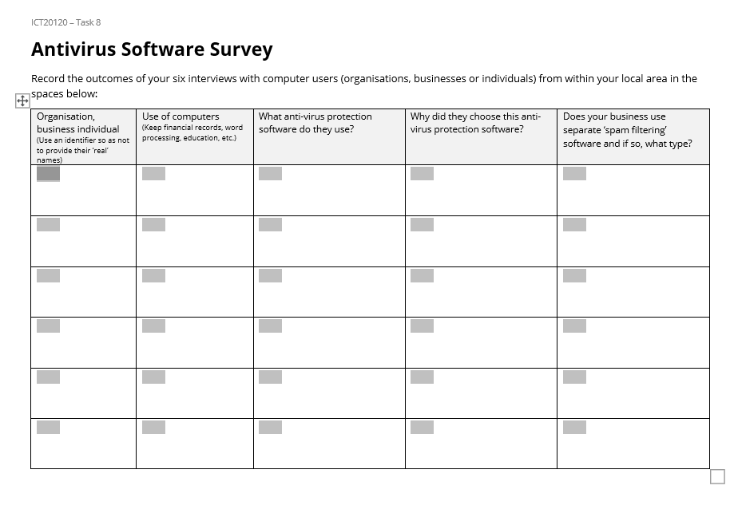
- Three screen capture videos that address the following topics:
  - Updating of the antivirus software and if in use, spam filtering software. Adjust the settings of a computer to ensure these are set to provide maximum security and protection to the computer.
  - Detect and remove at least one piece of spam from a computing device; and,
  - Detect and remove malware (which could be a virus) from a different computing device.

Field’s Accountancy – Issue 1:
- Read and print email attachment from Mark Hamden (Computer).
- Access, read and print as necessary the Learning Resources and Your Task (Bookcase folders)
- You are encouraged to research information to support your work in developing a policy position for the Field’s Accountancy company (internet).
- An example of a policy document for Field’s Accountancy can be found in the Learning Resources area – it is called Policies and Procedures: Digital Security (Learning Resources).
- Construct policy positions of no more than 2 A4 pages for Safe Internet Use.

Assessor judgement required.
The following must be present in the response:
- The policy and procedures document must focus on safe Internet use.
- The policy document must have the headings below or similar in evident in the policy:
  - User logon integrity
  - Safe websites
  - Security
  - Appropriate and inappropriate use of the Internet
  - Saving of files
Here is a sample policy and procedures:
Policy purpose
Our business Internet policy outlines our guidelines for using the company’s Internet connection, network and equipment. We want to avoid inappropriate or illegal Internet use that creates risks for our company’s legality and reputation.
Scope
This employee Internet usage policy applies to all our employees, contractors, volunteers and partners who access our network and computers.
Employee Internet usage policy elements
What is appropriate employee Internet usage?
Our employees are advised to use our company’s Internet connection for the following reasons:

- To complete their job duties.
- To seek out information that they can use to improve their work.
- To access their social media accounts, while conforming to our social media policy.
- We don’t want to restrict our employees’ access to websites of their choice, but we expect our employees to exercise good judgement and remain productive at work while using the Internet.
Any use of our network and connection must follow our confidentiality and data protection policy.
Employees should:
- Always keep their passwords secret.
- Log into their corporate accounts only from safe devices.
- Use strong passwords to log into work-related websites and services.
- What is inappropriate employee Internet usage?
- Our employees mustn’t use our network to:
- Download or upload obscene, offensive or illegal material.
- Send confidential information to unauthorized recipients.
- Invade another person’s privacy and sensitive information.
- Download or upload movies, music and other copyrighted material and software.
- Visit potentially dangerous websites that can compromise the safety of our network and computers.
- Perform unauthorized or illegal actions, like hacking, fraud, buying/selling illegal goods and more.
- We also advise our employees to be careful when downloading and opening/executing files and software. If they’re unsure if a file is safe, they should ask [their supervisor/ IT manager/ etc.]
Our company has installed anti-virus and disk encryption software on its computers. Employees may not deactivate or configure settings and firewalls.
Anjark Services does not CCWPTany responsibility if employee devices are infected by malicious software, or if their personal data are compromised as a result of inappropriate employee use.
Company-issued equipment
We expect our employees to respect and protect our company’s equipment. “Company equipment” in this computer usage policy for employees includes company-issued phones, laptops, tablets and any other electronic equipment, and belongs to our company.
We advise our employees to lock their devices in their desks when they’re not using them. Our employees are responsible for their equipment whenever they take it out of their offices.
Email
Our employees can use their corporate email accounts for both work-related and personal purposes if they don’t violate this policy’s rules. Employees shouldn’t use their corporate email to:
- Register to illegal, unsafe, disreputable or suspect websites and services.
- Send obscene, offensive or discriminatory messages and content.
- Send unauthorized advertisements or solicitation emails.
- Sign up for a competitor’s services unless authorized.
- Our company has the right to monitor corporate emails. We also have the right to monitor websites employees visit on our computers.
Disciplinary Action
Employees who don’t conform to this employee internet usage policy will face disciplinary action. Serious violations will be cause for termination of employment, or legal action when appropriate. Examples of serious violations are:
- Using our internet connection to steal or engage in other illegal activities.
- Causing our computers to be infected by viruses, worms or other malicious software.
- Sending offensive or inappropriate emails to our customers, colleagues or partners.

Field’s Accountancy – Issue 2:
- Read and print email attachment from Mark Hamden (Computer).
- Access, read and print as necessary the Learning Resources and Your Task (Bookcase folders). You will need to become familiar with the style guide for a Short Report (Learning Resources).
- You are encouraged to research information to support your work in developing policy positions for the Field’s Accountancy company (Internet).
- Your recommendations with explanations are to form a short report to Field’s Accountancy management team. The report is to cover the issues of:
  - The protocols and methods of digital communication by Field’s staff not being consist over time or across different staff members.
  - The security of the information being shared by staff clients.
  - The lack of records of this communication which will cause difficulties and vulnerabilities in the future.
  - A lack of understanding or clarity as the purpose and methods of official company digital communication.
Assessor judgement required.
The following must be present in the response:
- The response must be in an acceptable, business style report.
- The report must contain recommendations and explanations as to how to addresses each of the following issues:
  - The protocols and methods of digital communication by Field’s staff not being consist over time or across different staff members.
  - The security of the information being shared by staff clients.
  - The lack of records of this communication which will cause difficulties and vulnerabilities in the future.
  - A lack of understanding or clarity as the purpose and methods of official company digital communication.
Field’s Accountancy – Issue 3:
- Read and print email attachment from Mark Hamden (Computer).
- Access, read and print as necessary the Learning Resources and Your Task (Bookcase folders)
- You should research information to support your advice to the Field’s Accountancy company (Internet).
- You are to provide advice on what settings the client should have on their workstations’ Operating System to maximise their protection from potential hackers and malware.
- This information is to be shared with the client in the following ways:
  - A brochure displaying the setting areas and their configuration to prevent malware, hacking and viruses.
  - A presentation (PowerPoint) showing how to be how to identify possible spam and how to set Outlook settings to minimise its collection in worker intrays.
  - A brief fact sheet that explains the process when a security threat to a computer’s operation and safe storage of data is identified.

Assessor judgement required.
The following must be present in the response:
Brochure – Windows security settings
At least five of the following elements must be presented:
- Virus and threat protection - Monitors threats to a device, runs scans, and gets updates to help detect the latest threats.
- Account protection - Accesses sign-in options and account settings.
- Firewall and network protection - Manages firewall settings and monitors what is happening with attached networks and Internet connections.
- App and browser control - Updates settings for Microsoft Defender SmartScreen to help protect a device against potentially dangerous apps, files, sites, and downloads.
- Device security - Reviews built-in security options to help protect a device from attacks by malicious software.
- Device performance and health - Views status information about a device’s performance health, keeps the device clean and up to date with the latest version of Windows.

Presentation
- Presentation must have a minimum of four slides.
- Layout and style must be consistent throughout, i.e. colour, layout, font use, etc.
- A sample answer (in this case for Outlook 365) is below:
Mail identified as possible junk email can be automatically moved to the Junk Email folder. Any malware—potentially malicious software or code—is disabled.

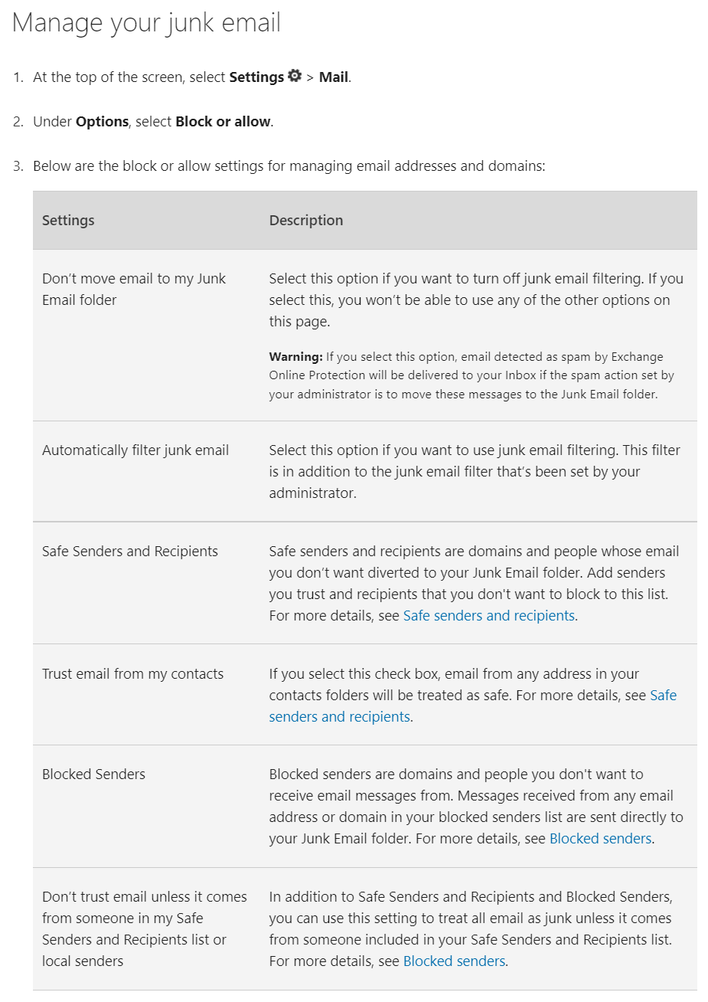
Fact sheet
A clear process that focuseson retaining files and preventing further damage must be articulated in the response. A sample response is provided below:
What to do right away after you believe the security of your computer is threatened
Remember, you may have identified the problem before too much damage has occurred. You can probably mitigate anything bad that has happened if you act quickly.
- Reset your passwords
This might seem like a large job but focus on the key places; social networks (Facebook, Twitter, Instagram), emails, devices (phone, laptop, etc.) and anywhere involving credit cards and finance (shopping, banking).
- Log out of all online accounts
After resetting passwords, log out. It’s easy to forget that we tend to have our social media (and other online accounts) set to automatically log us in.
- Disconnect from the internet
Shut down contact to the internet: that means turning off Wi-Fi on your computer and switching phones and tablets to airplane mode.
- Remove external hard drives
Remove any external drives. This means USB sticks or external hard drives. Be sure to “eject” them first. (Go to the appropriate folder, then click “eject”).
- Back up hard drive files
Back up any files you have (you can even save them to the cloud, like Google Drive or email small files to yourself); switch off all power sources; shut the computer down.
- Scan your computer for malware and viruses
This can be done with your own devices’ security software, or with third party security.
- Wipe your hard drive (if necessary)
If the scan reveals a significant virus or hack, you can (and probably should) wipe your hard drive, then reinstall your OS. Wiping means to permanently erase, so be aware that whatever you’re deleting will be gone for good unless you back it up.
Do not just manually delete files: they’ll still exist somewhere in your hard drive. Instead, use a downloadable programme to carry out the wipe. Like a virus scan, a wipe will let you know when it’s been carried out completely.
- Let others know
Unfortunately, your hack might have affected people in your contact list: friends and families might have been emailed by a hacker posing as you. If that happens, it’s important to contact those who have been emailed or texted to let them know you weren’t behind the message and you may have been hacked.
This is especially important if your troubles were the result of clicking on a suspicious email or attachment. Warn others of the attack. Similar hacks tend to happen in waves, as multiple victims are contacted at a time.
- Closely monitor your credit and financial accounts
After the hack, keep an eye on your online expenditures, regularly checking your bank and credit card accounts.
- Install security software
Up-to-date, reputable security software is the best line of defense against a future hack.
Field’s Accountancy – Issue 4:
- Read and print email attachment from Mark Hamden (Computer).
- Access, read and print as necessary the Learning Resources and Your Task (Bookcase folders)
- You are encouraged to research information to support your work in providing recommendations to the Field’s Accountancy company (Internet).
- You are to prepare a recommendation on what antivirus software to install on each of the Field’s Accountancy workstations. Also provide an explanation of why this software package is the best for that company.

Assessor judgement required.
The following must be present in the response:
- A business-like report that details the advantages and any disadvantages of the selected software package.
- The reasons why this software package was recommended.
- Costs associated with the purchase and installation of this software.

Task 9
In this task, you will need to develop your knowledge of PhotoFiltre to enhance your photo editing skills. You will need to download and install PhotoFiltre and use the help files as required to develop your skills. You will need to edit a series of images to meet the needs of a client and share these with other team members (classmates) for their feedback and comments via a common social media site. This task may best be done as a collaborative project.

NOTES: 1. This task may be done in conjunction with the image editing component of Task 8. Please discuss this option with your teacher.
2. While this task specifically makes use of PhotoFiltre, you may wish to use an alternative image editing program. Please discuss this with your teacher.

Develop a social media site:

- You are to work in a team of no less than three for this part of the task. If this is not possible, you will need to gain special approval from your teacher for independent work.
- Assess social sites considering the project goal.
- Review social media learning object from Task 5.
- Access and select preferred social media site as a share workspace.
- Register and create site and establish presence (either individually or as a group).
- Establish security parameters for site in consultation with your teacher.
- Later in the task, you are to upload your images to the site and seek feedback from others.
- Prepare a series of screenshots (3) of social media site at key points in the project.

Assessor judgement required.
The actual social media site to be used is at the teacher’s discretion.
The following must be present in the response:
- The social media site must have a business-like appearance following a set style guide.
- There must be evidence within the site that it has been used to share information and collaborate with others.
- The evidence may be in the form of either direct access to the site or a series of screenshots that demonstrate the criteria.

Locate, download and install PhotoFiltre:
- Read and print email from Andrew Reid. (Computer)
- Access, read and print as necessary the Learning Resources and Your Task. (Bookcase folders)
- Locate and save PhotoFiltre installation file. (Internet)
- Using a screen capture video app, record your installation of PhotoFiltre, with an audio commentary, onto your computer.
- Install PhotoFiltre to your computer.

Assessor judgement required.
The candidate must submit a screen-capture video with audio commentary that shows the installation of the required software onto a computer.

Edit digital images:
- Access email from Andrew Reid. (Computer)
- Access the digital images from Andrew Reid. (Camera)
- Refer to the image adjustments required by the client. (Andrew’s email)
- Adjust images to meet client requirements.
- List steps that you used to edit each image on the accompanying Digital Image Adjustment Record Sheet. (Bookcase folders)
- Upload your edited images to the shared social media page and seek feedback on your work If you can improve your work based on the feedback, do so.
- Print final images and submit to your supervisor (i.e. teacher).

Assessor judgement required.
The following must be present in the response:
- The edited images, i.e. the images after editing has occurred.
- A printed copy of each digital image. Note, is this is not possible due to distance/time constraints then the images placed into a document and saved as a PDF file may suffice (assessor’s decision).
- A completed entry for each edited image on the Digital Image Adjustment Record Sheet. Note full details of edit must be evident.

Images are to be submitted as .jpg and not pasted into a Word document, as ‘Capture a digital image’ is being assessed.

 | 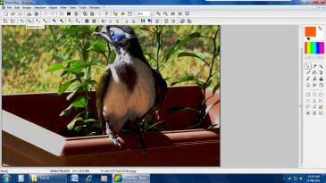

Picture 1 - Bird - it looks a bit too bright and the contrast could really be better

 | 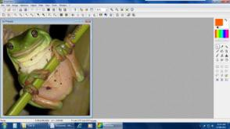

Picture 2 - Frog - get rid of the background to just include the frog. It is just the frog that I am after. I think there is also a bit too much light from the camera flash.

 | 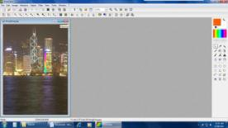

Picture 3 - Hong Kong - straighten this up

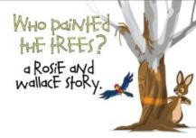 | 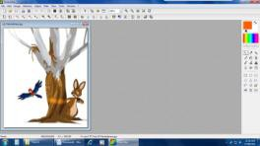

Picture 4 - Painted Trees - I had this drawn but would like all the text removed. I know this will be a bit difficult where the writing runs over the branch but told this can be restored. Once this is done, I would get rid of all the white space where the writing would have been.

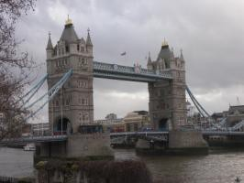 | 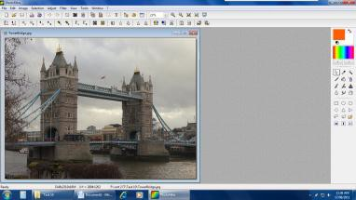

Picture 5 - Tower Bridge, London - the picture is a bit crooked. It would be good if you could straighten it up. The colour is also a bit washed out.

Prepare an invoice and email:
- Access an invoice template from the Internet. (Internet)
- Construct a company Invoice template adding the company logo to the invoice. (Logo – Camera)
- Complete the invoice charging for the number of hours this task has taken at $65.00 per hour with a 10% GST on the total amount being charged.
- Prepare an email to Andrew informing him what action you have taken to edit each image. Add the invoice to the email as an attachment. You do not need to send the email, simply prepare as a draft and take a screenshot of it.

Assessor judgement required.
The following must be present in the response:
- A constructed invoice template containing the Anjark Services logo and details.
- A completed invoice for this task with appropriate times, hourly rate and totals. Note that the numerical operations must be correct.
- A draft of the email that details:
  - The work that was carried out
  - Indicating that the invoice is attached
  - General business salutations, thanks for the work and signature block.

Discussion Questions
- Explain the various methods that may be used for backup and storage of your digital images.
To create a backup on your own computer, go to control panel and select backup and restore.
You may choose to backup to your computer’s hard drive or to an external drive. Choose the files that you want to backup and then start backing up those files.
Choose the schedule for regular backups: e.g. every Monday at 10 am and type in a starting date.
Once this is setup the computer will regularly backup the files on the specified day and time if the computer is turned on otherwise back up will start when the computer is turned on.

- Digital images may be saved in many formats. What are the advantages of each of the following?
JPEG (or JPG); GIF; RAW; BMP
JPEG stands for Joint Photographic Experts Group and was named after the committee that wrote the Standard. JPEG is an image compression mechanism designed for compressing full colour or gray scale images of natural real world scenes. It works well on photographs and similar material but not on lettering, simple cartoons or line drawings. The advantages of JPEG are that it makes the image file size smaller but they still appear the same as the original. It also stores full colour information and loses less information than GIF.

GIF stands for Graphic Interchange Format and it is an image format that is widely used on the web but it will only store 8 bits per pixel or 256 or fewer colours. It is better used on an inexpensive computer display. GIF format is not suited for photography and is more suited for graphics and logos on the web.

RAW stands for a raw image file that contains minimally processed data from the image sensor of a digital camera or scanner. They are not yet processed and are not ready to be printed or edited. A Raw file is the digital equivalent to a negative. An advantage of the digital RAW file format is that it offers the photographer more control over how the final JPEG image is composed. A raw file is developed into a JPEG image in several steps and each step may contain several irreversible image adjustments. The advantage is that the photographer can postpone applying these adjustments until later and then using then in a way that suits each image the best.

BMP is short for bitmap format which is a commonly used raster or paint graphic format used for saving image files. BMP format stores colour data for each pixel in the image without compression. This method of storing information gives crisp, high quality images but produces large file sizes. Another advantage of BMP format is that using photo editing software the BMP image can be changed, small details can be refined and effects can be intensified.

- Describe the process that you would use to convert an image from JPEG to another file format.
Right click the image
Choose Open with and choose Paint.
Click on File and click Save as.
Change the type to the one required
Click Save

- Explain the relationship between light levels, shutter speed and aperture opening. How might these apply in low light conditions?

Light level is the amount of light that is available as either natural light or artificial light. Shutter speed is the exposure or length of time the shutter is open to allow light into the sensor. The aperture opening is the diameter that the lens opens to control the amount of light that reaches the sensor. In low light conditions the shutter speed is slower so that more light is allowed in to the sensor and the aperture opening is wider to allow more light to reach the sensor.

- Using the Internet locate 2 photo sharing sites where users can upload, view, search, and share photos. Provide the web address of each along with a brief description. 2 possibilities are provided below:
Flickr - http://www.flickr.com/ -
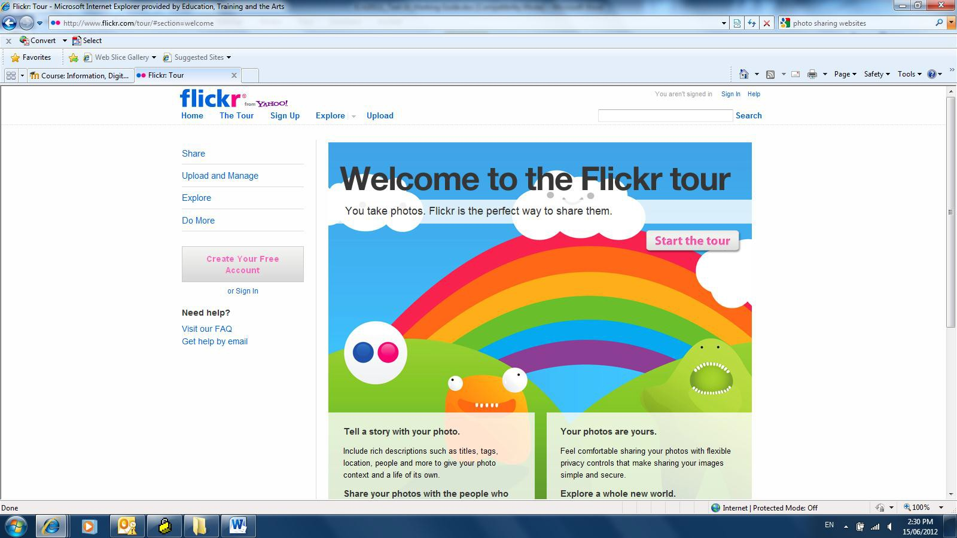

http://www.snapfish.com/snapfish/aboutUs
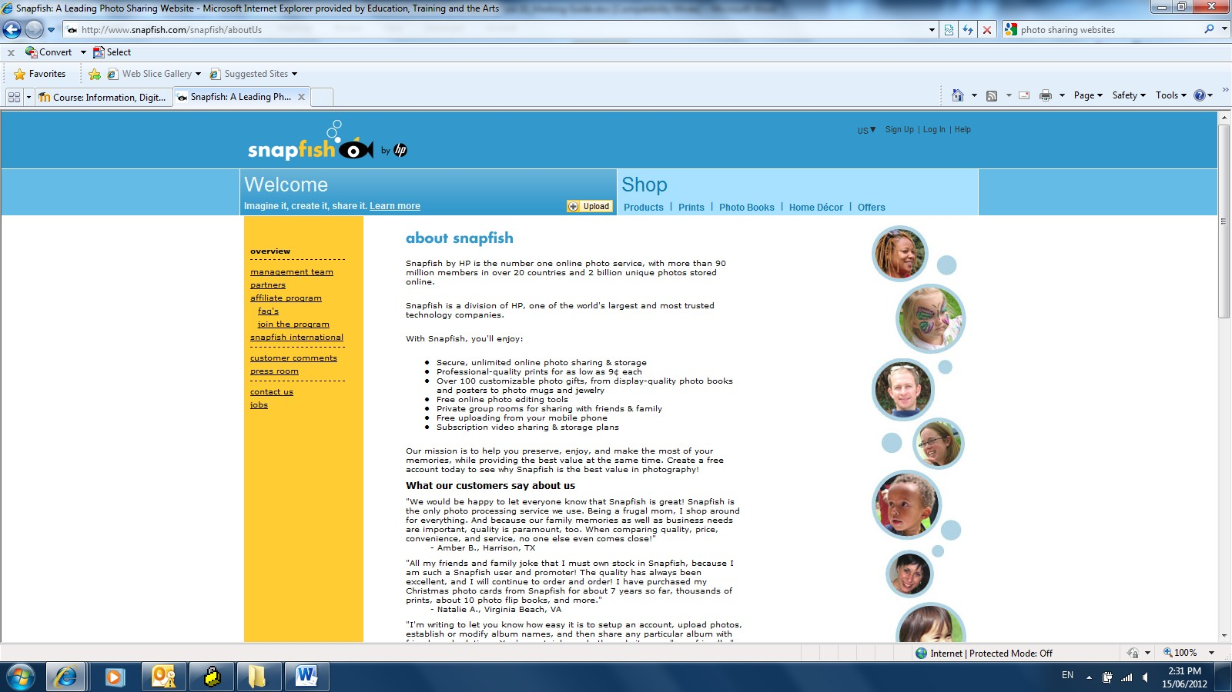

- Considering the nature of Task 10, what social media site do you believe is the most appropriate for a collaborative workspace of this type? Why?
Assessor judgement required.
Example: EdStudio – protected environment; less susceptible to hackers

- What copyright provisions might apply to online content such as images and video? How can you check these provisions?
Copyright provisions apply to online content. Copyright information is generally at the bottom of the webpage.

Task 10
In this task, you will need to clarify and follow client briefs, prepare photographic shoots, capture digital images, adjust and edit photographic images and arrange delivery to clients.

NOTE: While it is recommended that the editing occurs with either PhotoFiltre or GIMP, you may wish to use an alternative image editing program. Please discuss this with your teacher.
Preparation:
- Access, read and print as necessary the Learning Resources and Your Task (Bookcase folders).
- Complete the e-learning course on Capturing Digital Images (Learning Resources in Bookcase folders).
- Collect your completed course tasks into an e-portfolio. This must be sent to your manager (Teacher).
- Complete the Digital Image quiz (Learning Resources in Bookcase folders).

Assessor judgement required.
The following must be present in the response:
E-portfolio

Digital Image quiz
A copy of the quiz result sheet recording a Pass in the quiz needs to be submitted.

Local Promotion Group:
- Read the email from Melissa Brady seeking you to complete a small photography project for a local promotions group. Download and read the Photo Brief she has provided (Email).
- Analyse the brief and plan you shoot in your local area.
- After conducting the shoot select the eight images you are going to work on and submit to the client.
- Using the photo editing software, you have negotiated to use, edit and adjust the images to make these the best that they can be and address the standards provided by the client, e.g. size, file format, balance, and other factors in the composition of the images.
- Record your adjustments and edits that you make to each image in the Digital Image Adjustment Record Sheet (Learning Resources in Bookcase folders).
- When images are ready, negotiate with your supervisor on how the client’s requested images along with the Digital Image Adjustment Record Sheets are delivered to the client. Your supervisor (i.e. your teacher) will inform you of the delivery process.

Assessor judgement required.
The following must be present in the response:
- Eight images need to be submitted – 2 different images from 4 different locations/different scenes.
- Each image is to be provided in the following formats:
  - Original download - Images to be raw state directly from camera download.
  - Edited jpg - to be high quality suitable for use in a wide range of media; cropping and adjustments to occur; 3 sizes to be provided:
  - 1024 x 768 pixels.
  - 1080 x 1080 pixels.
  - 1280 x 720 pixels.
  - Edited png - reduced in size to 400 pixels x 400 pixels for future use in Twitter; images will need to be adjusted and cropped to fit size and remain viable as an image.
- A Digital Image Adjustment Record Sheet for each image recording the various adjustments that were made to each image.

Chocydodah request:
- Read and print email from Robin Nesbett at Chocydodah. (Computer)
- Download and complete a Photo Brief based on his email (Learning Resources in Bookcase folders). You will need to do some research on what appropriate sizes for use in a poster (A2 size) and for websites/social media outlets are and work to these recommendations.
- Send Photo Brief for Chocydodah to your supervisor (i.e. teacher) for comment and review.
- On return of the supervisor’s comments adjust, if necessary, your Photo Brief.
- Gather the necessary equipment and items and conduct a studio style shoot on three chocolate products.
- Using a photo editing software package, you have negotiated with your teacher, edit the images to the specifications set in the Photo Brief.
- Record your adjustments and edits that you make to each image in the Digital Image Adjustment Record Sheet (Learning Resources in Bookcase folders).
- When images are ready, negotiate with your supervisor on how the client’s requested images along with the Digital Image Adjustment Record Sheets are delivered to the client. Your supervisor (i.e. your teacher) will inform you of the delivery process.
- Prepare a business document to Chocydodah explaining why you selected the three products provided in the accompany package and thanking them for the business.

Assessor judgement required.
The following must be present in the response:
- A photo brief document must be formed and sent to the teacher prior to the photography session. The teacher must endorse the brief prior to the images being captured.
- Studio style images of three chocolate items must be captured. It is expected there will be multiple images of each item and the student will select the image that best suits the photo brief and is most aesthetic.
- The three images selected are to be adjusted and the adjustment process recorded in the Digital Image Adjustment Record Sheet.
- The images are to be formed in the following formats:
  - For a A2 size poster it would be either in a TIF or JPG format. using the image format commonly used for in-house printing by businesses.
  - For a webpage and social media site it would be in a GIF format.
- The delivery process of the images and documentation occurs with the teacher and an effective and reliable method is employed by the student. Examples may include through the submitted work section of a LMS, Dropbox, OneDrive, physically dropped into the teacher, etc.).
- A letter or email is constructed to business standard explaining why the three products provided in the accompany package were selected and thanking the client for the business.

2.4 Evidence of competency
Evidence is information gathered that provides proof of competency. While evidence must be sufficient, trainers and assessors must focus on the quality of evidence rather than the quantity of evidence.

Rules of evidence
There are four rules of evidence that guide the collection of evidence. Evidence must be:
- valid – it must cover the performance evidence and knowledge evidence
- sufficient – it must be enough to satisfy the competency
- current – skills and knowledge must be up to date
- authentic – it must be the learner’s own work and supporting documents must be genuine.

Principles of assessment
High quality assessments must be:
- fair – assessments are not discriminatory and do not disadvantage the candidate
- flexible – assessments meet the candidate’ s needs and include an appropriate range of assessment methods
- valid – assessments assess the unit/s of competency performance evidence and knowledge evidence
- reliable – there is a common interpretation of the assessments.

Types of evidence
Types of evidence that can be collected, sighted or validated include:
- work records such as position descriptions, performance reviews, products developed and processes followed and/or implemented
- third-party reports from customers, managers and/or supervisors
- training records and other recognised qualifications
- skills and knowledge assessments
- volunteer work.

Gathering evidence
Evidence can be gathered through:
- real work/real-time activities through observation and third-party reports
- structured activities.
Evidence can also be gathered through:
- formative assessments: where assessment is progressive throughout the learning process and validated along the way by the trainer – also known as assessment for learning
- summative assessment: where assessment is an exercise or simulation at the end of the learning process – also known as assessment of learning.

Evaluating evidence
The following steps may help you evaluate evidence.

Step 1: Evidence is gathered.

Step 2: Rules of evidence are applied – evidence is valid, sufficient, current and authentic.

Step 3: Evidence meets the full requirements of the unit/s of competency.

Step 4: The assessment process is valid, reliable, fair and flexible.

Step 5: The trainer or assessor makes a straightforward and informed judgment about the candidate and completes assessment records.

2.5 Assessment records
Learners must provide evidence of how they have complied with the performance and knowledge evidence requirements outlined in the unit of competency. These requirements should be assessed in the workplace or in a simulated workplace; assessment conditions are specified in each unit of competency.
You can use the following assessment forms to record the learner’s evidence of competency:
- The Assessment Instructions Checklist helps the trainer/assessor provide clear instructions to the candidate as to which assessment activities to complete.
- The Pre-Assessment Checklist helps the trainer determine if the learner is ready for assessment.
- The Self-Assessment Record allows the learner to assess their own abilities against the requirements of the unit of competency.
- The Performance Evidence Checklist facilitates the observation process; it allows trainers to identify skill gaps and provide useful feedback to learners.
- The Knowledge Evidence Checklist can be used to record the learner’s understanding of the knowledge evidence; it allows trainers to identify knowledge gaps and to provide useful feedback to learners.
- The Portfolio of Evidence Checklist helps the trainer annotate or detail aspects of the learner’s portfolio of evidence.
- The Workplace Assessment Checklist can be used by the learner’s supervisor to show workplace-based evidence of competence.
- The Observation Checklist/Third Party Report records the candidate’s performance in the workplace.
- The Record of Assessment form is used to summarise the outcomes of the assessment process in this unit.
- The Request for Qualification Issue is used by the assessor to inform the RTO authorities that the process for issuing a Statement of Attainment or Qualification may commence.

Assessment instructions – ICTICT215
Candidate’ s name:
Unit of competency: ICTICT215 Operate digital media technology packages
Trainer/assessor:
Date:
The candidate must complete the following assessment activities, provided by the trainer/assessor:
 |  | Y/N | Whole activity/ specific questions
Candidate Self-assessment
Final assessment -
Final assessment -
Final assessment -
Portfolio
Workplace Assessment
Workplace Assessment (video)
Competency Conversation (using RPL)
Workplace Observation
Third Party Report
Other assessment activities as detailed below:
Candidate signature: |  | Date:
Assessor/trainer signature: |  | Date:

Pre-assessment checklist – ICTICT215
Candidate’ s name:
Unit of competency: ICTICT215 Operate digital media technology packages
Trainer/assessor:
Date:
Checklist
Talked to the candidate about the purpose of the assessment |  |  |  |  | Yes No
Explained the unit of competency |  |  |  |  | Yes No
Discussed the various methods of assessment |  |  |  |  | Yes No
In consultation with trainer/assessor, the following assessment methods will be used:
Question/answer |  | Observation/Demonstration |  | Log, Journal, Diary
Case study |  | Portfolio, work samples |  | Third Party Reports
Reports
Assessment environment and process
When will assessment occur?

Where will assessment occur?

Special needs (if any)

How many workplace visits are required (if appropriate)?

What resources are required?
Information has been provided on the following:
Confidentiality procedures |  | Re-assessment policy |  | Appeals process
Regulatory information |  | Authenticity of candidate’ s work
Discussed self-assessment process |  |  |  |  | Yes No
Summarised information and allowed candidate to ask questions |  |  |  |  | Yes No
Candidate signature: |  |  | Date:
Assessor/trainer signature: |  |  | Date:

Self-assessment record – ICTICT215
Candidate’ s name: |  |  |  |  | Part D
Unit of competency: ICTICT215 Operate digital media technology packages
Trainer/assessor:
Date:
Tasks | I do the workplace task… |  |  | Candidate’s comments
Tasks | …very well  I’m sure I can do the task | …quite well  I think I can do the task | …no, or not well  I don’t (or can’t) do the task
I can set up workstation according to work health and safety standards and organisational requirements.
I can identify requirements of design brief and user environment.
I can determine required digital media package.
I can determine required data set according to task requirements.
I can manipulate and adapt data according to task requirements.
I can incorporate graphics, moving images and sound according to task requirements.
I can name and save document in file and folder.
I can test digital media presentation incorporated graphics, moving images and sound.
I can present digital media package to required personnel.
I can seek and respond to digital media package presentation feedback from required personnel.
I can review final product against design brief and obtain final sign off from required personnel.
Candidate signature: |  |  | Date:

Performance evidence checklist – ICTICT215
Candidate’s name:
Unit of competency: ICTICT215 Operate digital media technology packages
Trainer/assessor:
Date:
Did the candidate demonstrate the following performance evidence at least once: |  |  |  | Yes |  | No | N/A
- identify and define data set, incorporate data set into media technology package and present output on one occasion.
During the above, the candidate must:
- Interpret basic requirements of a design brief
- Meet organisational requirements using digital media package
- Apply workplace health and safety (WHS) principles and responsibilities
- Use help manuals and online support.
In the assessment/s of the candidate’s performance evidence, did they demonstrate the four dimensions of competency?
Task skills
Task management skills
Contingency management skills
Job/role environment skills
The candidate’ s performance was: |  | Not satisfactory |  | Satisfactory
Feedback to candidate:

Candidate signature: |  |  | Date:
Assessor/trainer signature: |  |  | Date:

Knowledge evidence checklist – ICTICT215
Candidate’s name:
Unit of competency: ICTICT215 Operate digital media technology packages
Trainer/assessor:
Date:
Did the candidate show their knowledge of the following? |  |  |  | Yes |  | No | N/A
- Basic principles of visual design
- Functions and features of digital media packages and technologies
- Graphic design and stylistic language conventions
- WHS principles and responsibilities
- Principles of digital imaging and file formats, video and sound file formats, file management and transfer systems
- Vendor product directions in digital media hardware and software
- Creative information, scripts (text) and images
- Basic principles of legal and regulatory requirements that apply to operating digital media technology packages.
In the assessment/s of the candidate’s knowledge evidence, did they demonstrate the four dimensions of competency?
Task skills
Task management skills
Contingency management skills
Job/role environment skills
The candidate’ s performance was: |  | Not satisfactory |  | Satisfactory
Feedback to candidate:

Candidate signature: |  |  | Date:
Assessor/trainer signature: |  |  | Date:

Portfolio of evidence checklist – ICTICT215
Candidate’s name: |  |  |  |  |  | Part E
Unit of competency: ICTICT215 Operate digital media technology packages
Trainer/assessor:
Date:
Description of evidence to  include in portfolio | Assessor’ s comments |  | Tick*
Description of evidence to  include in portfolio |  |  | V | S | C |  | A
Candidate signature: |  | Date:
Assessor/trainer signature: |  | Date:
* V = Valid; S = Sufficient: C = Current; A = Authentic

Workplace assessment checklist – ICTICT215
Candidate’s name: |  |  |  |  |  | Part F
Unit of competency: ICTICT215 Operate digital media technology packages
Trainer/assessor:
Date:
Name of organisation:
Address:
Telephone: Email:
Workplace supervisor:
Performance evidence  Candidate demonstrates the ability to: |  |  | Evidence provided/observation comments
 | Identify and define data set, incorporate data set into media technology package and present output on one occasion.
 | Interpret basic requirements of a design brief
 | Meet organisational requirements using digital media package
 | Apply workplace health and safety (WHS) principles and responsibilities
 | Use help manuals and online support.
Knowledge evidence
Candidate knows and understands:
 | Basic principles of visual design
 | Functions and features of digital media packages and technologies
 | Graphic design and stylistic language conventions
 | WHS principles and responsibilities
 | Principles of digital imaging and file formats, video and sound file formats, file management and transfer systems
 | Vendor product directions in digital media hardware and software
 | Creative information, scripts (text) and images
 | Basic principles of legal and regulatory requirements that apply to operating digital media technology packages.
Workplace supervisor’ s signature: |  |  |  | Date:

TEIA Ltd

Observation Checklist/Third Party Report
This is a confidential report. It is for the perusal of the supervisor, the candidate and the assessor. (Part G)
Name of candidate:
Units of competency: | ICTICT215 Operate digital media technology packages
As part of the assessment for the units of competency above we are seeking evidence to support a judgement about the above candidate’s competence. This report may be completed as either an Assessor Observation Checklist or a Third Party Report where the candidate has access to a suitable work environment. Multiple reports may be completed where a single person is unable to verify all elements.

Note that assessors may also use this document to record and confirm competency in routine tasks associated with a learning program over an extended period of time, i.e. accumulated evidence.
This report is being completed as: | Assessor Observation Third Party Report
Name of Supervisor:
Position of Supervisor:
Workplace:
Address:
Telephone:
Email:
Has the purpose of the candidate's assessment been explained to you? |  |  | Yes No
Are you aware that the candidate will see a copy of this form? |  |  | Yes No
Are you willing to be contacted should further verification of this statement be required? |  |  | Yes No
What is your relationship to the candidate?
How long have you worked with the person being assessed?
How closely do you work with the candidate in the area being assessed?

What is your experience and/or qualification(s) in the area being assessed? (Include teaching qualifications if relevant.)

Does the candidate consistently perform the following workplace activities? |  |  | Yes | No
Interpret basic requirements of a design brief
Use digital media package to meet organisational requirements
Apply Workplace Health and Safety (WHS) principles and responsibilities for ergonomics, such as work periods and breaks.
Use help manuals and online help when appropriate
Use digital media technologies to support design brief requirements
Apply basic principles of visual design
Make use of the core functions and features of digital media packages and technologies
Apply basic graphic design and stylistic language conventions
Applies WHS principles and responsibilities for ergonomics, such as work periods and breaks
Makes use of the principles of digital imaging and file formats, video and sound file formats, file management and transfer systems
Applies vendor product directions in digital media hardware and software
Uses help manuals and online support.
Task 1
- Video the partial construction of a digital media project. It might include adding video, images or audio to a document. Use your video glasses or a screen capture application.
Comment (if relevant):
Task 2
- Provide two examples of your work with a digital media package. Share what the design brief was; why you constructed it the way you did; and, why you selected these resources.
Comment (if relevant):
Does the candidate: |  |  | Yes | No
- perform job tasks to industry standards?
- manage job tasks effectively?
- implement safe working practices?
- solve problems on-the-job?
- work well with others?
- adapt to new tasks?
- cope with unusual or non-routine situations?
Overall, do you believe the candidate performs to the standard required by the units of competency on a consistent basis? |  | Yes No
Identify any further training in this area that the candidate may require:
Comments:
Supervisor’s Signature: | Date:

Record of Assessment
ICTICT215 Operate digital media technology packages
Name of candidate
Name of assessor
Use the checklist below as a basis for judging whether the candidate’s document and supporting evidence meets the required competency standard.
 |  | Yes No
- Prepare to operate a digital media package

1.1 Set up workstation according to work health and safety standards and organizational requirements
1.2 Identify requirements of design brief and user environment
1.3 Determine required digital media package
1.4 Determine required data set according to task requirements
- Operate digital media package
2.1 Manipulate and adapt data according to task requirements
2.2 Incorporate graphics, mowing images and sound according to task requirements
2.3 Name and save document in file and folder
- Review digital media design
3.1 Test digital media presentation incorporated graphic, moving images and sound
3.2 Present digital media package to required personnel
3.3 See and respond to digital media package presentation feedback from required personnel
3.4 Review final product against design brief and obtain final sign off from required personnel
Does the candidate meet all the unit of competency’s requirements?
 |  | Yes | No
- Critical evidence requirements met
- Underpinning knowledge and understanding demonstrated
- Key competencies / Employability skills demonstrated at appropriate level
- Sufficiency of evidence

Evidence provided for this unit of competency is… |  |  | Valid | Authentic | Current
Candidate is:
Competent |  | Not competent currently
Withdrawn after participation |  | Withdrawn without participation
Not seeking assessment
Signed by the assessor: Date:

Feedback to candidate

Request for Qualification Issue
As the assessor this course working with this learner, my records indicate the following Statements of Attainment/Qualification should be issued as detailed below:

Student’s Name:
Organisation:

Qualification/Statements of Attainment Details
Statement/s of Attainment  Units of Competency to be issued |  | Tick if SOA required | Full Qualification  ICT20120 Certificate II in Applied Digital Technologies |  | Tick if Qualification required
 | BSBSUS211* Participate in sustainable work practices |  |  | BSBSUS211* Participate in sustainable work practices
 | BSBTEC202* Use digital technologies to communicate in a work environment |  |  | BSBTEC202* Use digital technologies to communicate in a work environment
 | BSBWHS211* Contribute to the health and safety of self and others |  |  | BSBWHS211* Contribute to the health and safety of self and others
 | ICTICT213* Use computer operating systems and hardware |  |  | ICTICT213* Use computer operating systems and hardware
 | ICTICT214* Operate application software packages |  |  | ICTICT214* Operate application software packages
 | ICTICT215* Operate digital media technology packages |  |  | ICTICT215* Operate digital media technology packages
 | ICPDMT321 Capture a digital image |  |  | ICPDMT321 Capture a digital image
 | ICTICT216 Design and create basic organisational documents |  |  | ICTICT216 Design and create basic organisational documents
 | ICTICT206 Install software applications |  |  | ICTICT206 Install software applications
 | ICTICT219 Interact and resolve queries with ICT clients |  |  | ICTICT219 Interact and resolve queries with ICT clients
 | ICTICT221 Identify and use specific industry standard technologies |  |  | ICTICT221 Identify and use specific industry standard technologies
 | ICTSAS214 Protect devices from spam and destructive software |  |  | ICTSAS214 Protect devices from spam and destructive software
Qualification requirements: (6 core units – asterisked – and 6 elective units)

Assessor’s Review

As the assessor I have… | Yes | No
Checked that all units of competency listed have been judged Competent.
Checked other Training Package requirements have been addressed (e.g. foundation skills, essential elements, etc.)
Confirmed Literacy and Numeracy requirements as per qualification have been achieved.
Comments:

Assessor’s Name:
Assessor’s Email: |  | Assessor’s Telephone:
Authorised by School/Institution Representative:
Date:
Processed at RTO by:
Date:

Note: The issuing of the qualification incurs a fee. This may change so contact TEIA for the most current arrangement. An invoice will accompany the printed documents and be returned by post to either the candidate or the funding organisation.

Glossary
This glossary explains common terminology used in the VET sector and in this trainer’s and assessor’s guide.
Access and equity: Applying access and equity principles to training and assessment means meeting the individual needs of learners without discriminating in terms of age, gender, ethnicity, disability, sexuality, language, literacy and numeracy level, etc.
Assessment: Assessment means collecting evidence and making decisions as to whether a learner has achieved competency. Assessment confirms the learner can perform to the expected workplace standard, as outlined in the units of competency.
Assessment mapping: Assessment mapping ensures assessments meet the requirements of the unit/s of competency through a process of cross-referencing.
Assessment records: Assessment records are the documentation used to record the learner’s evidence of competency.
Assessment tools: Assessment tools are the instruments and procedures used to gather, interpret and evaluate evidence.
AQTF: The AQTF is the Australian Quality Training Framework. It was superseded by the VET Quality Framework and the Standards for NVR Registered Training Organisations in some jurisdictions in July 2011.
AQTF standards: The AQTF standards are national standards designed to ensure high-quality training and assessment outcomes. They were superseded by the VET Quality Framework and the Standards for NVR Registered Training Organisations in some jurisdictions in July 2011.
ASQA: ASQA is the Australian Skills Quality Authority, the national regulator for Australia’s vocational education and training sector. ASQA regulates courses and training providers to ensure nationally approved quality standards are met.
Authentic/authenticity: Authenticity is one of the rules of evidence. It means the learner’s work and supporting documents must be genuinely their own.
Competency: Competency relates to the learner’s ability to meet the requirements of the unit/s of competency in terms of skills and knowledge.
Current/currency: Currency is one of the rules of evidence. It means ensuring the learner’s skills and knowledge are up to date.
Delivery plans: Delivery plans are lesson plans that guide the process of instruction for trainers.
Dimensions of competency: The dimensions of competency relate to all aspects of work performance. There are four dimensions of competency: task skills, task management skills, contingency management skills and job/role environment skills.
Fair/fairness: Fairness is one of the principles of assessment. It means assessments must not be discriminatory and must not disadvantage the candidate.
Flexible/flexibility: Flexibility is one of the principles of assessment. It means assessments must meet the candidate’s needs and include an appropriate range of assessment methods.
Knowledge evidence: Knowledge evidence is specified in the unit of competency. It identifies what a person needs to know to perform the work in an informed way.
Performance evidence: Performance evidence is specified in the unit of competency. It describes how the knowledge evidence is applied in the workplace.
Principles of assessment: Principles of assessment ensure quality outcomes. There are four principles of assessment – fair, flexible, valid and reliable.
Recognition: Recognition is an assessment process where learners match their previous training, work or life experience with the performance and knowledge evidence outlined in the units of competency relevant for a qualification.
Reliable/reliability: Reliability is one of the principles of assessment. It means that assessment must have a common interpretation.
Rules of evidence: Rules of evidence guide the collection of evidence. There are four rules of evidence – it must be valid, sufficient, current and authentic.
Skill sets: Skill sets are single units of competency or combinations of units of competency that link to a licence, regulatory requirement or defined industry need. They build on a relevant qualification.
Standards for NVR Registered Training Organisations 2011: The Standards for NVR Registered Training Organisations superseded the AQTF in some jurisdictions in July 2011. They are designed to ensure nationally consistent, high-quality training and assessment services for the clients of Australia’ s vocational education and training (VET) system.
Sufficient/sufficiency: Sufficiency is one of the rules of evidence. Sufficiency of evidence means there is enough to satisfy the unit/s of competency.
Training and assessment strategy: A training and assessment strategy must be developed by training organisations for all their training programs. It is a framework that guides the learning requirements.
Valid: The term valid relates to the rules of evidence and principles of assessment. It means meeting the unit/s of competency’s performance and knowledge evidence requirements.
Validation of assessment: Validation of assessment means a range of assessors must review, compare and evaluate assessments and assessment processes on a regular basis to ensure they meet the unit/s of competency assessed. The evaluation process must be documented and form part of the RTO’s continuous improvement process.
VET Quality Framework: The VET Quality Framework superseded the AQTF in some jurisdictions in July 2011. It is aimed at achieving greater national consistency in the way providers are registered and monitored and in how standards in the VET sector are enforced.

