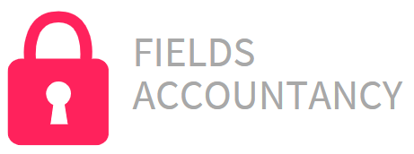**Task 8 - Email**

**From:** mark.hamden@fieldsaccountancy.com.au

**To:** admin@ramemberus.com.au

**CC.:**

**Subject:** Assistance please…further work needed.

Good morning,

Our company would like to express our thanks for the provision and installing of our new computer system. The training of our staff, the migration of our data from the old system to the new technology and the levels of service were excellent.

We have however struck a problem that did not occur to us!

With the rapid use of digital technology for communication we note that our accountancy firm is not prepared in either the level of understanding by our staff nor the firm’s policies and procedures of the levels of use we are now trying to implement.

We seek your assistance in several ways. I have attached a brief of work that we wish you to undertake as an extension of your recent project with us. We are happy with your existing terms and rates, so the provision of a quote is not necessary.

Would you please confirm that you are able to undertake this work.

Regards

Mark