The Importance of Social Media Policies in the Workplace
With more than 15 million monthly Facebook users in Australia and an average of 35% of Australians using social media at work, the issue of social media and its role within the workplace is growing. As the boundaries between corporate life and private life become more blurred, employees’ actions can affect the organisation’s brand more than ever. It is therefore critical that organisations have a detailed policy on social media.
iHR Australia’s Managing Director Stephen Bell, who produced the Responsible Use of Social Media eLearning program says, “Sometimes people use social media as a means of expressing their views about the organisation, its products and services, and its customers and stakeholders. Sometimes people who work together bring their own banter or issues online. All of this is an on-going risk to the organisation from a brand, performance and compliance perspective”.
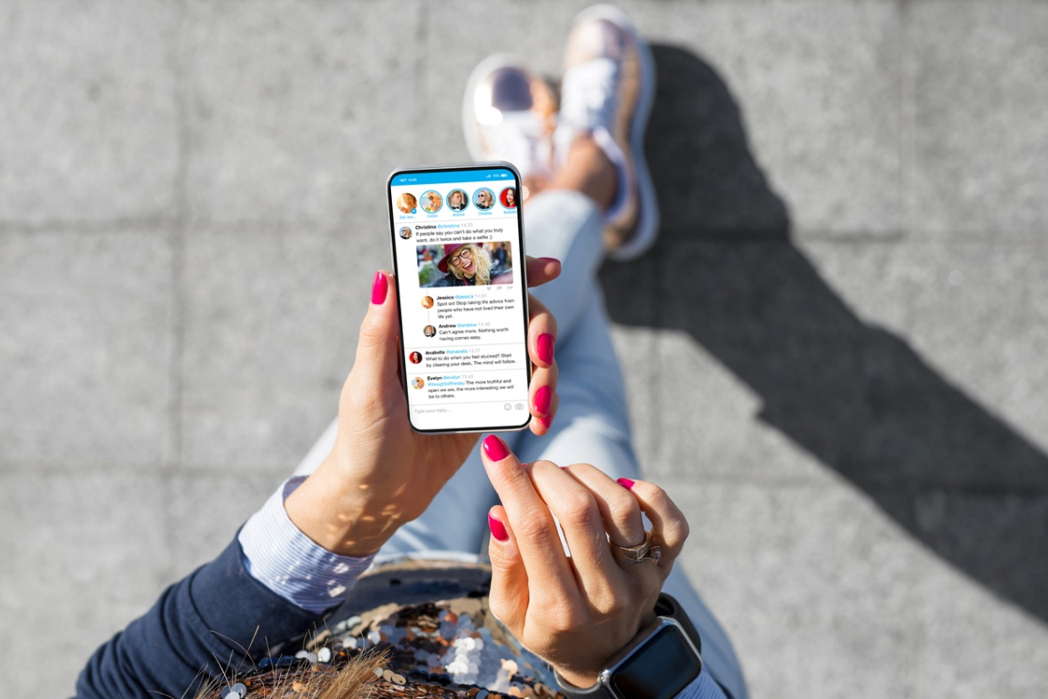
The impact of social media on organisations can be serious with employers held vicariously liable for employees conduct on social media even when comments were made outside of the workplace and office hours. Organisations can also have their reputation and brand damaged by comments made by employees. Organisations should therefore make clear their expectations on the responsible use of social media in policies and through training to mitigate associated risks.
In a leading case on social media and unfair dismissal, Fair Work Australia found there was no valid reason for termination of an employee after he posted derogatory comments about his managers out of hours on his personal Facebook page. Whilst an internal investigation by the organisation found the employees comments amounted to unlawful discrimination, Fair Work criticised the company’s lack of social media policy, alongside other findings, and ruled the employee was unfairly dismissed and ordered compensation and reinstatement.
According to John Boardman, iHR Australia’s Director Workplace Relations, having an organisational social media policy is becoming more important every day. “Social media comes in many forms and is in fact really just a vehicle for individuals’ comments or behaviour to be disseminated. Its impact might, however, be more serious than other forms of publishing, in the sense that it might be seen by broader and unintended audiences”.
Stephen Bell suggests that organisations need to have and communicate a social media policy before dismissal is an option. “In our environment you really need a policy and training before you can effectively hand over liability to a worker for their actions. Many organisations are really missing the training piece”.
Mr Boardman elaborates on Mr Bell’s point about reducing the organisation’s liability, “Preventative measures can never provide absolute protection from liability. It is however, about risk minimisation and taking all reasonable steps. The more you can demonstrate that you have taken steps to prevent injury (or damage), the easier it will be to defend the organisation”.


Company social media policies should cover every possible work-related social media interaction and should include:
- Definition of social media.
- Definition on appropriate and reasonable usage.
- When an employee can use social media at work and how this relates to productivity.
- What company information can / cannot be shared to protect data and sensitive information?
- Who is subject to the policy (i.e contractors and volunteers)?
- Reference to other company policies and links this to social media usage.
- A guide on social media outside usage outside of the workplace and work hours that could be associated with the company, employees or clients.
- The organisation’s response to breaches of policy including disciplinary action or even termination.
When asked when the best time to educate on the responsible use of social media is, Mr Bell responded, “Yesterday. The make-up of the workforce, the nature of the business and employee’s access to technology at work are all factors to consider when assessing the risk of not having a social media policy. All policies are a work in progress and should be updated periodically and at least once every two years”.

Source: iHR Australia, as at https://ihraustralia.com/social-media-policies-in-the-workplace/, as on 25th September, 2018.

