Task D
With that support request addressed, it is now time to obtain feedback from both the users of the software and the leaders of the team. You obtain feedback so that what is currently done and available can be improved, or better methods can be added to provide support.
In this task, you are required to obtain feedback from the client and the users regarding the solution and support you have provided.
This task comprises of two parts.
Part One
Using the topic headings provided, create three questions in each topic based on those criteria. These questions are to be designed so that they can be distributed by email, the respondent can answer then email the results back to you. Also provide the instructions on how to complete the survey.
Finally write a draft of an email to a respondent giving them details of the survey, how to complete it and expressing your thanks.
Topic headings:
- Overall experience with TATA technical services (using services again, recommendation etc.)
- Performance, services and knowledge
- Quality (include damage, completion of documents, timeliness)
- Speed and dependability (timeliness of training, upgrade etc.)
Email your work to your supervisor.

Part Two
You have received the feedback (summary in the table below) about the IT advice you have provided to them.
You now must analyse the results, identify any areas for improvement and explain how to improve them. You are required to use the table format below to complete the task.

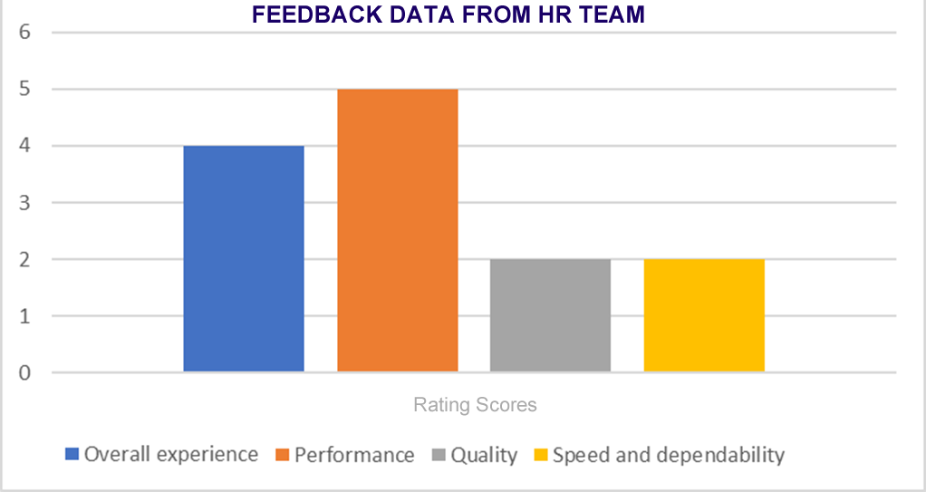

No. | Areas of improvement | Ways to improve
1.
2.
Add more rows if required.

