**Task 1 – Social Media Use**

This assessment task requires you to establish a social media presence in a business, which may be in the tourism, travel, hospitality, events and other service industry sector.

This assessment task can take place in either:

* an industry workplace; or
* a simulated industry workplace set up for the purpose of skills assessment.

as determined by your Assessor.

Specifically, you are required to over the period of a month to:

* identify at least six content items suitable for use on a social media platform, demonstrating use of both internal content development and external content sourcing
* use social media tools on at least five occasions to engage with different customers by:
* asking questions to determine customer needs
* responding to questions and complaints within timelines and according to organisational policy and procedures
* referring customers to relevant information as needed
* responding to customer reviews and other user-generated content
* communicating effectively in writing to a variety of audiences
* respond to customers from each of the following different social media customer responder categories, through at least two different social media platforms:
* troll
* rager
* misguided customer
* unhappy customer
* market and promote a business using social media tools over a period of one month by:
* managing a business account on at least one social media platform
* following monthly content calendar to pre-plan a variety of content
* curating content appropriate to business needs
* monitoring and reporting on organisational measurement metrics according to social media plan.

In content selection, you must take into account:

* privacy legislation and confidentiality requirements
* spamming
* copyright and intellectual property considerations
* creative commons

and apply legal and ethical practices for use of social media including:

* responsible use of platforms and tools
* responsible marketing practices
* fair competition guidelines
* duty of care
* bullying and harassment policies

Sources of information for social media content should include:

* compliments
* complaints
* images and photos
* links to other websites
* current trends
* internet
* Use Generated Content

Note: In order to complete this Assessment task, the following must be accessed and used:

* content calendar that lists:
* key events
* milestones and relevant dates
* content for release
* files for use in social media:
* images
* text files
* PDFs
* audio files
* video files
* link associated files
* organisational social media plan
* computer or mobile device with internet access
* social media monitoring tools
* social media platforms and tools
* social media platform and tool policies and terms of use
* customers or stakeholders on social media with whom the individual can interact; these can be:
* customers or stakeholders in an industry workplace; or
* individuals who participate in role plays or simulated activities, set up for the purpose of assessment, in a simulated industry environment operated within a training organisation.

At the end of the month, you are required to compile and submit:

A report outlining:

* Summary of the organisational social media plan
* Social media monitoring tools utilised
* Summary of how legal and ethical practices for use of social media were addressed
* List of all content sources (indicating internal and external)
* Copies of user-generated content
* Sample copies of your posts showing use social media tools on at least five occasions
* Summary of potential incidents or points of conflict and escalation to relevant personnel as required
* Results of all tracking and monitoring
* Interpretation of tracking and monitoring results
* Recommendations for improvements to marketing and promotion
* Appendices of Weekly reports showing your social posting activities

**Guidance to establish your social media presence (Travel Agency Example)**

**Create a Facebook Profile[1]**

As a travel agency, you must have a business page on Facebook. Add an appealing cover image and profile picture that’s relevant to the travel business. Take a look at this snapshot from the Facebook page of Escape Travel, Geelong:

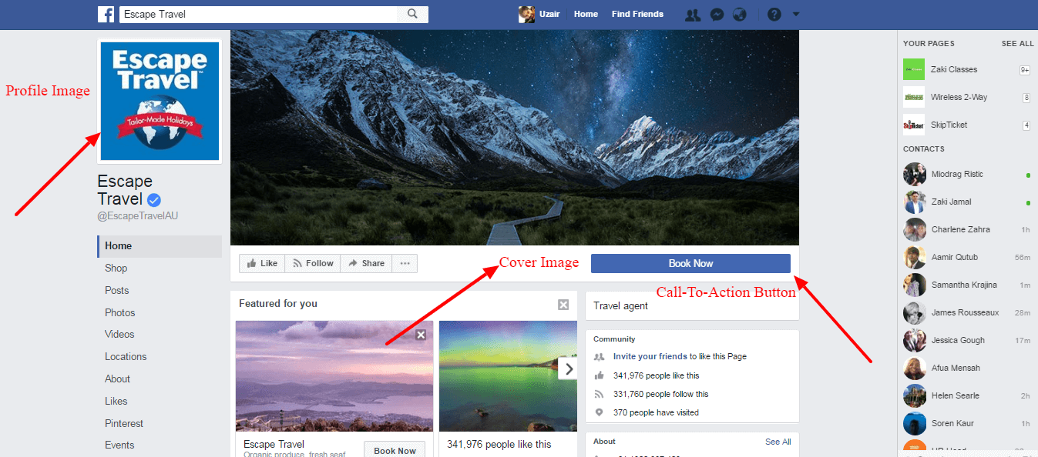

You must also optimise the Call-to-Action button on your Facebook page as shown in the snapshot above. It should drive your page visitors to a landing page where they can make a travel booking.

The next step is to optimise the ‘About’ section of your page:

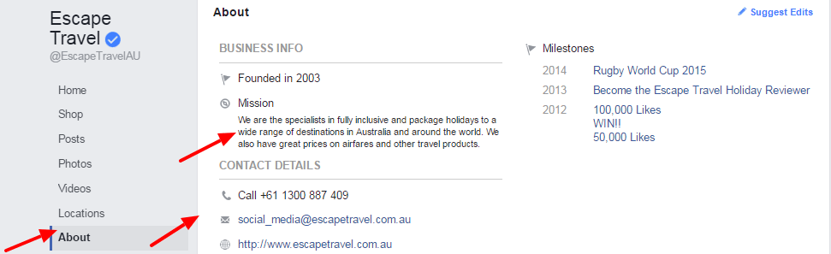

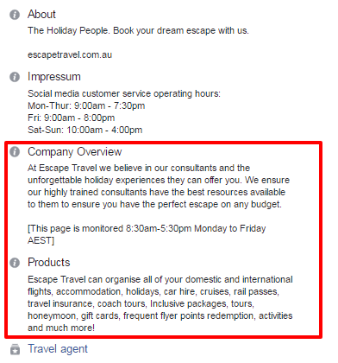

You can add the following details about your company on your Facebook page:

* Year of establishment
* Mission
* About the company
* Company overview
* Products
* Milestones and contact details

While creating your Facebook page, you can define your target audience as well. Once you have a page ready, you need to add interesting updates to it on a daily basis. You should add at least two posts every day, to engage with your Facebook fans.

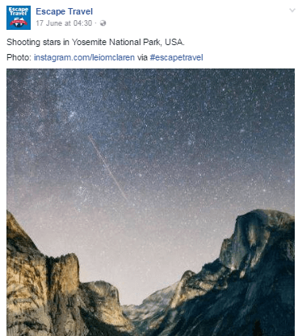

Add posts that will be of interest to your Facebook fans. Here are some examples of the type of posts you can add:

* Talk about favourite travel destinations
* Traditional seasonal destinations
* Travel facts
* Travel advice

You can also give discount offers and create a paid campaign targeting prospects in Geelong. Make sure you are replying to each of the comments you are getting on your Facebook posts.

Take a look at this example from Expedia Australia’s Facebook page. The post talks about a unique music concert hall in Barcelona:

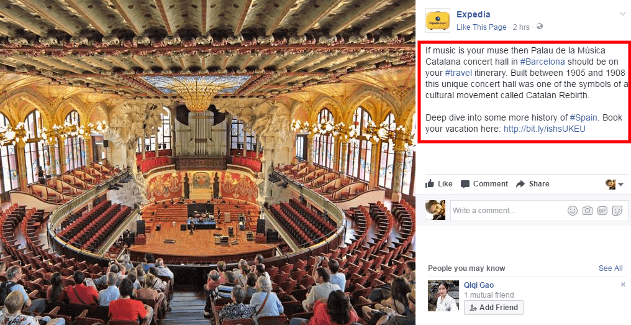

Such fascinating itinerary ideas are helpful in maintaining the interest level of your Facebook fans.

*“Consumers are particularly keen on discounts (54%) and giveaways (48%) from the brands or businesses they follow.”*

Here is an example on how you can lure your fans and convert them with an attractive discount offer:

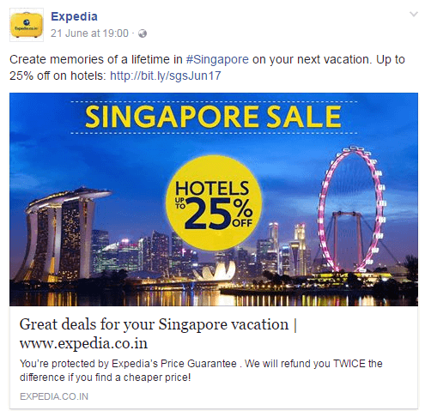

Here is another example of the kind of contest you can run on your Facebook page. Just ask a fun travel related question and choose a winner with the most creative answer:

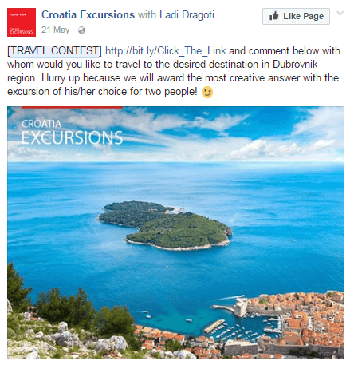

The more you engage with your fans, the higher will be your rate of conversion. Besides that, contests would help you add virality to your posts, helping you to spread a word about our services.

Create a monthly goal for your Facebook page and make sure it’s overall reach and engagement is going up consistently. Use the Facebook Insights tool to track some of the key metrics related to your page.

Here are some of the Facebook page metrics that you can and must track:

* Organic vs. Paid Likes
* Likes from Geelong (local region)
* Average Post Reach
* People Who Clicked the Call-to-Action Button
* Website Clicks
* Total Pageviews
* Audience Demographics
* Post Engagement Level – Likes, Comments and Shares

You can use the following free template to create and manage weekly reports of your social media activities:

**Creating Your Twitter Profile**

Twitter is another channel where you must have your business profile. The channel helps you to interact with your prospects and follow them. It will help you to get more followers for your business. To create a professional business presence on Twitter, you need to create a new account and spruce up your profile:

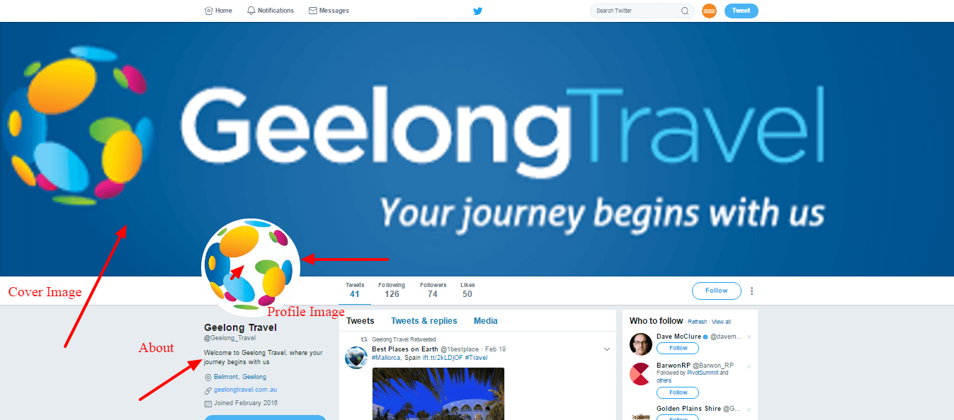

Update your Twitter profile by adding the following details:

* Cover image
* Profile image
* About the company
* Website link

Create a persona of the people you wish to target. Your persona should include their demographics, psychographics and preferences. Use Twitter search to look for such people in Geelong and nearby areas. Next, you should follow these people and engage with them. It will ensure that quite a few of these are following you back. Post tweets from your Twitter account on an ongoing basis. Research for the appropriate hashtags using a tool like Hashtagify.me. Make sure you are using at least one hashtag in each of your tweets.

Take a look at this example:

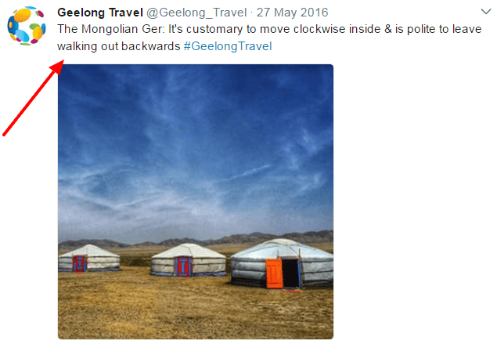

You must also engage with your prospects by retweeting and liking their tweets. You can use the direct message feature of Twitter to send offer related DMs to your followers and get more conversions for your business.

Also, use Twitter ads and promoted tweets to fetch leads and followers for your business.

Create weekly goals for the number of Twitter followers you are getting. You must also use Twitter analytics to analyse some of the key metrics of your Twitter account. Some of these include:

* Number of tweets
* Mentions
* Profile visits
* Total followers

Track these metrics and make sure you can maintain an upward trend for all of them.

Here is a snapshot of how your Twitter analytics would look like:

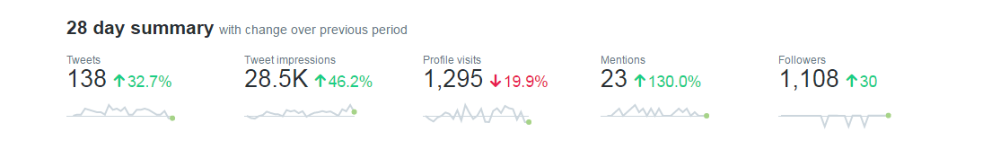

Here is a free weekly reporting template that you can use for Twitter: http://bit.ly/2s3niXH

**Create a Presence on Instagram**

Instagram is a visual medium for showcasing your travel business and attracting potential customers. Create a profile and start adding updates on a regular basis.

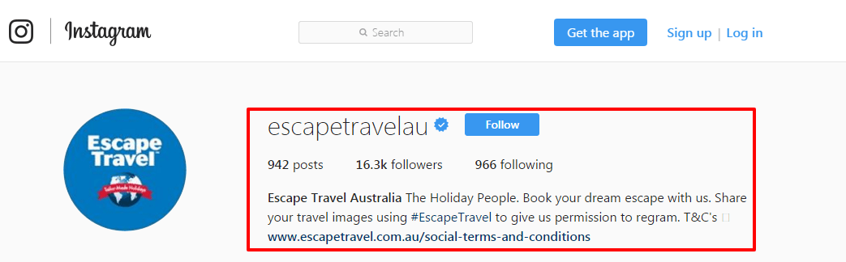

Instagram, helps you to add photos, short videos and stories which are visible to your followers. Make sure you are adding high quality and professional images on your Instagram account. You can use tools like Websta to research for relevant hashtags to be used in the captions.

Follow Instagram accounts of your potential clients and engage with them by liking their posts and commenting on them.

The platform also allows you to run paid campaigns and get targeted followers for your business. Once you have relevant followers on your Instagram profile, you can use the direct message feature to offer them a special discount on your services.

You must track some of the key metrics of your Instagram page as well. Use this free template and record the results and improve them over time: http://bit.ly/2rK84Yg

**Build a Community**

For a thriving travel business in Geelong, you must build a community of travel lovers to participate in stimulating and engaging conversations. You should at least have a presence on Facebook, Twitter and Instagram. Run contests and paid ad campaigns to grow your community. Get your followers to interact with your pages through conversations related to travel and reward them with gifts and offers.

All of your efforts will help you to grow your community and get more business from it.

You can add a LinkedIn page and a Google+ page as well. A Google+ page will help you to improve your search engine visibility.

**Social Media Automation**

You can automate the posts that you are adding on your social media pages with the aid of a tool like Hootsuite. The free version of the tool helps you to post up to three social media profiles simultaneously. It also allows you to schedule your posts and save time in posting on all your profiles manually.

You can create a content calendar for adding posts to your social media pages. You can plan your posts according to the seasonal popularity of travel destinations.

Create a spreadsheet and add say 60 posts for the month, to be published twice daily. Create separate images for each of your posts. You can use a tool like Canva to design your images and add the necessary text and filters to them. You can create a style guide for designing the social media images. Use the guide to maintain design consistency of your social posts. Here is an interesting list of free social media tools that you can use, to promote your travel business more efficiently - https://www.business.com/articles/15-free-social-media-marketing-tools-for-small-businesses/.

1. Source: Enterprise Monkey, as at https://enterprisemonkey.com.au/blog/social-media-tips-travel-agencies-geelong/, as on 26th September, 2018.